Fabrication of cuprous nanoparticles in MIL-101: an efficient adsorbent for the separation of ethylene and ethane mixtures
Ganggang Chang†, Zongbi Bao*†, Qilong Ren†, Shuguang Deng†‡, Zhiguo Zhang†, Baogen Su†, Huabin Xing†, and Yiwen Yang†
Key Laboratory of Biomass Chemical Engineering of Ministry of Education, Department of Chemical and Biological Engineering, Zhejiang University, Hangzhou 310027, China
Abstract
Separations of olefin/paraffin mixtures are one of the most energy-intensive processes in the chemical industry due to their very small relative volatilities and close molecular sizes. Their separations performed at a large scale are currently achieved by cryogenic distillations, which are operated at low temperature and high pressure. An alternative olefin/paraffin separation process with low energy consumption would significantly reduce operating expenses. Among all competing techniques toward this end, the adsorptive separation seems to be one of the most promising and energy-efficient processes. Recently, an emerging class of solid materials known as metal-organic frameworks (MOFs), which offer a high surface area, adjustable pore dimensions, and chemical tenability have also been examined for olefin/paraffin separation.
Over the past decades, research efforts have been mostly aimed at preparing new MOF structures and studying their applications in molecule storage and separation. Nowadays, loading of metal ions inside the porous matrices of MOFs is of current interest. Among the numerous MOFs reported so far, MIL-101 is one of the excellent MOF materials due to its extra high specific surface area, pore volume, and high thermal and chemical stability to water as well as common organic solvents. The combination of these outstanding features makes it an interesting candidate for adsorption and catalysis. Moreover, the mesoporous cages can be used to confine the metal nanoparticles and to restrict their growth, which are the promising features for their applications in adsorption. Herein, we reported the synthesis of a new π-complexation adsorbent by using MIL-101 as the support and cuprous chloride as the active component, of which CuCl was introduced to MIL-101 by the “double solvents” method. An optimized cuprous loaded MIL-101 was shown to have an enhanced ethylene adsorption capacity and higher ethylene/ethane selectivity (14.0) compared to the pure MIL-101 (1.6). The great improvement of selectivity can be attributed to the newly generated nano-sized cuprous chloride particles that can selectively interact with the carbon-carbon double bond in ethylene through the π-complexation.

The following pictures are some relative results:
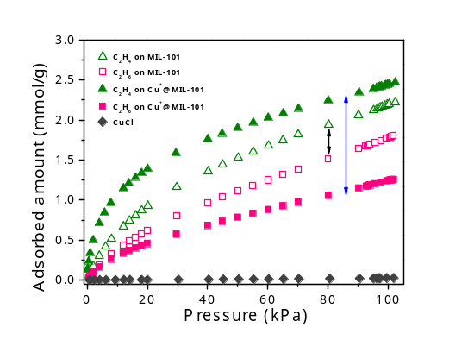
Figure 1. Ethylene and ethane isotherms for the pure, 40wt%Cu⁺ loaded MIL-101 and pure CuCl at 30ºC and 1bar.

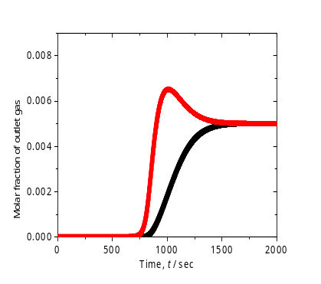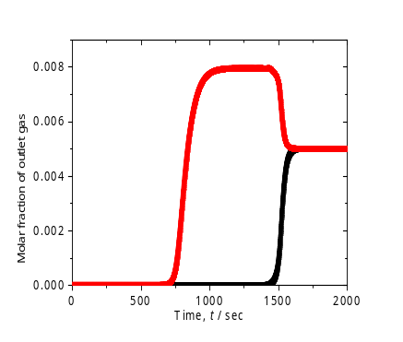
Figure 2. Breakthrough curves of equimolar mixtures of ethane/ethylene in columns of MIL-101(a) and Cu⁺@MIL-101 (b) at 303.15 K and 1 bar calculated using AspenTM.(black: ethylene, red: ethane)

Reference
- Chang, G. G.; Bao, Z. B.; Ren, Q. L.; Deng, S. G.; Zhang, Z. G.; Su, B. G.; Xing, H. B.; Yang, Y. W. Fabrication of cuprous nanoparticles in MIL-101: an efficient adsorbent for the separation of ethylene and ethane mixtures. RSC Adv. 2014, DOI: 10.1039/c4ra02125h.
- Wu, X. F.; Bao, Z. B.; Yuan, B.; Wang, J.; Sun, Y. Q.; Luo, H. M.; Deng, S. G. Microwave synthesis and characterization of MOF-74 (M = Ni, Mg) for gas separation. Micropor. Mesopor. Mater. 2013, 180, 114-122
- Bao, Z. B.; Alnemrat, S.; Yu, L.; Vasiliev, I.; Ren, Q. L.; Lu, X. Y.; Deng, S. G. Adsorption of ethane, ethylene, propane, and propylene on a magnesium-based metal-organic framework. Langmuir 2011, 27,13554-13562
- Bao, Z. B.; Alnemrat, S.; Yu, L.; Vasiliev, I.; Ren, Q. L.; Lu, X. Y.; Deng, S. G. Kinetic separation of carbon dioxide and methane on a copper metal-organic framework. J. Colloid Interface Sci. 2011, 357, 504.
- Bao, Z. B.; Yu, L.; Ren, Q. L.; Lu, X. Y.; Deng, S. G. Adsorption of CO₂ and CH₄ on a magnesium-based metal organic framework. J. Colloid Interface Sci. 2011, 353, 549.
- Saha, D.; Bao, Z. B.; Jia, F.; Deng, S. G. Adsorption of CO₂, CH₄, N₂O, and N₂ on MOF-5, MOF-177, and Zeolite 5A, Environ. Sci. Technol. 2010, 44, 1820-1826.

