Visualization and Prediction of Operating Conditions of Blast Furnace

Koji Hazama^{a,†} (koji.hazama@gmail.com)
Koichi Fujiwaraª (fujiwara.koichi@i.kyoto-u.ac.jp)
Manabu Kanoª (manabu@human.sys.i.kyoto-u.ac.jp)
Shinroku Matsuzaki^{b} (matsuzaki.96y.shinroku@jp.nssmc.com)
Akira Morita^{b} (morita.882.akira@jp.nssmc.com)
ªDepartment of Systems Science, Kyoto University, Kyoto, Japan
^{b}Nippon Steel & Sumitomo Metal Corporation, Kimitsu, Japan

Keywords: visualization, prediction, operating conditions, supervised dimensionality reduction

Abstract
The present work is aiming to develop a method for visualizing and predicting operating conditions of a manufacturing process: how good the process is and will be operated. Nowadays a large number of variables are measured and the number is fast increasing. However, process data are not necessarily fully utilized to monitor operating conditions and improve the productivity and the stability of manufacturing processes. The effective use of process data is not easy; engineers and operators have faced difficulties in extracting important information from a huge amount of data in real time. In particular, it is difficult to grasp the relationship among many process variables. Thus the visualization of operating conditions in a low-dimensional space must be useful.
In this research, supervised dimensionality reduction techniques such as partial least squares (PLS) regression and supervised distance preserving projection (SDPP) were investigated and compared through their applications to operation data of a blast furnace at Nippon Steel & Sumitomo Metal Corporation. In the steel industry, blast furnaces are used to smelt iron ore to produce pig iron. Their stable operation is especially important to realize efficient operation of the entire plant. However, their complexity makes it difficult. Thus, the present work aims to develop a method for visualizing and predicting operating conditions of the blast furnace, in which 177 process variables are measured. A total of 5000 samples were used for analysis. PLS and SDPP were used to visualize the operating conditions in a two-dimensional space. In addition, new techniques were developed to predict future operating conditions. The proposed techniques use past data to derive the expected transition of operating conditions in the future; they are Just-In-Time approaches.
Experienced engineers labeled a part of samples as, for example, very good, good, bad, very bad, and low production in advance, and the labels were used as the reference (teacher) signals. Samples with the same label are expected to form a cluster, which is as far from each of other clusters with different labels as possible. In addition, clusters corresponding to ordered labels such as very good, good, bad, and very bad should be in proper order in the two-dimensional space. Although labeling samples requires expertise in operation of the target blast furnace, it is sufficient to label representative samples that are easy to evaluate the corresponding operating conditions. Once a model is developed, the current operating conditions can be easily displayed in the two-dimensional space when process variables are measured. Such visualization enables engineers and operators to easily evaluate the operating conditions and judge if intervention is necessary or not.
In this work, each axis of the two-dimensional space has physical meaning. One axis is corresponding to the goodness of the operating conditions, and the other axis is corresponding to the throughput, i.e. production rate. The visualization results confirmed that the samples were located according to their labels (reference signals) in proper order in the two-dimensional space, that is, operating conditions were successfully visualized and also that the goodness of the operating conditions had a tendency to linearly correspond to the amount of production.
Furthermore, the proposed methods can visualize future operating conditions in a low-dimensional space. The prediction of operating conditions is achieved though a Just-In-Time approach. The procedure is as follows: 1) Prepare a database consisting of process data measured in the past, 2) select K samples xk(tk) (k=1, 2, …,K) nearest to the target sample, i.e., the current sample x(t), from the database, 3) select their future samples xk(tk+d) from the database, and 4) evaluate the operating conditions at time t+d by using the selected samples. The nearness is measured with the Euclidean distance in the two-dimensional space in this work; however, correlation or other indexes can be also used to measure the nearness in the low-dimensional space or in the original high-dimensional space. In this work, we propose two types of methods for evaluating the operating conditions in the future. One is an evaluation method based on the frequency of neighbor samples, referred to as a frequency-of-neighbors method. The other is an evaluation method based on the distribution of neighbor samples; this method is referred to as a track-forecast method because it is like a typhoon (tropical cyclone) track forecast.
The result of the frequency-of-neighbors method showed that it could predict the goodness of the future operating conditions successfully. On the other hand, a result of the track-forecast method is illustrated in Fig. 1, where samples with labels such as very bad, bad, good, very good, and low production are colored red, magenta, cyan, blue, and green, respectively, and actual data are colored yellow. This result clearly shows that the operating conditions would deteriorate in next three hours. Moreover, the result (actual data) confirmed that the operating conditions deteriorated. Hence, the proposed visualization and prediction methods can provide engineers and operators with useful information to evaluate the operating conditions and judge whether intervention is necessary or not.

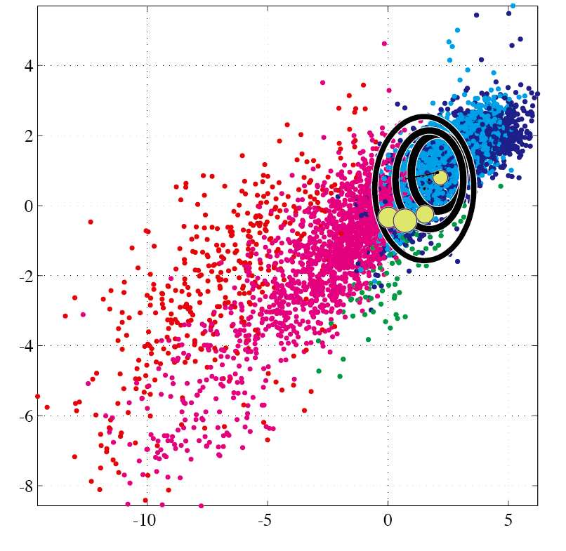
Fig. 1. Result of the track-forecast method

