An integrated model of a spiral-wound membrane module for reverse osmosis considering the effects of winding and spacers
Boram Gu, Claire Adjiman, Yun Xu
Department of Chemical Engineering, Imperial College London

Keywords: Reverse osmosis, spiral-wound module, spacer, computational fluid dynamics
Reverse osmosis (RO) membrane technology has been considered to be more effective in terms of separation capability, its simple installation and less energy requirement than any other water purification technologies [1]. For this reason, RO processes have been successfully applied to water purification and seawater desalination for several decades, particularly in large-scale plants. Of various commercially available RO membrane modules, the spiral-wound module (SWM) has been accepted as most suitable for large-scale use due to its high packing density, low fouling propensity and easy cleaning [2]. From the viewpoint of system design, it is crucial to predict the performance of SWM because it is directly related to the specific energy consumption and required footprint of plants, which are also correlated with cost.

An SWM for RO is made by assembling folded flat sheet membranes and spacers inserted in between and rolling them around a perforated central pipe. By gluing permeate spacers to the membrane, the feed stream flows in the longitudinal direction, while the permeate flows in a spiral direction without mixing with the feed stream. Since the set of folded membranes and spacers is rolled around the central pipe, the geometry of an SWM becomes far more complex than a plate-and-frame module; the latter is simply a stack of membranes and spacers, with alternating feed and permeate channels. Therefore many existing computational models of SWM have been developed under the assumption that feed and permeate channels are rectangular and two sides of the folded membrane are symmetrical in order to simplify the geometry. However the assumptions are inadequate for describing a unique feature, which differentiates an SWM from a plate-and-frame module.

In the present work, a detailed spiral model is developed in order to describe the winding geometry and corresponding geometric parameters more accurately, which may affect the prediction of the module performance. By introducing a third parameter, the winding angle θ, the cross-sectional spiral geometry of an SWM can be reconstructed as shown in Figure 1. Based on the reconstructed spiral geometry, more accurate cross-sectional area and flow path length can be obtained. Interestingly, it is found that a part of the outer membrane (coloured in grey in Figure 1) is not used to generate permeate flux. This is due to the absence of a concentration difference between the two sides where the feed stream flows. Therefore the effective area is less than the total membrane area used to assemble a module.

Considering variations in the channel height, the flow path length and the cross-sectional area along the membrane, the permeate fluxes through an inner and outer membrane are calculated separately by employing a solution-diffusion model, which is the most widely used theory to describe water and solute transport through a semi-permeable membrane. Differential equations describing the overall and component material balances and pressure drop are solved simultaneously by means of MATLAB, in order to obtain flow velocity, concentration and pressure distribution for the feed and permeate channel.
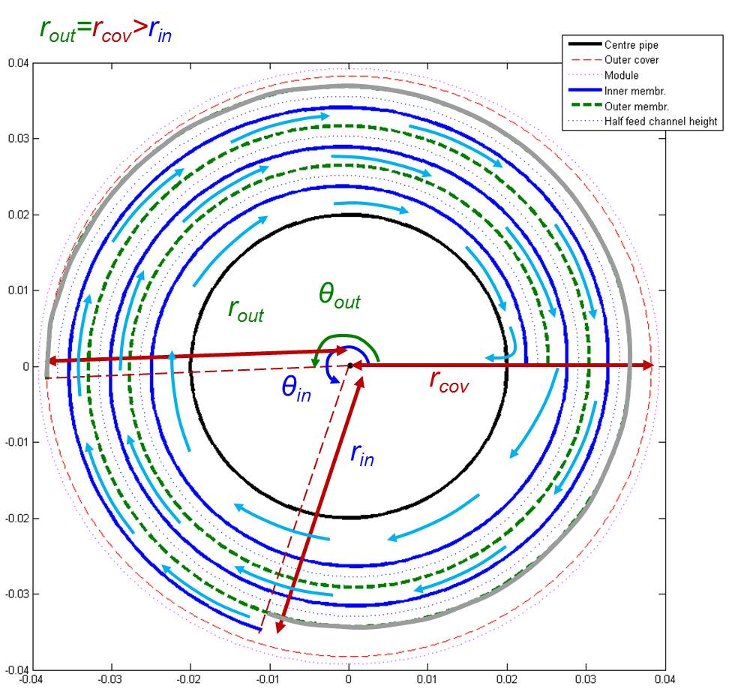
Figure 1. Reconstructed spiral geometry. Blue solid line: inner membrane, green dashed line: outer membrane, blue dotted line: the half feed channel, red dashed line: outer cover, magenta dotted line: arbitrarily chosen actual outer cover added due to numerical instability.

Apart from the spiral geometry, the performance of an SWM is strongly influenced by spacers, especially, feed spacers. Not only do the spacers prevent the two sides of a folded membrane from being in contact with each other but also mitigate concentration polarisation, which is caused by the accumulation of rejected solutes on a membrane surface and consequently results in reduced driving force for water permeation [3]. However, a drawback with the spacers is that they cause elevated pressure drop along the feed channel compared to an empty channel. Since concentration and pressure are the most important variables used to calculate the permeate flux and pumping energy, the concentration polarisation and pressure drop inside the module should be accurately predicted by taking into account the presence of the spacers. There are many publications which deal with spacer-filled channels in two- and three-dimensions in order to study the effects of spacers on mass transfer and pressure drop using computational fluid dynamics (CFD) packages. However, most of the CFD simulations focus on qualitative comparisons of various spacer-filled channels. There is a lack of detailed quantitative study which mathematically correlates the concentration polarisation and pressure drop with variables involved in the CFD simulations. Although a number of mass transfer correlations have been proposed, they are limited to a specific type of spacers [4].

In the present work, therefore, correlations for a mass transfer coefficient and frictional coefficients are developed with respect to design parameters of spacers such as the distance between parallel filaments, the angle of crossed filaments, the variation in the diameter of a filament and the type of spacers (woven/non-woven). Figure 2 shows a small segment of a spacer-filled channel surrounded by non-woven spacers with filaments of a uniform diameter, which represents the most basic geometry. A CFD package, COMSOL, is used to simulate flow, concentration and pressure patterns inside a spacer-filled channel in three-dimensions. Finally, the developed correlations for concentration polarisation and pressure drop are implemented into the detailed spiral model described earlier.

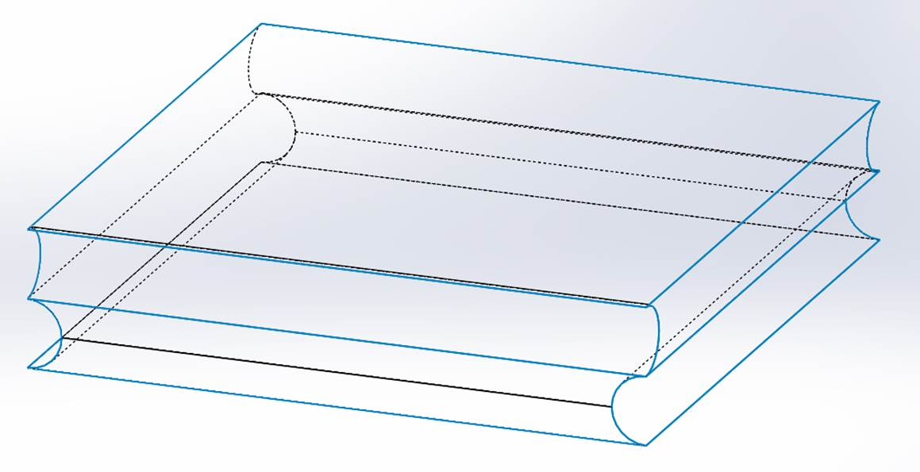
Figure 2. A small segment of the spacer-filled channel with non-woven and uniform-diameter filaments.

By integrating the MATLAB-based two-dimensional model for SWM and the detailed three-dimensional CFD model for an elemental unit of the space-filled channel, it is possible to take into account both the entire dimensions of the module, which cannot be easily handled in a CFD model due to the high computational demand, and the presence of spacers, which is impossible to be considered in a lumped or two-dimensional model due to the complex geometry. Furthermore, the integrated model can predict the performance more accurately and provide more information and insights into the module design because of the approach developed here allow the spiral geometry to be reconstructed in a more realistic manner.

References
[1] M. Elimelech, W.A. Phillip, The future of seawater desalination: energy, technology, and the environment, Science 333 (2011) 712–717
[2] J. Schwinge, P.R. Neal, D.E. Wiley, D.F. Fletcher, A.G. Fane, Spiral wound modules and spacers: Review and analysis, Journal of Membrane Science 242 (2004) 129–153
[3] E. Matthiasson, B. Sivik, Concentration polarization and fouling, Desalination 35 (1980) 59–103
[4] C.P. Koutsou, S.G. Yiantsios, A.J. Karabelas, Direct numerical simulation of flow in spacer-filled channels: Effect of spacer geometrical characteristics, Journal of Membrane Science 291 (2007) 53–69

