Introduction: Cardiovascular disease accounts for over one-third of all deaths in the United States¹, and a long-standing shortage of donor organs² motivates the efficient development of implantable cardiac tissue which can be grown in vitro from stem cells. Because the relationships between biomaterial chemistries and their effects on stem cell behavior are not well known³, the rational design of biomaterials to incorporate cues that will control stem cell fate remains challenging. Using high-throughput synthesis methods to generate libraries of biodegradable hydrogels, we elucidate how biomaterials may be modified to direct iPSC differentiation towards cardiac lineages.

Materials and Methods: Hyaluronic acid (HA) was selectively modified using triazine-activated amidation of carboxyl groups to incorporate amines of varying hydrophobicities, shown in Figure 1. HA carboxyl groups were reacted with an extent of modification of 10% for each biomaterial. High-throughput synthesis allowed the generation of a library of 15 modified HA polymers, which were cross-linked using barium chloride. Gelation was evaluated by retention of Fluorescein after crosslinking, and material hydrophobicity was quantified through contact angle measurements.
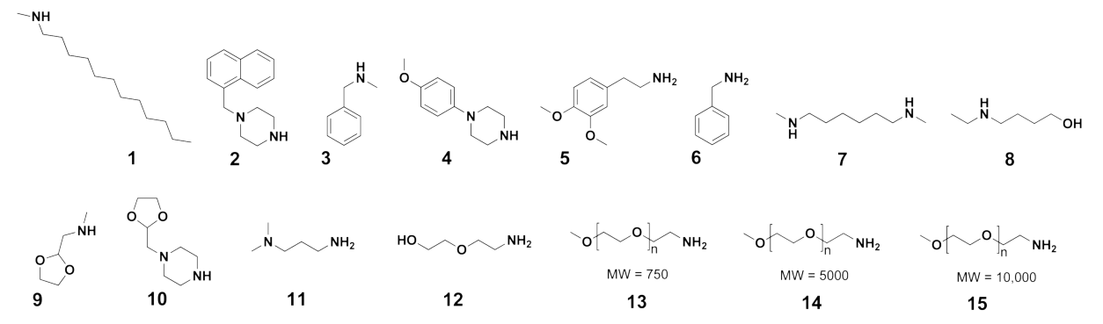
Figure 1. Amines used in HA modification, in order of increasing hydrophilicity.
Results and Discussion: Nuclear Magnetic Resonance verified that HA was successfully modified as intended, and the polymer library was confirmed to be a collection of uniquely modified materials. As expected, HA materials with hydrophobic amines had high contact angles on glass, while HA materials with hydrophilic amines had small contact angles. Gelation was observed in HA materials incorporating amines of intermediate hydrophobicities, indicating that these groups are good candidates for use in hydrogels for future iPSC work.

Conclusions: This work created a hydrogel polymer library which will be used in future studies to evaluate iPSC differentiation towards cardiac cell lines. The polymer library created demonstrates how selective modification of HA with a range of amines can produce hydrogels with desirable properties for iPSC differentiation. Future studies will evaluate adhesion and viability of cells in contact with these materials, as well as which materials promote differentiation towards cardiac lineages.

Acknowledgements: AJ acknowledges support from the National Science Foundation Graduate Research Fellowship Program (DGE-1110007).

References:
(1) Roger, V. L. Circulation, (2011), 123, e18–e209. (2) Langer, R. Science, (1993), 260, 920–6.
(3)Hook, A. L. Biomaterials, (2010), 31, 187–98.

