Nanoporous Carbon from Renewables for Supercapacitor Applications
Satish K. Nune, Ju-Won Jeon, Libing Zhang, John P. Lemmon, Melvin P. Tucker, Peter B. McGrail, Bin Yang

Due to the increased energy consumption, efficient and cost-effective electrical energy storage systems are highly desired. Supercapacitors that bridge the gap between batteries (high energy and low power) and capacitors (low energy and high power) have been playing crucial role as one of the energy storage systems and have started to realize their potential in transportation as well as consumer electronics. However, their use is relatively limited because of poor performance (low energy density) and high cost. Significant efforts have been made to develop highly efficient less expensive supercapacitors. We proposed to use low-cost renewable biomass such as lignin as a potential precursor to produce porous carbons for Supercapacitor applications. Lignin is a natural amorphous polymer that acts as an essential glue to give plants their structural integrity. It is a main component in lignocellulosic biomass (15-30% by weight, 40% by energy), together with cellulose and hemicelluloses. Simple carbonization of lignin results in carbons with very low surface area that is not suitable for supercapacitors. We investigated the effect of molecular weights of the lignin precursors on surface area and energy densities. We will present our results on the carbon residues obtained from three different lignin precursors that differ in molecular weights and their electrochemical performances.

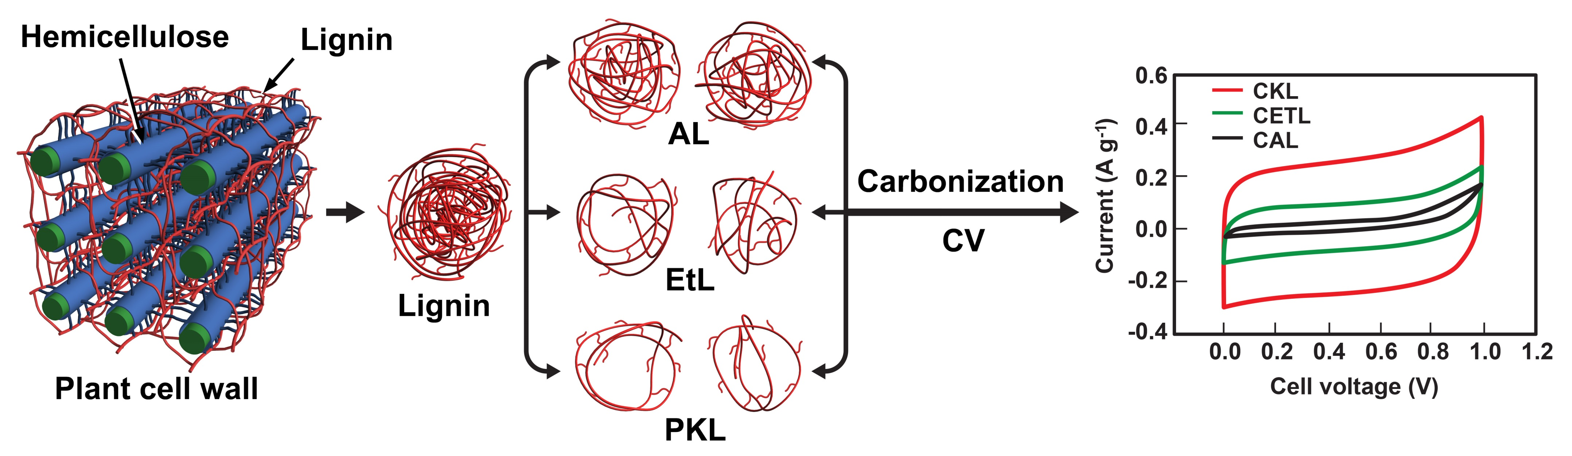Figure 1: Extraction of ligin with three different molecular weights and corresponding CV plots.

