Wall shear stress generated by bubble swarms in Newtonian and non-Newtonian liquids
L Böhm¹, M Kraume¹
¹Chair of Chemical and Process Engineering, Technische Universität Berlin, Germany
FH6-1, Strasse des 17. Juni 135, 10629 Berlin, Germany. Tel: +493031472791, email: lutz.boehm@tu-berlin.de

Aim
Aeration is a common measure to detach deposition layers from membranes. A detailed view at commercially available flat sheet membrane modules reveals that although aeration is a main cost factor in the operation of membrane bioreactors (MBR), no optimal design and operation with respect to the cleaning efficiency was found yet. Different gap distances between the membrane cushions, different bubble sizes, additional mechanical cleaning with the help of granulates, pulsating aeration etc. are applied. This investigation’s focus is gaining a fundamental understanding about the behavior of bubble swarms in such systems. The complexity of the behavior of a bubble swarm in an MBR is rather high. The fundamental approach of investigating the bubble swarm behavior in one rectangular channel helps getting a deeper insight into the bubble dynamics in such systems. Especially the investigations with model solutions imitating the rheological behavior of activated sludge can deepen the understanding of the cleaning process.

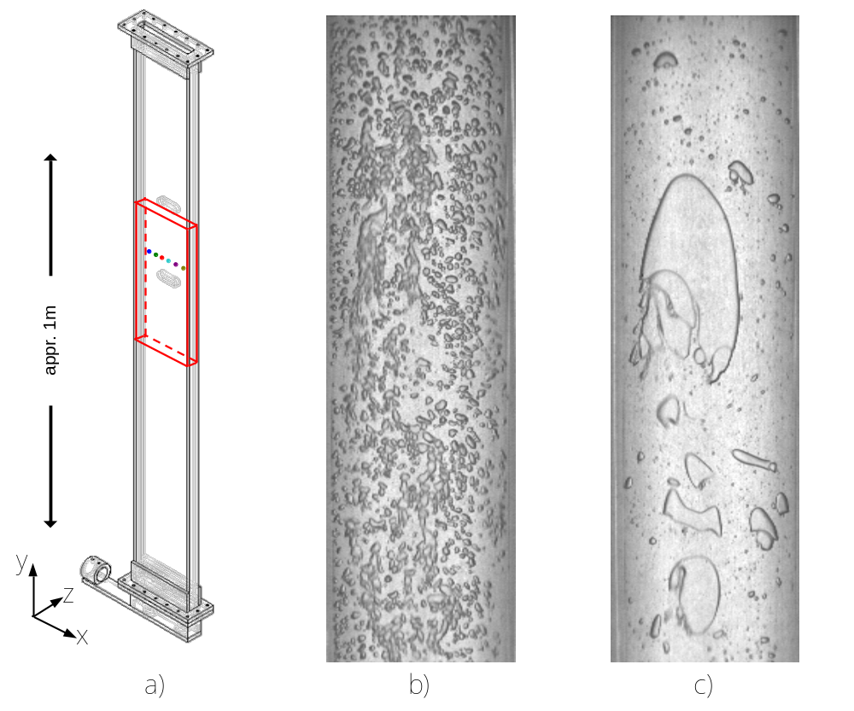
Figure 1. Schematic of the rectangular channel (a), exemplary image of the bubble swarm in water+ions (b) and in non-Newtonian Xanthan solution+ions (c) for the same parameter combination

Methods
For this purpose, an experimental apparatus was built which represents one of the channels between two flat sheet membrane cushions with a rectangular cross section area [1]. Acrylic glass is used to make optical measurements possible (Fig.1a). At the bottom of the channel, for the aeration, a pipe is installed over the whole width of the channel with 15 holes, each with a diameter of 0.7mm. This assured in most cases an evenly distributed bubble swarm directly above the aerator. The fully automated rig is used to investigate bubble swarms rising in the channel with the help of the electrodiffusion method for the determination of the generated shear stress on the walls. An array of 6 sensors is installed horizontally approximately at a height of 1 m above the aerator. The recorded data is analyzed in terms of mean shear rates and standard deviations where the latter one takes the fluctuations of the shear stress into account. Such fluctuations are thought to be beneficial for the cleaning purpose. Additionally, high speed imaging is performed for the determination of the bubble dynamics (exemplary images can be found in Fig.1b) and c)). In this investigation, the gap distance between the plates (5-7 mm), the gas flow rate (100-600 L/h), the superimposed liquid velocity (0-0.2 m/s) and the rheology of the liquid (Newtonian, non-Newtonian) was varied. For the experiments with the non-Newtonian liquid, a Xanthan solution was used which had the same shear-thinning behavior as waste water sludge found in membrane bioreactors [2].

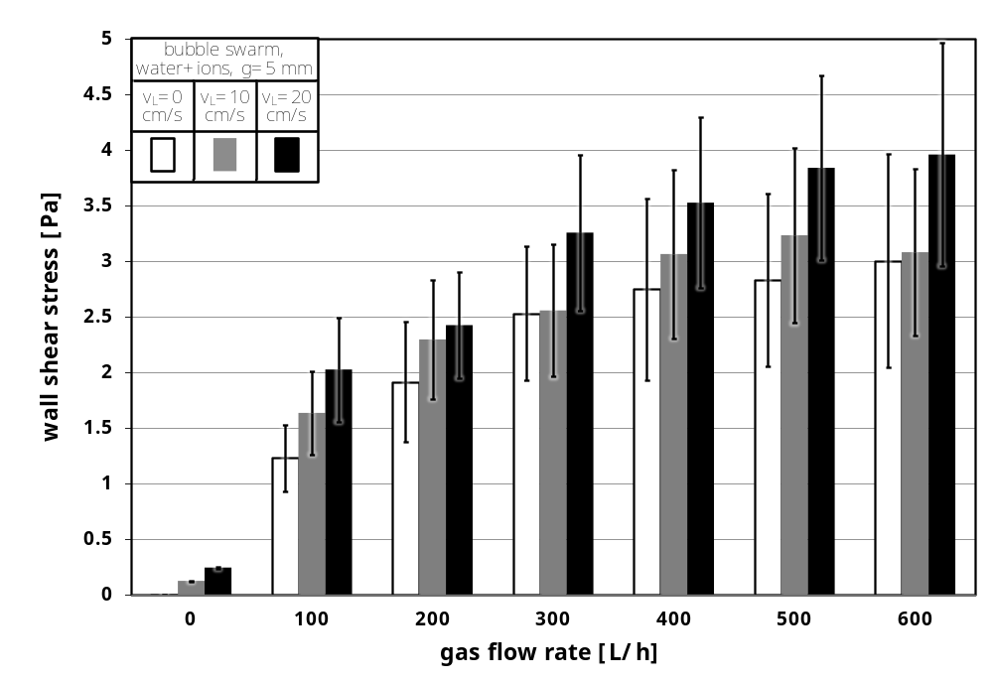
Figure 2. Wall shear stress generated by a bubble swarm in water+ions for different gas flow rates and superimposed liquid velocities in the channel with a depth of 5 mm

Results
Figure 2 shows the determined mean wall shear stresses and according standard deviations generated by the bubble swarm in water+ions (channel depth: 5 mm) as a function of the gas flow rate and superimposed liquid velocity. Generally, the mean values and the fluctuations increase with increasing gas flow rate while a trend can be assumed that the values asymptotically approach a constant shear stress value with increasing gas flow rate. Keeping the gas flow rate constant, an increasing superimposed liquid velocity also increases the wall shear stress. The values found for the bubble swarm are higher by a factor of 2 to 3 in comparison the shear stress generated by a single bubble [1].

Conclusion
This fundamental investigation illustrates the influence of the liquid rheology in MBRs on the bubble dynamics and therefore the cleaning effect. In shear thinning liquids, the generated shear rates are in the same value range as in Newtonian liquids but as the viscosity depends on the shear rate and, in the given case, is generally one to two orders of magnitudes higher in comparison to the viscosity of water, the resulting shear stresses are accordingly much higher.

References
[1] L. Böhm, A. Drews, and M. Kraume. Bubble induced shear stress in flat sheet membrane systems - serial examination of single bubble experiments with the electrodiffusion method. J. Membr. Sci., 437:131–140, 2013.
[2] S. Rosenberger, K. Kubin, and M. Kraume. Rheology of activated sludge in membrane bioreactors. Eng. Life Sci., 2(9):269–275, 2002.

