2014 AIChE Annual Meeting

Toughening of Thermosets from Epoxy and Poly(styrene-alt-maleic anhydride)-Polystyrene-Block-Poly(n-butyl acrylate)-Block-Polystyrene Tetrablock Copolymer (SMA-SBAS) Synthesized Via RAFT Mini-Emulsion Polymerization

Abstract

Epoxy resins is one of the main commercial thermosets and widely been applied as the matrices of composites, adhesives, powder coatings and electronic encapsulations. However, epoxy resins are brittle materials due to its highly-crosslink nature. Recently, block copolymers (BCPs) have been shown to be highly effective at improving mechanical properties of thermosets. To form ordered or disordered nanostructures in thermosets, reactive or miscible functionalities are usually incorporated into BCPs, such as eSBS¹, PEO-PEP², SBM^{3, 4} and MAM^{5, 6} etc. These nanostructured thermosets have improved mechanical properties: they keep high modulus and are super-tough. Meanwhile, reactive block copolymers were considered to be able to minimize reaction-induced phase separation (RIPS) during the curing process using certain hardeners, but are scarcely investigated because of the narrow composition window and restricted monomers via anionic polymerization⁷⁻⁹.
On the other hand, reversible addition-fragmentation chain transfer radical (RAFT) polymerization have been investigated extensively over the last few years because these methods are compatible with almost all types of vinyl monomers and with emulsion polymerization processes where water is used as polymerization media¹⁰. BCPs with large amount of various reactive groups can be prepared by optimizing polymerization process, i.e. RAFT mini-emulsion polymerization.
Based on the method of RAFT mini-emulsion polymerization, the styrene/butyl acrylate block copolymer (SMA-SBAS) was successfully synthesized, mediated by maleic anhydride/styrene alternating copolymer (SMA) as the amphiphilic macroRAFT agent⁵⁻⁷. SMA-SBAS (10%)/ diglycidyl ether of bisphenol A (DGEBA, epoxide equivalent weight 180~190)/MDA blends achieve a nano-micro phase separation. TEM results revealed that due to the compatibility of SMA block with DGEBA matrix and immiscible polystyrene-b-poly-n-butyl acrylate-b-polystyrene chains, they self-assemble to form nano-micro structured spherical micelles. These nano-micro structured thermosets showed 2 folds increase in K_{IC} and 6 folds increase in notched impact strength, while at the same time, brings slight reductions in tensile stiffness, strength and glass transition temperature. This work demonstrated that the RAFT mini emulsion polymerization holds good promise for preparing copolymers with reactive functional blocks, with which high-performance nanocomposites can be achieved.

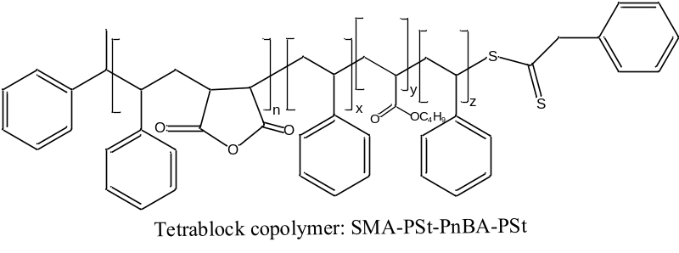

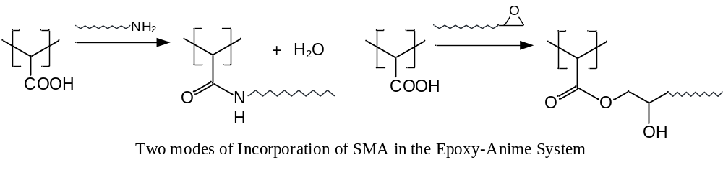

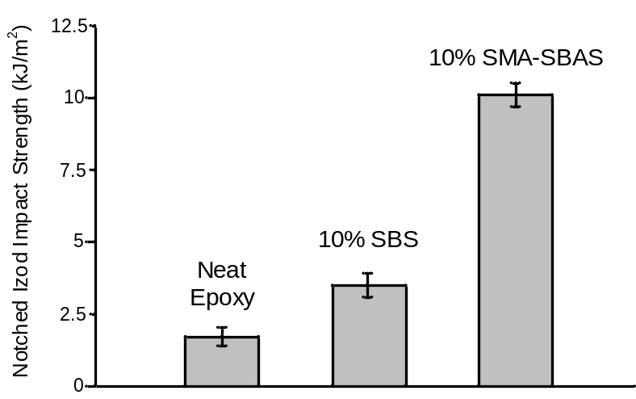

References:
1. George, S. M.; Puglia, D.; Kenny, J. M.; Causin, V.; Parameswaranpillai, J.; Thomas, S. Industrial & Engineering Chemistry Research 2013, 52, (26), 9121-9129.
2. Liu, J. D.; Thompson, Z. J.; Sue, H.; Bates, F. S.; Hillmyer, M. A.; Dettloff, M.; Jacob, G.; Verghese, N.; Pham, H. Macromolecules 2010, 43, (17), 7238-7243.
3. Ritzenthaler, S.; Court, F.; Girard-Reydet, E.; Leibler, L.; Pascault, J. P. Macromolecules 2002, 36, (1), 118-126.
4. Chong, H. M.; Taylor, A. C. JOURNAL OF MATERIALS SCIENCE 2013, 48, (19), 6762-6777.
5. Kishi, H.; Kunimitsu, Y.; Imade, J.; Oshita, S.; Morishita, Y.; Asada, M. Polymer 2011, 52, (3), 760-768.
6. Bashar, M. T.; Sundararaj, U.; Mertiny, P. Polymer Engineering & Science 2013,, n/a-n/a.
7. Grubbs, R. B.; Dean, J. M.; Broz, M. E.; Bates, F. S. Macromolecules 2000, 33, (26), 9522-9534.
8. Rebizant, V.; Abetz, V.; Tournilhac, F.; Court, F.; Leibler, L. Macromolecules 2003, 36, (26), 9889-9896.
9. Rebizant, V.; Venet, A.; Tournilhac, F.; Girard-Reydet, E.; Navarro, C.; Pascault, J.; Leibler, L. Macromolecules 2004, 37, (21), 8017-8027.
10. Luo, Y.; Wang, X.; Zhu, Y.; Li, B.; Zhu, S. Macromolecules 2010, 43, (18), 7472-7481.

