From single drop experiments to stirred tanks - Systematic analysis of coalescence in liquid/liquid dispersions

Jörn Villwock¹, Johannes Kamp¹, Felix Gebauer², Hans-Jörg Bart², Matthias Kraume¹
¹Chair of Chemical & Process Engineering, Technische Universität Berlin, Germany
²Chair of Separation Science and Technology, Technische Universität Kaiserslautern, Germany

Dispersions of two immiscible liquids are an integral part of several unit operations. The drop size distribution, which is the result of the competing phenomena of drop breakage and coalescence, influences a decisive part of the overall process efficiency. Existing models for the coalescence rate include the physical phase properties, but also hydrodynamic characteristics like energy dissipation rate and relative velocity. However, these influencing parameters are implemented in existent models with different proportionalities and in some cases even contradictorily. As in experimental validation the independent examination of each parameter is necessary, the system is reduced to the fundamental behavior of single droplet coalescence and the impact of the parameters is quantified separately. The gained detailed knowledge can be implemented into the framework of population balance equations which can be applied to describe the transient drop size distribution in technical applications. Following this approach the fundamental behavior of single droplets can be related to the macroscopic behavior of droplet swarms.

In this work the systematic analysis from single drop experiments and batch settling tests to the description of stirred tanks is presented. It focuses on the binary droplet coalescence and two quantities will be discussed in detail: coalescence probability with the addition of ions in varying concentrations and contact/coalescence time depending on the drop size and relative velocity. Additionally the results of standardized batch settling tests for the addition of different ions with varying concentrations are shown.
Using a fully automated test cell (see Fig. 1), serial examinations of binary droplet collisions under different system conditions (varying e.g. drop sizes, mass transfer direction and intensity, pH, ionic strength, disperse and continuous phase) using high speed imaging are possible. With this setup, based on the principle to observe the collision of a pendant drop at a top cannula and a second rising droplet detached from a lower cannula, a significant number of experiments can be conducted to provide a statistically solid data base. Analyzing the recorded images of the coalescence process, important quantities like coalescence probability, contact and coalescence time, relative velocity, momentum and deformation can be achieved. All experimental results were achieved using the EFCE recommended standard test system for liquid/liquid extraction toluene/water.
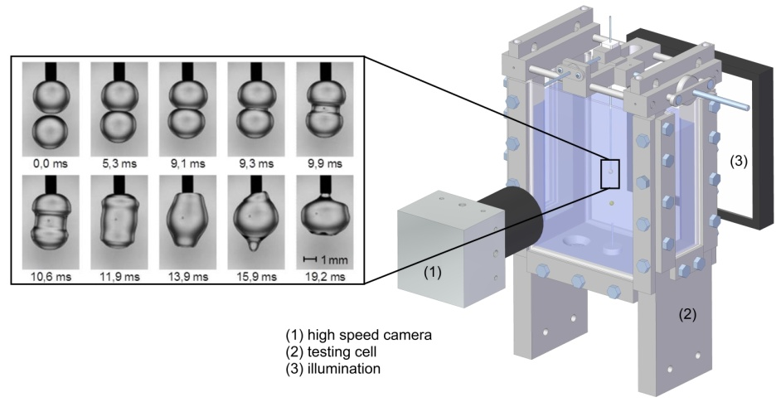
Fig. 1: Sample image sequence for coalescing droplets recorded in the schematically shown test cell
Investigations with NaCl and NaOH in a concentration range of 10⁻⁵ - 10⁻¹ mol/L indicated that the coalescence probability strongly decreases with the addition of the ions. However, for a NaCl concentration of 10⁻¹ mol/L, an increase of the coalescence probability with increasing equivalent drop diameter was observed, which could not be found for NaOH at the same concentration.
The contact time was determined in the range of 10 - 40 ms for drop sizes between 1 to 3 mm. With increasing drop size ratio as well as increasing drop rise velocity, contact times became longer. With respect to coalescence time two different types of coalescence can be distinguished: spontaneous coalescence (< 10 ms) and slower coalescence (> 10 ms) where mainly the slower type occurred in the described experiments.

Further investigations will include systematic variations of ion species according to the Hofmeister series with different concentration and the deeper analysis of fluid dynamics. All these results will be used to validate and refine existing models or to develop new models, which describe the drop size distribution in liquid/liquid dispersions.

Financially supported by DFG project KR 1639/19-1 “Coalescence efficiency in binary systems”.

