Thermodynamics of DNA Strands Encapsulated into Electrically Charged Nanotubes

Fernando J.A.L. Cruz and José P. B. Mota

Requimte/CQFB, Dept. Chemistry, Universidade Nova de Lisboa, Caparica, Portugal.

fj.cruz@fct.unl.pt

I. Introduction
Deoxyribonucleic acid (DNA) and single-walled carbon nanotubes (SWCNTs) are prototypical one-dimensional structures; the former plays a central role in chemical biology and the latter holds promise for nanotechnology applications [1-3]. From the point of view of biological purposes and DNA manipulation, carbon nanotubes have been proposed as templates for DNA encapsulation, intracellular penetration via endocytosis and delivery of biological payloads and ultrafast nucleotide sequencing. While structure in its natural form and environment is well established (e.g. B-DNA in aqueous solution), their interactions have been the subject of intense investigation, nonetheless, the corresponding molecular-level phenomena remain rather unexplored. Recently we have shown that, given a sufficiently large hydrophobic nanotube, the confinement of a double-stranded DNA segment, 5'-D(*CP*GP*CP*GP*AP*AP*TP*TP*CP*GP*CP*G)-3', is thermodynamically favourable under physiological environments (134 mM, 310 K, 1 bar), leading to DNA-nanotube hybrids with lower free energy than the unconfined biomolecule [4]. To accommodate itself within the D = 4nm nanopore, the DNA’s end-to-end length increased from 3.85 nm up to approximately 4.1 nm, due to a 0.3 nm elastic expansion of the strand termini. The canonical Watson-Crick H-bond network was essentially preserved throughout encapsulation, showing that contact between the DNA dodecamer and the hydrophobic carbon walls results in minor rearrangements of the nucleotides H-bonding. A diameter threshold of 3 nm was established below which encapsulation is inhibited.
It is well known that nanotubes can be electrically charged, either using an AFM tip and applying a voltage bias or by chemically doping the solids with p-type dopants to obtain positively charged nanotubes [5, 6]. The effect of charge density upon the energetics and dynamics of confinement needs to be carefully addressed; because DNA’s outer surface is negatively charged (phosphate moieties), its interaction with a positively charged solid might lead to the occurrence of encapsulation which is inhibited for hydrophobic pores. We address this issue using molecular dynamics and enhanced sampling algorithms (metadynamics, umbrella sampling) to probe the encapsulation mechanism of an atomistically detailed DNA dodecamer, onto positively charged (q = + 0.05 e–/C) SWCNTs of different diameters (3 nm, 4 nm), while employing precise physiological conditions.
II. Results and Discussion
In contrast with the purely hydrophobic (40,0) topology (D = 3 nm), the existence of an overall positive charge density on the solid indeed favours the encapsulation of the DNA molecule. To probe the thermodynamical stability associated with encapsulation, free-energy landscapes are built using the well-tempered metadynamics scheme [7] and two order parameters relating the distance between centres of mass of DNA and SWCNT, ξ₁, and the end-to-end length of the biomolecule, ξ₂. The corresponding free-energy maps recorded in Fig.1 show that: i) the nanopore endohedral volume (ξ₁ < 2) is the thermodynamically preferred region, by comparison with the bulk (ξ₁ > 2), ii) encapsulated DNA retains its translational mobility, diffusing freely between adjacent free-energy minima contained within the solid and iii) whilst DNA maintains a quasi B-form end-to-end length within the (51,0) topology (D = 4 nm), the double-strand seems to suffer an elastic contraction when subjected to such a constraining volume as a (40,0) nanotube. The end-to-end length probability distributions, P(Ω₂), have been determined by independent umbrella sampling calculations and the results are recorded in Fig.2 for both topologies, (40,0) and (51,0), along with the previous curve obtained for a purely hydrophobic (51,0) SWCNT [4]. It now becomes clear that charge density on the solid plays a paramount role upon the encapsulation mechanism; the elastic expansion of the double-strand observed for the (51,0) hydrophobic pore (L = 4.1 nm) is annihilated when the solid becomes electrically charged resulting in a maximum probability DNA end-to-end length of L = 3.73 nm, consistent with the canonical B-DNA form [8]. On the other hand, to accommodate itself within the constricting volume of the (40,0) topology, the DNA molecule undergoes a contraction and exhibits a maximum probability of occurrence of L = 3.54 nm.
A nanoscopic picture of the encapsulated DNA molecule can be produced by calculating the corresponding number density maps, as indicated in Fig.3 and obtained from atomically detailed mass histograms. Fig.3 reveals the existence of a cylindrical exclusion volume centred along the (51,0) main axis, where molecular density is ρ ≈ 0, which can be attributed to the strong electrostatic attraction between DNA (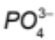 ions) and the solid, driving the former towards the walls and away from the nanopore center. Entropic effects caused by the pore narrowness of the (40,0) SWCNT force the DNA molecule to cluster tightly around the nanopore center, where it exhibits the region of highest molecular density.
As far as we are aware these observations are the first of their kind, and they come to pave the way for the design of smart nanotube based devices for in vivo DNA encapsulation.

Acknowledgements. The authors would like to acknowledge Requimte/CQFB (Universidade Nova de Lisboa, Portugal) for generous CPU time. This work makes use of results produced with the support of the Portuguese National Grid Initiative (more information in https://wiki.ncg.ingrid.pt). F.J.A.L. Cruz gratefully acknowledges financial support from FCT/MCTES (Portugal) through grants SFRH/BPD/45064/2008 and EXCL/QEQ-PRS/0308/2012.

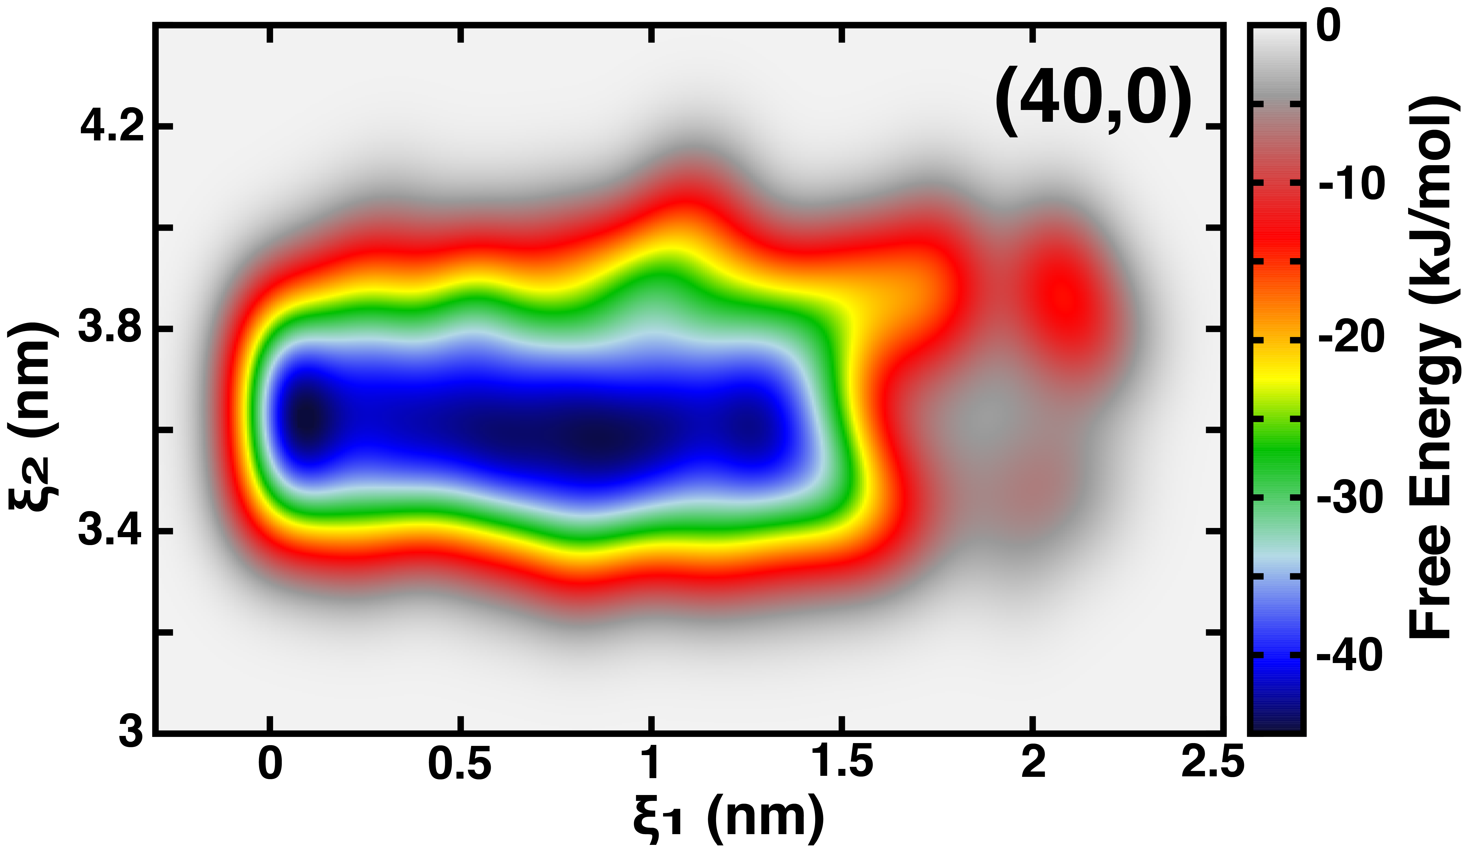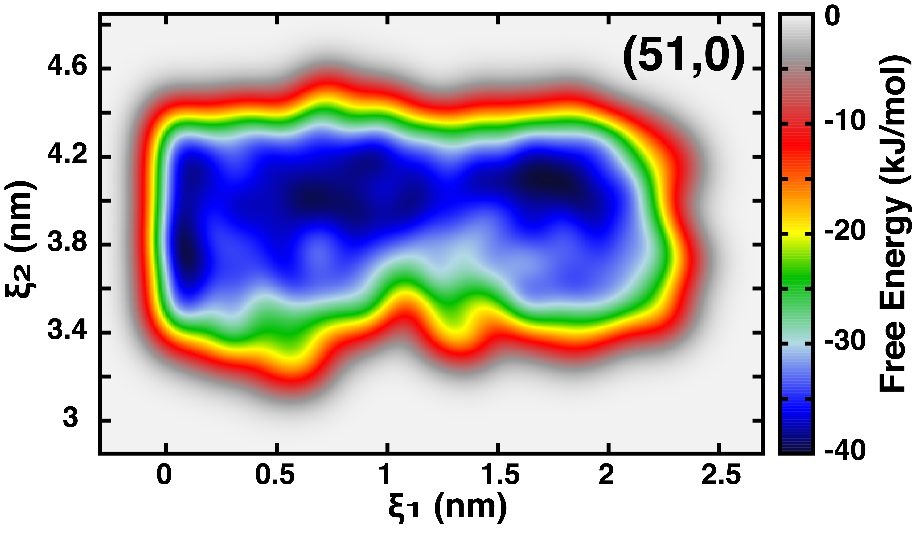
FIGURE 1 − Free energy landscapes of DNA@SWCNT hybrids. ξ₁ is the distance between centres of mass of the DNA and SWCNT, projected along the nanopore main axis, and ξ₂ is the absolute distance between (GC) termini on opposite sides of the double-strand, equivalent to the DNA end-to-end length. The several free-energy minima along ξ₁ demonstrate that the molecule is relatively mobile to translocate along the nanotube; interestingly, all the ξ₁ minima are located along a quasi-linear path defined by ξ₂ ≈ 3.7 nm (40,0) and ξ₂ ≈ 4 nm (51,0) highlighting the enhanced thermodynamical stability corresponding to the canonical B form under the (51,0) topology.
FIGURE 2 – Potential of mean force and probability distribution profiles. Ω₂ corresponds to the end-to-end length of DNA. Symbols are umbrella sampling results and red lines are free fittings of data to Gaussian statistics, 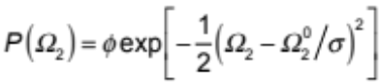: blue) DNA@(40,0) SWCNT, black) DNA@(51,0) SWCNT, green) DNA@(51,0) hydrophobic SWCNT [4].
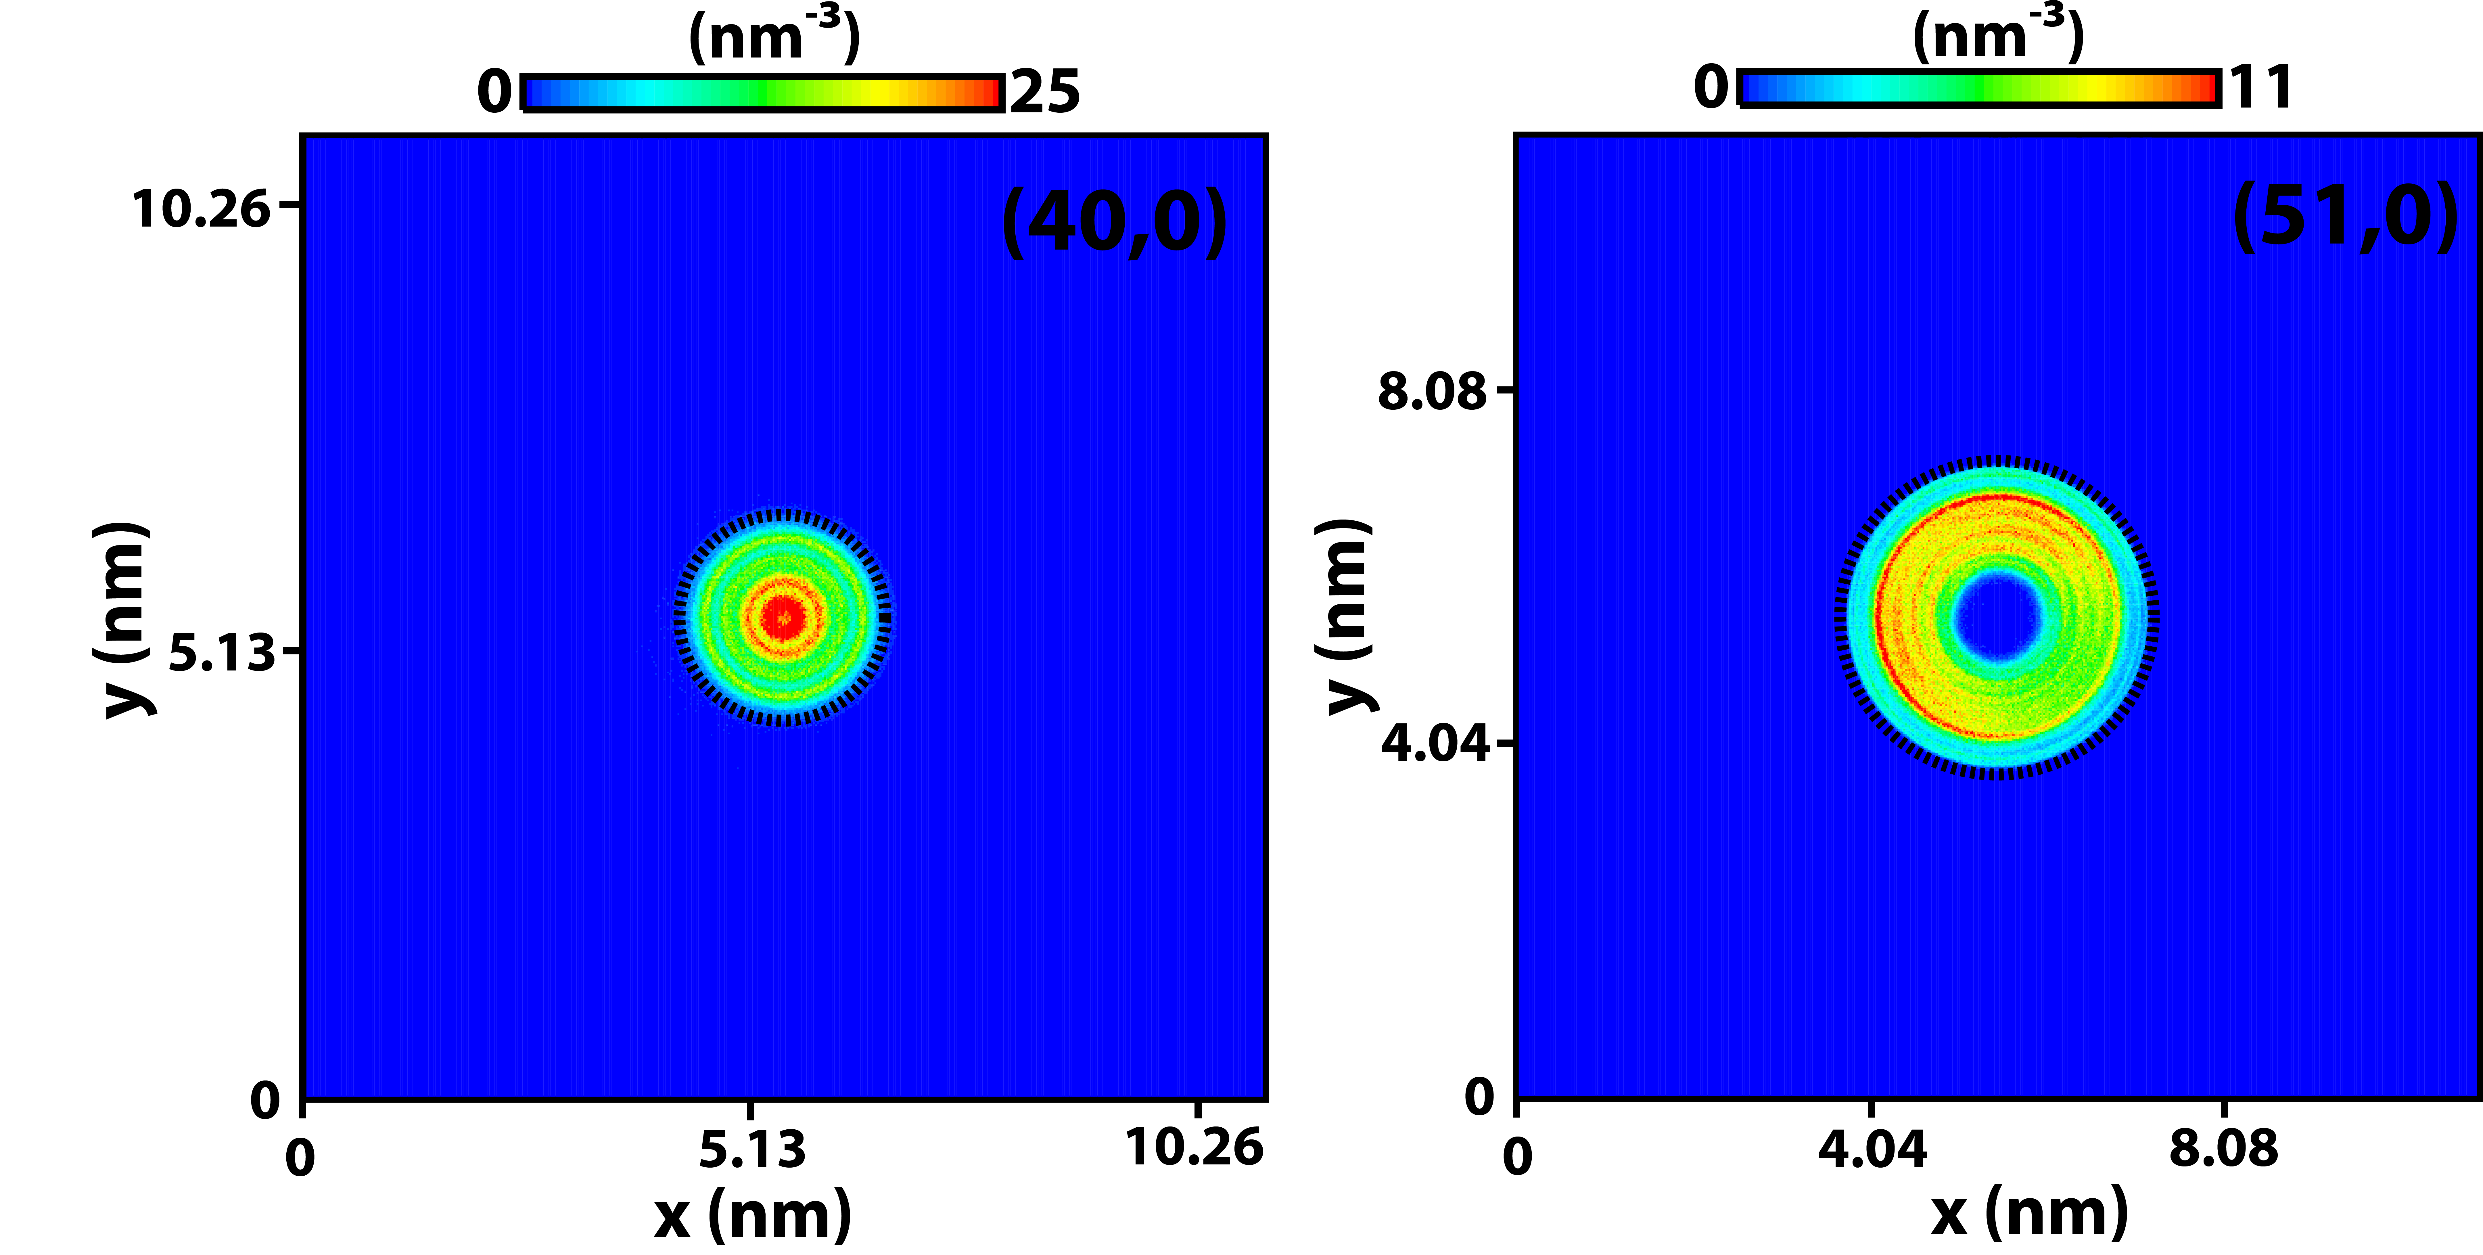
FIGURE 3 – Number density maps of DNA@SWCNT. The existence of a cylindrical exclusion volume centred along the (51,0) nanopore main axis, ρ ≈ 0, is the direct consequence of strong electrostatic attractions between the heavily charged phosphate groups and the solid. The dashed lines indicate the boundaries of the nanotube.

References
[1] H. Kumar et al., Soft Matter 7, 5898 (2011).
[2] B. M. Venkatesan, and R. Bashir, Nature Nano. 6, 615 (2011).
[3] A. D. Franklin et al., Nano Lett. 12, 758 (2012).
[4] F. J. A. L. Cruz, J. J. de Pablo, and J. P. B. Mota, J. Chem. Phys. (submitted) (2014).
[5] X. Zhao, and J. K. Johnson, J. Am. Chem. Soc. 129, 10438 (2007).
[6] W. Lv, Chem. Phys. Lett. 514, 311 (2011).
[7] A. Barducci, G. Bussi, and M. Parrinello, Phys. Rev. Let. 100, 020603 (2008).
[8] J. M. Vargason, K. Henderson, and P. S. Ho, Proc. Nat. Acad. Sci. 98, 7265 (2001).

