Impacts of CO, H₂ and C₃H₆ on the SCR reactions over
a Cu-chabazite SCR catalyst
Yang Zheng, Michael P. Harold*, Dan Luss*
Department of Chemical &Biomolecular Engineering
University of Houston
Houston, TX 77204
Abstract
Upcoming EPA Tier 3 emission regulation sets a strict tailpipe NOx standard for light duty diesel and lean burn gasoline vehicles. A promising deNOx technology that helps automakers overcome the regulatory challenge is the combined LNT+SCR system, wherein the selective catalytic reduction (SCR) catalyst stores and utilizes reductants, generally NH₃, produced over the lean NOx trap (LNT) catalyst during rich purges for additional NOx reduction. The SCR component is periodically exposed to a rich feed typically containing a mixture of CO, H₂ and hydrocarbons for LNT regeneration. This periodic exposure to reducing agents could somehow affect the SCR reactions, which are normally conducted under oxidizing conditions for stand-alone SCR system.

In order to understand the effect of rich feed on SCR catalysts, we study the impacts of CO, H₂ and C₃H₆ on the NH₃-SCR mechanisms over a commercial Cu-Chabazite (Cu-CHA; SSZ-13) SCR monolithic catalyst. The steady state reactions of NO, NO₂ with the reducing agents (CO, H₂ and C₃H₆) are first examined. Although there is almost no reaction of NO alone with these reducing species, these reductants effectively promote the decomposition of NO₂ to NO in the order of C₃H₆ > CO > H₂, presumably through their oxidation which yields NO. Hence, such reducing agents are able to affect SCR reactions by varying the NO:NO₂ ratio in favor of NO. We then examined the effects of CO, H₂ and C₃H₆ on the SCR reactions of NOx with NH₃ under both steady state and cyclic conditions. As for steady-state standard and fast SCR reactions, CO and H₂ only slightly affect the NOx conversion, while C₃H₆ inhibits both SCR reactions due to an apparent poisoning effect of surface species formed between C₃H₆ with NOx and O₂, as well as the efficient NO₂ reduction to NO by C₃H₆ at a rate of similar order of magnitude as the fast SCR reaction. When it comes to slow SCR (NH₃ + NO₂), CO and C₃H₆ enhance the NOx conversion at low temperatures (< 280 ºC) due to the increased NO:NOx ratio that favors the fast SCR reaction. While increasing temperature above 300 ºC to further raise NO:NOx ratio in favor of the standard SCR reaction, markedly decreases NOx conversion for C₃H₆ case only. A similar but more complex trend is observed under cyclic conditions. Finally, the influence of these reductants on NH₃ storage and oxidation is determined. Negligible change in NH₃ storage capacity is observed in the presence of the reducing agents. NH₃ oxidation is moderately inhibited in the presence of C₃H₆ due to the aforementioned poisoning effect.
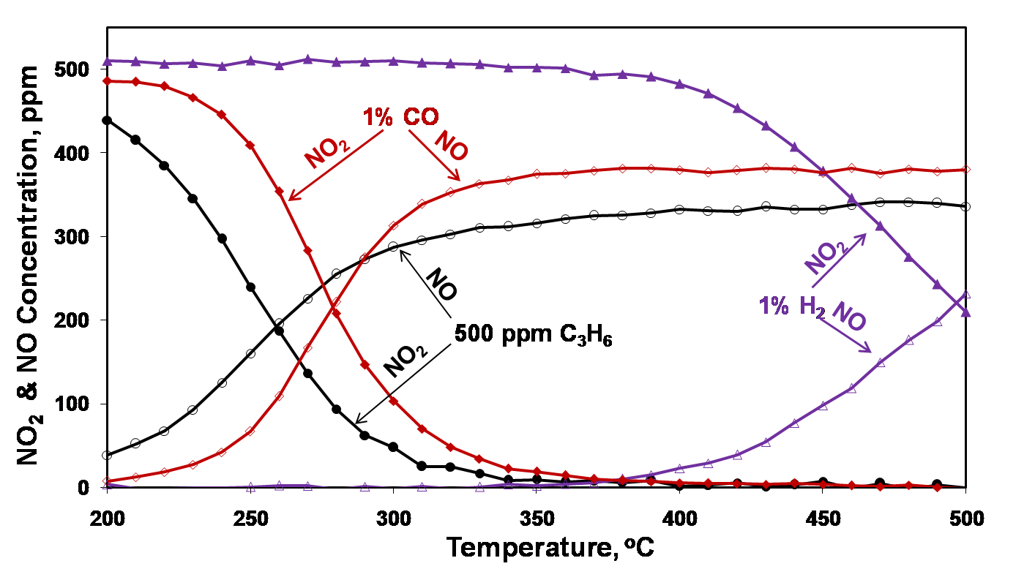

Fig.1 NO₂ reactions with CO, H₂ and C₃H₆. Feed condition is 500 ppm NO₂, 2.5% H₂O and 2% CO₂ with either 1% CO, or 1% H₂ or 500 ppm C₃H₆.
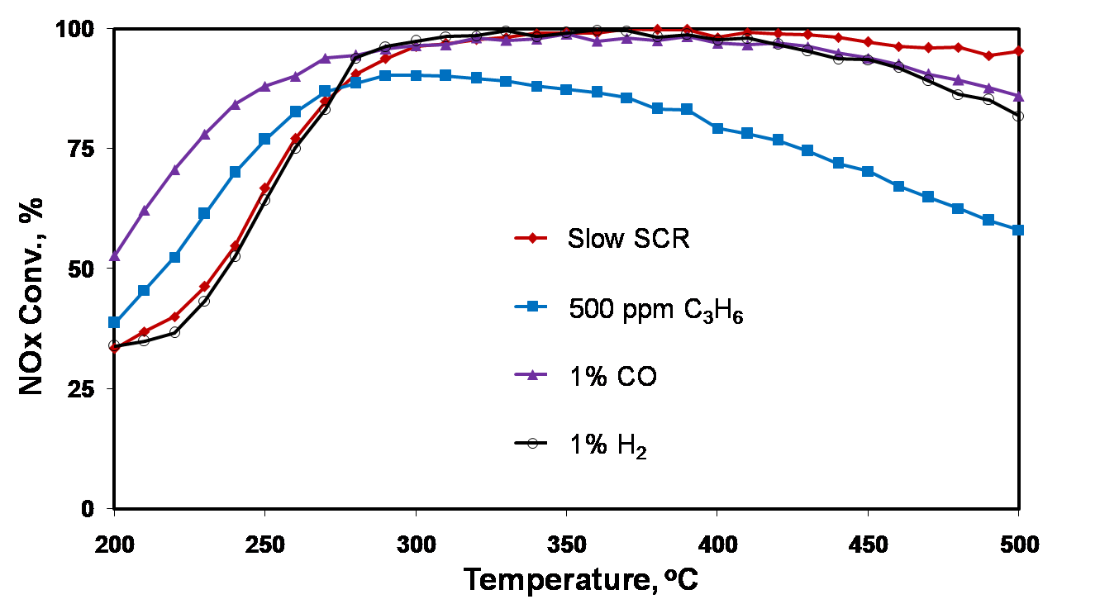

Fig.2 Steady-state slow SCR reaction in the presence of CO, H₂ and C₃H₆. Feed condition for slow SCR is 500 ppm NO₂, 500 ppm NH₃, 2.5% H₂O and 2% CO₂.

