Introduction:
Formaldehyde is one of the most important intermediate chemicals and has been produced industrially for many years. In particular, formaldehyde is converted to thermosetting resins used as binders and adhesives in wood-based panel. Formaldehyde condenses with urea, melamine, phenols, urethanes, cynamide, aromatic sulfonamides and amines to produce a number of resins. Formaldehyde is produced through a sequence of reactions – (1) steam reforming of natural gas produces synthesis gas (Eq. 1), which is converted to methanol via methanol synthesis reaction (Eq. 2) and eventually partial oxidation of methanol at 270-400°C leads to formaldehyde production (Eq. 3).
$CH_{4}+H_{2}O→CO+3H_{2}$ $∆{\hat{H}}_{r}^{o}=206.16 kJ/mol$ Eq. 1
$CO+2H_{2}→CH_{3}OH$ $∆{\hat{H}}_{r}^{o}= -90.84 kJ/mol$ Eq. 2
$CH_{3}OH+ \frac{1}{2}O_{2} →CH_{2}O+H_{2}O$ $∆{\hat{H}}_{r}^{o}= -159 kJ/mol$ Eq. 3
In this study, formaldehyde is produced directly from synthesis gas at room temperature using the following reaction –
$CO+H_{2}→CH_{2}O$ $∆{\hat{H}}_{r}^{o}= -5.3 kJ/mol$ Eq. 4
Initial evidence of formaldehyde production was observed in Temperature Programmed Surface Reaction (TPSR) test using Pd-Ni/Al₂O₃ catalyst at room temperature and atmospheric pressure. Formaldehyde production was confirmed in a pressurised fixed bed reactor operating at room temperature and 20 – 120 bar pressure. Higher concentration of formaldehyde was achieved in aqueous phase reaction in a batch reactor operating at room temperature and 100 bar pressure.
Method:
The catalysts used in this process were produced using wet impregnation method. Appropriate amount of Ni(NO₃)₂.6H₂O and Pd(NO₃)₂ 10 wt% in 10wt% nitric acid solution precursors were added to commercial γ-Al₂O₃ suspended in 20 ml water. The mixture was stirred for 5 h at 50°C, followed by drying at 90°C overnight. The dried catalyst was calcined at 500°C for 6 h. The catalyst was reduced (in-situ for TPSR and fixed bed reactor test and ex-situ for batch reactor test) by flowing 50ml/min H₂ through the catalyst bed for 5 h at 400°C followed by purging with Ar for 1 h at 400°C and finally cooled to room temperature under Ar flow. In fixed bed reactor tests, H₂ and CO were fed to the reactor in 1:1 mole ratio. 60 ml/min of gas mixture was passed through 1 g catalyst bed for 4 h at room temperature and 20 -120 bar pressure. The gas stream leaving the reactor was passed through a series of two scrubbers filled with 40 ml of 5 v/v% methanol to recover formaldehyde. At the end of the run, formaldehyde concentration was measured using the photometric cell test kit (Merck Millipore) in a spectrophotometer. In the batch reactor tests, 1 g reduced catalyst was added to 40 ml of 5 v/v% methanol in a batch reactor and pressurized to 100 bar with 1:1 mole ratio H₂ and CO and stirred at 200 rpm for 2 – 24 h. At the end of the run, solution was filtered and formaldehyde concentration was measured by using the above method.
Results:
Based on a study done in HSC ChemistryTM software, it was concluded that high temperatures are not favourable for reaction Eq. 4 because the Gibbs free energy of formation increases with temperature. This theoretical result was proven by running two experiments in a fixed bed reactor at room temperature (20°C) and at 40°C at 85bar. The formaldehyde concentrations measured in these tests were 0.17 ppm and 0.08 ppm, respectively. Unlike temperature, Eq. 4 is directly proportional to pressure. Increasing the pressure from 40 bar to 117 bar resulted in increase of formaldehyde concentration from 0.09 ppm to 0.25 ppm. Figure 1 shows that the concentration increases linearly with respect to temperature. All the concentrations reported here are from the first scrubber in the fixed bed reactor setup.
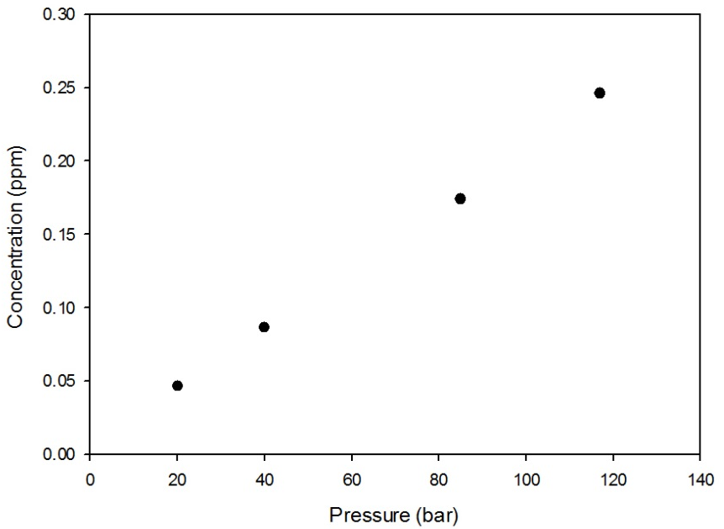
Figure 1: Formaldehyde concentration with respect to changes in pressure in the fixed reactor operating at room temperature
Since the Eq. 4 is thermodynamically limited, an aqueous phase process was tested in the batch reactor. This would shift the equilibrium of the reaction by removing formaldehyde from the catalyst surface and absorbing it in methanol/water mixture. At room temperature (25-26°C) and 100bar, up to 10.9 ppm formaldehyde was achieved using a batch reactor after 24 hours of operation. Figure 2 shows that the formaldehyde concentration increased with time. Interestingly, the formaldehyde concentration achieved at 4 h in the batch reactor is more than the gas phase reaction carried out in the fixed bed reactor.
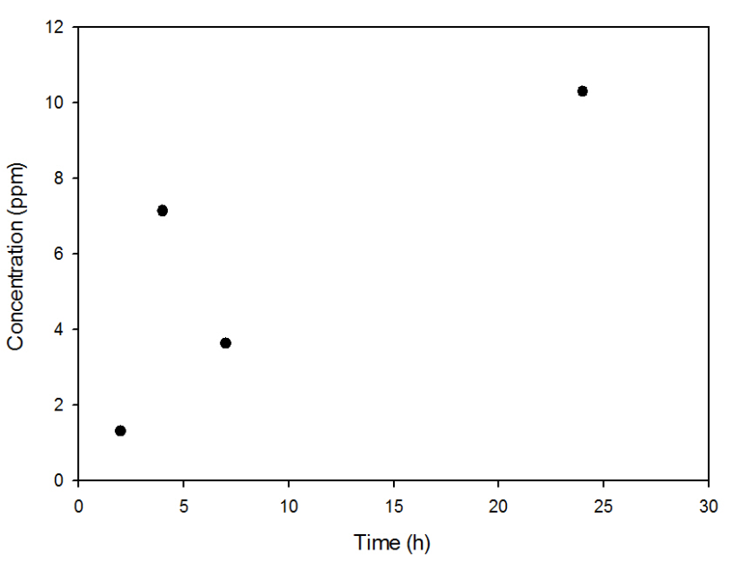
Figure 2: Formaldehyde concentration with respect to changes in time in the batch reactor operating at room temperature and 100 bar

