Design and Optimization of a Pure Refrigerant System with Subcooling in Liquefied Natural Gas Plant

Inkyu Leeª, Kyungjae Takª, Sunkyu Leeª, Daeho Ko^{b}, Il Moon^{a,*}
ªDepartment of Chemical and Biomolecular Engineering, Yonsei University, 50 Yonsei-ro, Seodaemun-gu, Seoul 120-749, Korea
^{b}GS E&C, Gran Seoul 33 Jong-ro, Jongno-gu, Seoul 110-130, Korea

Natural gas liquefaction process is energy intensive because of its cryogenic characteristics.¹ Therefore, minimizing energy consumption is a major concern in design and optimization point of view. ² This research focused on minimizing the energy consumption of the pure refrigerant system by improving the subcooling system. To minimize energy consumption of the pure refrigerant system, several steps were performed as follows. First, the pure refrigerant system in the propane precooled mixed refrigerant (C3MR) process was simulated and analyzed thermodynamically with and emphasis on subcooling. With the coolant temperature limitation, it was found that high pressure is needed for subcooling. The base case design is shown in Figure 1. Second, new design of subcooling system was proposed for the pure refrigerant system. The proposed design introduces a cooling system using lower pressure pure refrigerant after the cooler. Thus, the temperature is lowered for subcooling instead of the pressure increase which affects to the compression energy increase directly. The energy reduction of the pure refrigerant system is about 16.48% compared with the base case. Figure 2 shows the proposed design. Third, mathematical optimization of the proposed design was performed. The objective function is minimizing total energy consumption of compressors because most of energy in the natural gas liquefaction process is consumed by compression. As the optimization result, an additional 1.26% of energy was reduced and total 17.74% of energy was saved compare to the base case. The results shows the proposed design significantly reduced energy consumption by decreasing the highest pressure of the pure refrigerant.

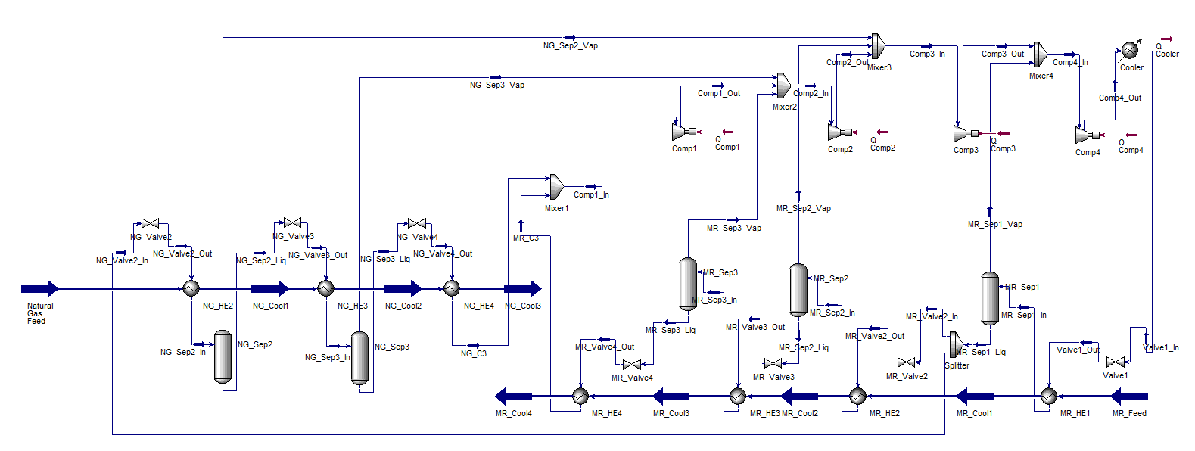
Figure 1. Base case design of a pure refrigerant system

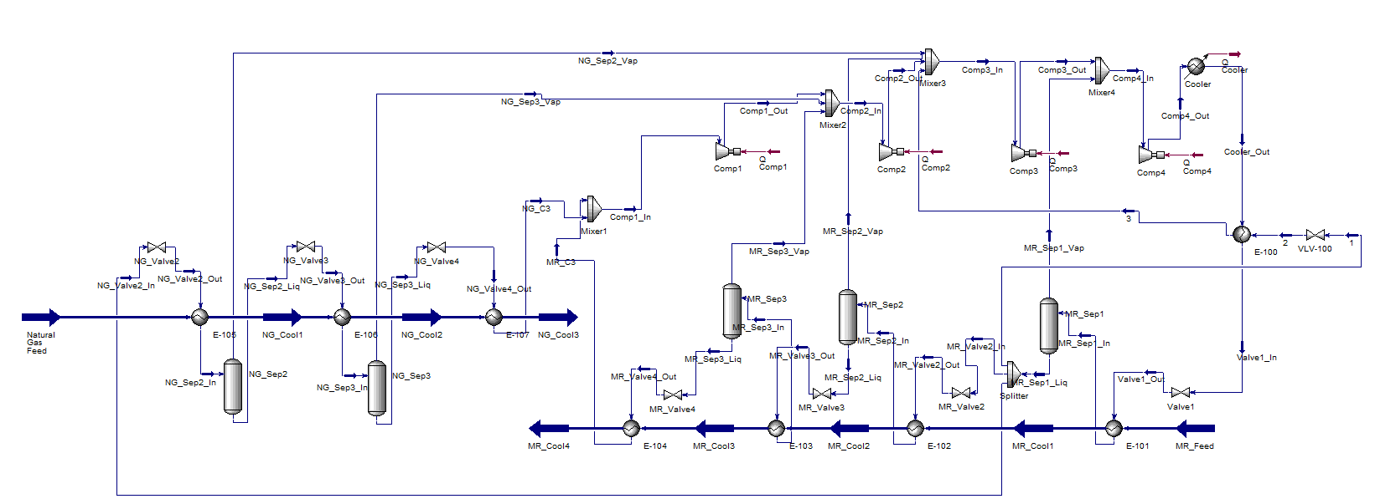
Figure 2. Proposed design of a pure refrigerant system

REFERENCES
[1] Hatcher, P.; Khalilpour, R.; Abbas, A. Optimisation of LNG mixed-refrigerant processes considering operation. Comput. Chem. Eng. 2013, 41, 123-133.
[2] Lim, W.; Choi, K.; Moon, I. Current Status and Perspectives of Liquefied Natural Gas (LNG) Plant Design. Ind. Eng. Chem. Res. 2013, 52, 3065-3088.

