A new system for predicting and rapidly responding chemical and nuclear disasters

Kwanghee Leeª and Il Moon^{a*}
ªDepartment of Chemical and Biomolecular Engineering, Yonsei University, 50 Yonsei-ro, Seodaemun-gu, Seoul 120-749, Korea

Chemical and nuclear disasters involve industrial accidents and chemical and nuclear power plants, incidents from the use of weapons at terror or wars, and accidents at transportation of hazardous materials. Those disasters incur release of severely hazardous materials into atmosphere, and are featured to be very difficult and expensive to forecast as well as highly lethal once an incident occurs. In recent years, many chemical and radiological accidents have taken place in South Korea, for example, the accident of hydrogen fluoride (HF) release at Gu-mi in 2012 killed 5 people and evacuated all Gu-mi residents impossible to sustain their daily business and life. After this disaster, South Korea has made enormous efforts to develop a set of systems for responsively and effectively managing chemical and nuclear disasters. A new software system has been developed by integrating two existing programs designed to predict and maneuver chemical and nuclear disasters in order to set up a response system for dealing with the combined two disasters, as shown in Figure 1, for the first time in Korea. The improved software system is designed to be mainly used by civil defense officers, together with an identification of 625 scenarios of chemical and nuclear disasters. The new system is expected to contribute to upgrade a more systematic regional public protection plan for chemical and nuclear disasters. In addition, it enables all relevant local divisions to share disaster information in real time, resulting in a minimization of possible fatal damages. This new system can potentially be expected to be of great help for the development of a program for managing chemical and nuclear disasters in South Korea. This study was funded by National Emergency Management Agency for two years, and two companies and five Universities are contributed to this project.

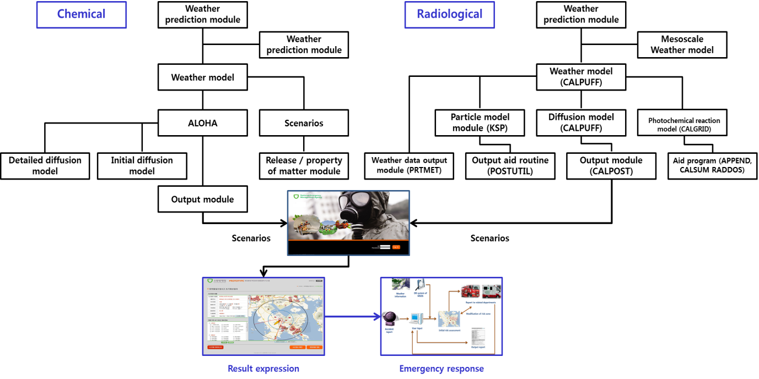
Figure 1 Scheme of integrated program

REFERENCES
[1] Michael M, Bradley. NARAC: an emergency response resource for predicting the atmospheric dispersion and assessing the consequences of airborne radionuclides. Journal of Environmental Radioactivity 2007;96:116-21.
[2] Park JD, Lee YH, Yoon Y, Kim JK, Cho JH, Moon I. Development of COI classification algorithm for chemical terrorism. The Korean Journal of Chemical Engineering 2013:30:559-62.
[3] Han MH, Kim EH, Suh WT, Hwang WT, Jeong HJ. Development of radiological dose assessment systems to support a radiological emergency preparedness in Korea. Annals of Nuclear Energy 2012;43:187-91.

