Bandgap tunable cross-linked PEDOT copolymers with superior optical property via oxidative chemical vapor deposition (oCVD)

Sunghwan Lee and Karen K. Gleason

High optical transmittance conjugated polymers with electrical conductivity are garnering much attention for the applications in organic optoelectronic devices including organic field effect transistors and organic photovoltaic solar cells. Polymers based on poly(3,4-ethylenedioxythiophene) (PEDOT) are particularly promising candidates with high conductivity, uniform surface planarity and excellent ductility. In this work, homopolymer PEDOT films deposited using oxidative chemical vapor deposition (oCVD) show the maximum conductivity as high as ~3500 S cm⁻¹ at a deposition rate <0.5 nm min⁻¹. However, their utility is limited due to the relatively low transmittance and abrupt decrease near the red edge in the visible regime.
Here, we report on the significantly improved optical properties achieved via tuning the band gap of cross-linked PEDOT copolymers using oCVD, offering a single-step process for the synthesis and deposition of copolymer films. The cross-linking monomers of biphenyl or anthracene are simultaneously evaporated with EDOT monomer and an oxidant of FeCl₃ during the deposition. Poly(anthracene-co-EDOT) [p(ANTH-co-EDOT)] shows the superior transmittance of ~ 93% to homopolymer PEDOT (~80%) and poly(biphenyl-co-EDOT [p(BPH- co-EDOT)] (~88%) at the wavelength of 550 nm. In addition, copolymer films show no significant transmission decay in the red edge regime of the light unlike homopolymer PEDOT that presents an abrupt transmission falloff. An improvement in optical transmittance is in agreement with an increase in band gap of materials (p(ANTH- co-EDOT), ~2.3 eV vs. PEDOT, ~1.8 eV). oCVD-processed band gap tunable PEDOT copolymers with enhanced transmittance may, therefore, have application in organic optoelectronic devices that require the high optical transparency.
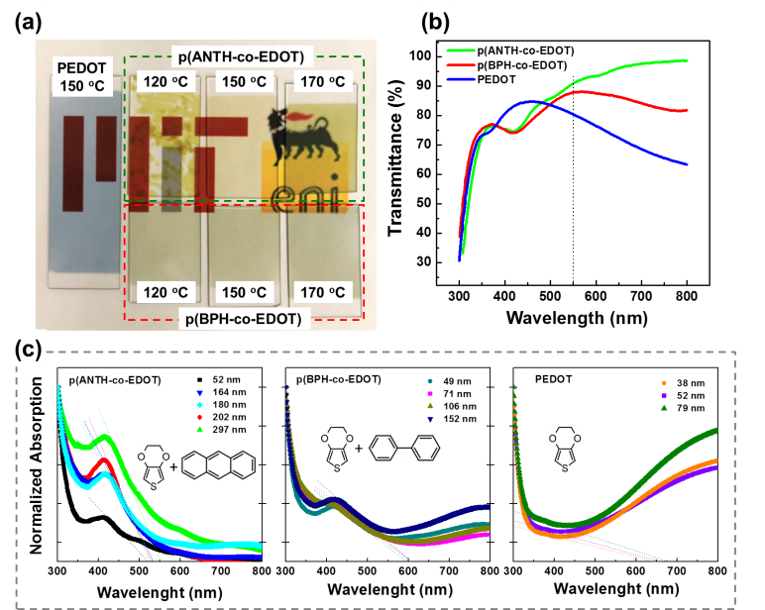

Figure 1. Optical properties of homopolymer and copolymer PEDOT films (a) photographs of p(ANTH-co-EDOT) and p(BPH-co-EDOT) copolymers with typical homopolymer PEDOT deposited on 25x75 mm glass slides, (b) optical transmission spectra from ~55 nm-thick samples investigated in the visible regime from 300 to 800 nm. The dotted line indicates the standard light wavelength of 550 nm, and (c) normalized absorption spectra of oCVD polymers as a function of film thickness. Each inset shows the monomer(s) used.

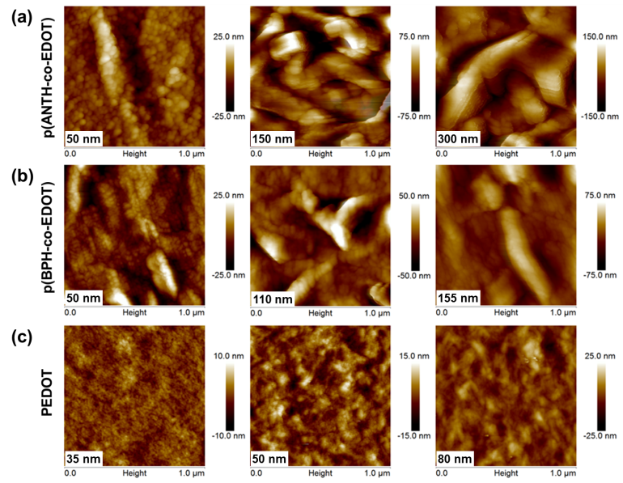

Figure 2. AFM surface topographic images obtained via non-contact height mode from oCVD films of (a) p(ANTH-co-EDOT), (b) p(BPH-co-EDOT) copolymers and (c) homopolymer PEDOT in different thickness.

