Insulator-based micropipette dielectrophoretic trapping of particles

Stuart J. Williams, Daniel G. Allgeier
Department of Mechanical Engineering, University of Louisville, Louisville, KY 40292

We report on the progress of our research in pipette-based electrokinetic manipulation of particles. Through numerical simulations and preliminary experimentation, we explore the use of pulled glass pipettes to induce dielectrophoresis (DEP) and electrohydrodynamic flow. Typically, non-uniform electric fields for DEP are formed using micrometer metal electrodes fabricated with clean room processes. We will demonstrate that sufficient electric field gradients can be generated by applying an electric field through the tip of a tapered glass pipette (ID < 5 μm) which was fabricated without the use of a clean room or photolithography. Field gradients were generated similarly to insulator-based DEP and reservoir-based DEP by constricting the field with insulative features. Experimental trapping of 2 μm and 8 μm polystyrene particles is demonstrated at frequencies up to 130 kHz and voltages less than 35 V. Further, numerical simulations will demonstrate the magnitude of the theoretical DEP force, Joule heating, and electrothermal flow under these conditions.

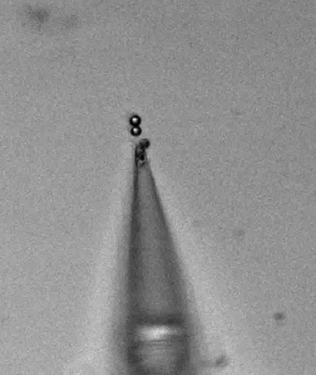
Figure 1. 8 μm polystyrene particles trapped near the tip of a pulled glass capillary at 120 kHz and 20 V.

