A mathematical model for the electrochemical conversion of gaseous CO₂ to liquid formic acid

Georgopoulou C.¹, Jain S.², Agarwal A. ², Rode E. ², Dimopoulos G.¹,
Sridhar N.², Kakalis N.M.¹
DNV GL Strategic Research and Innovation, Piraeus, Greece¹
DNV GL Strategic Research and Innovation, Dublin, Ohio, USA²

In recent years, CO₂ capture and utilization has gained attention in the industry, due to the increased concern in the environmental impact from anthropogenic greenhouse gas emissions. One possible pathway for CO₂ utilization is the conversion of CO₂ into chemical feedstock. There is a wide range of conversion processes that can use CO₂ as a source material for producing valuable products, like polymers and inorganic minerals; however, their technical feasibility depends on process economics and scale-up capabilities.
In 2011, a novel concept was introduced by DNV for the Electrochemical Reduction of CO₂ to Formate/Formic Acid (ECFORM) [1-5]. A schematic diagram of the ECFORM process is shown in Figure 1. The gaseous CO₂ is inserted into an electrochemical cell through the porous cathode electrode, where it is absorbed in the liquid electrolyte solution and chemically converted to formic acid, at the presence of electric voltage difference between the electrodes. The cell chambers are separated from each other via an ion-exchange membrane, which allows for electrical continuity but prevents the mixing of the catholyte and anolyte streams. The process has been demonstrated on experimental scale by DNV GL Strategic Research and Innovation in Ohio, US.
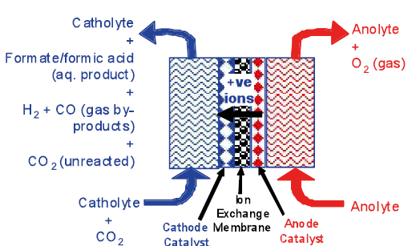
Figure 1. Schematic representation of the ECFORM process.
A cost-effective way to estimate the technology capabilities at different system sizes is via the use of process modelling and simulation techniques. Computer-aided methodologies can successfully address the complexity of processes governed by interdisciplinary phenomena and provide insight on the interactions of the key process parameters, how they are interconnected, and what is their influence on the overall system performance. This approach offers the advantage to design experiments and reduce the laboratory costs, as well as to conduct studies on steady-state and transient operation modes at different system sizes, using the same modelling resources.
In this paper, we present a novel phenomenological mathematical model for the ECFORM process. The model consists of a system of Partial Differential and Algebraic Equations (PDAEs) that describe the gas and liquid mass transport, reaction kinetics and electrochemistry. The model captures the steady-state and dynamic behavior of the gas and liquid flows in the cell. In addition, the PDAEs are discretized in the horizontal and vertical directions of each component, providing 2-dimensional profiles of the physical and electrochemical properties within the cell geometrical boundaries. Electrochemical and liquid bulk chemical reactions are also considered by applying rates for the forward and backward reactions [6]. The cell potential is modelled by considering that the total electric current, caused by the voltage differential and ion migration, remains unchanged.
A generic model structure is employed (Figure 2), by decomposing the ECFORM process into individual components that correspond to the physical modules of the system, including the gas and liquid flows, the anolyte, the catholyte, the membrane and the electrodes. The set of PDAEs is solved simultaneously using advanced numerical solvers [7].
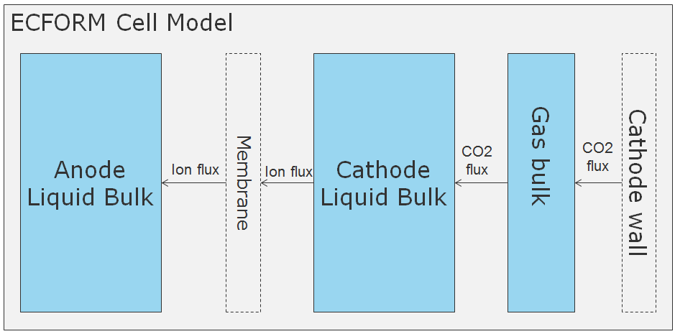
Figure 2. Schematic diagram of the ECFORM process model structure.
Model calibration with respect to experimental results is illustrated and the key parameters that affect system performance are discussed. Challenges with regards to calibrating and fitting the model to the experimental data are analyzed. The model captures the behavior of the ECFORM process and provides insights on system scale-up capabilities. Figure 3 presents model results for the p_{H} profile in the cell, at normal operating conditions. Figure 4 presents the calculated potential profiles in the anolyte, showing that the highest potential reduction is close to the electrodes. Figure 5, finally presents the concentrations of the key process products, namely formic acid (HCOOH) and potassium formate (HCOOK).
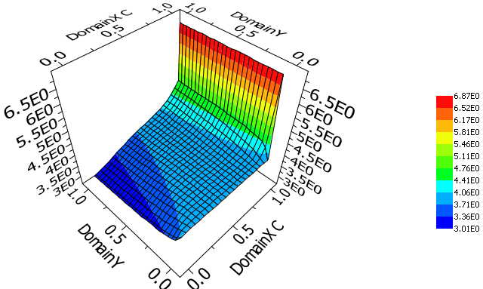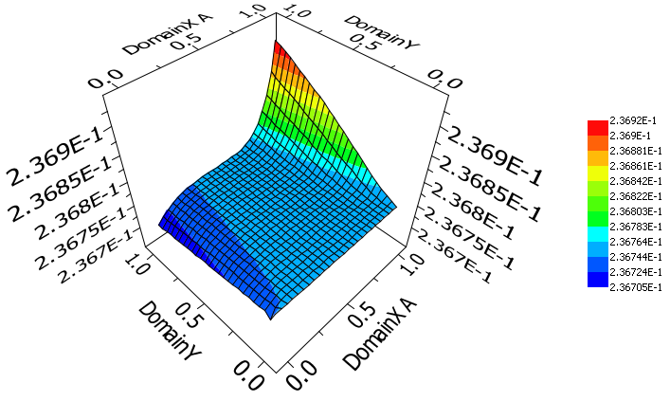
Figure 3. Model results for the p_{H} profiles in the catholyte (left) and anolyte (right).
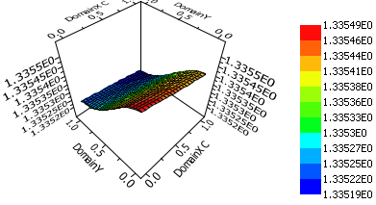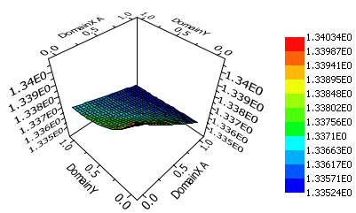
Figure 4. Model results for the potential (in V) profiles in the catholyte (left) and anolyte (right).
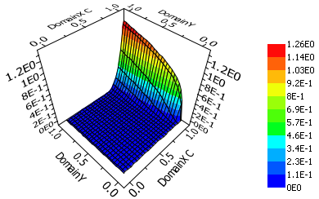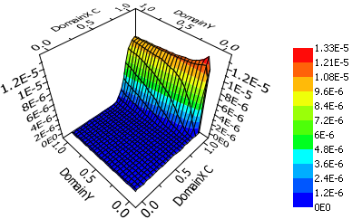
Figure 5. Model results for the HCOOH and HCOOK concentration (in mol/m³) profiles in the catholyte.
References

[1] Sridhar N., Zhai Y., Agarwal A., Chiachiarelli L., Hill D. Longterm demonstration of the electrochemical reduction of CO₂ to formic acid. The CO₂ Challenge Forum, September 27-28, 2010, CPE Lyon, Lyon, France.
[2] Zhai Y., Agarwal A., Chiacchiarelli L., Hill D., Sridhar N. Evaluation of tin electrocatalyst for conversion of CO₂ to formate salt via long term cathodic half-cell and continuous full cell testing. Future Directions in CO₂ Conversion Chemistry Workshop, October 21, 2010. Department of Chemistry at Princeton University, Princeton.
[3] Hill D., Zhai Y., Agarwal A., Rode E., Ayello F., Sridhar N. Energy storage via electrochemical conversion of CO₂ into specialty chemicals. Proceedings of the ASME 2011 5th International Conference on Energy Sustainability ES2011 August 7-10, 2011, Washington, DC, USA. Paper Nº ES2011-540.
[4] Sridhar N., Hill D. Carbon dioxide utilization; Electrochemical conversion of CO₂ – Opportunities and challenges. DNV Research and Innovation, Position Paper 07, 2011.
[5] Agarwal A., Zhai Y., Hill D., Sridhar N. The Electrochemical Reduction of Carbon Dioxide to Formate/Formic Acid: Engineering and Economic Feasibility. ChemSusChem (2011), 4, 1301 – 1310.
[6] Gupta N., Gattrell M., Macdougall B. Calculation for the cathode surface concentrations in the electrochemical reduction of CO₂ in KHCO₃ solutions. Journal of Applied Electrochemistry (2006) 36:161–172.
[7] Process systems enterprise. gPROMS, http://www.psenterprise.com/gproms/ ,
2014-05-01.

