Abstract
Coffee is one of the most important agroindustrial products in Colombia. Coffee processing generates significant amounts of residues from which valuable compounds can be extracted. These residues represent about 80% of the total weight of grounds (Puerta et al., 2013). A particular byproduct of coffee processing is spent grounds, a byproduct of the coffee brewing operation that represents 10% of the total weight of the fresh grain (Cenicafe, 2010). This byproduct contains valuable polyphenolic compounds, such as chlorogenic acids and other bioactive substances, for which applications in the food, cosmetic, pharmaceutical and chemical industries exist. Additionally, spent coffee grounds contain 35-44% fiber (holocellulose and lignin), 7-8% of water and about 12% of protein (Ramos 2010) that can be used in developing different value added byproducts.

Although containing highly valuable constituents, one of the most common uses of spent coffee grounds is as fuel in steam generation (at high, medium or low pressure). The latter reflects its heat capacity, which ranges from 24.91 to 29.01 MJ/Kg of dry spent coffee grounds. Spent coffee ground contains about 10% of coffee oil and considering the relatively low quantity of this component that is carried over to the beverage, it is possible to recover almost all of the coffee oil content of the ground coffee by processing the spent coffee ground, utilizing different advanced extraction methodologies. Among the latter are: i) mechanic extraction, ii) solvent extraction and iii) supercritical extraction. The first consists of applying pressure to extract and recover coffee oil. In the second technique a solvent (ethanol) is used to extract coffee oil at 70ºC, using a solvent-to-spent coffee grounds ratio of 7/1. The third approach is carried out using carbon dioxide at supercritical conditions (250 bar and 55 ºC) for 3 hours. The yield of coffee oil extraction from spent coffee ground was assessed for each of these technologies, both separately and in processes combining all the three approaches. In order to carry out the extraction in the “combined technologies mode” the sequencing concept was applied; this allowed configuring the process sequence that resulted in the highest extraction yield. Figure 1 shows the three techniques that were used at pilot plant level.

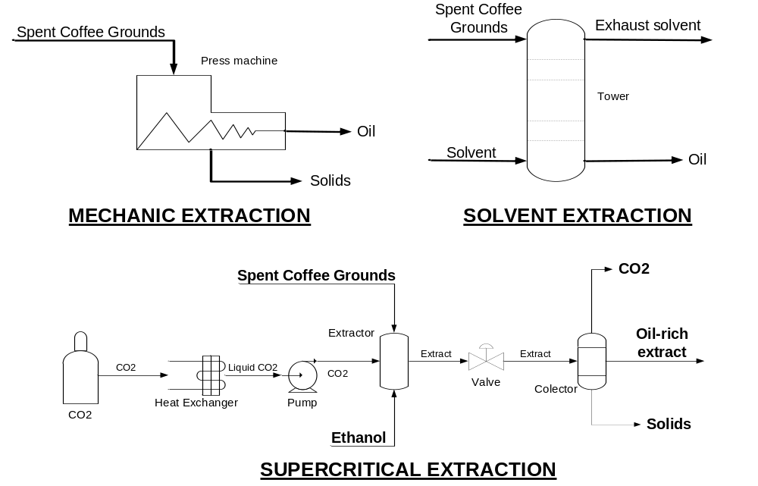
Figure 1. Schemes of oil extraction from spent coffee grounds

These three techniques were compared and analyzed according to the arrangements and the yields obtained. Supercritical extraction was found to be the best technique for extracting coffee oil from spent coffee grounds due to the high solubility of oil in supercritical carbon dioxide, which works as good solvent in supercritical conditions. However, the techno-economic analysis indicated different restrictions for using this method in the sequence. As a result, combined advanced techniques become promising alternatives for obtaining the oil from spent coffee grounds.
References
Cenicafé. Avances técnicos. Los subproductos de café: fuente de energía removable. No. 393 2010. Available in http://biblioteca.cenicafe.org/bitstream/10778/351/1/avt0393.pdf (Accessed May 2014).
Puertas Mejia Miguel A., Villegas Guzman Paola, Rojano Bemjamin Alberto. Colombian spent coffee grounds (Coffea arabica) as a potential source of substances with free radicals capacity in vitro. Revista Cubana de Plantas medicinales. Vol 18 No. 3 2013.
Ramos Rincon Jaidith Marisol. Estudio del proceso de biosorción de colorantes sobre la borra de café. Tesis de maestria. Universidad Nacional de Colombia, sede Bogotá. (2010).
Melo M. R., Barbosa H. M., Passos C., Silva C. Supercritical fluid extraction of spent coffee grounds: Measurement of extraction curves, oil characterization and economic analysis. Journal of supercritical fluids. 86 (2014) 150 – 159.

