Life Cycle Carbon Footprint of Linear Alkylbenzene Sulfonate from Coconut Oil, Palm Kernel Oil, and Petroleum Based Paraffins

Daniel P. Fogliatti‡, Scott A. Kemppainen‡, Tom N. Kalnes†, Jiqing Fan, David R. Shonnard*
Department of Chemical Engineering, Michigan Technological University
†UOP a Honeywell Company, Des Plaines, IL USA
*Department of Chemical Engineering, Sustainable Futures Institute, Michigan Technological University, corresponding author

Key words: Linear Alkybenzene (LAB), Linear Alkylbenzene Sulfonate (LAS), renewable surfactants, coconut oil, palm kernel oil, land use change
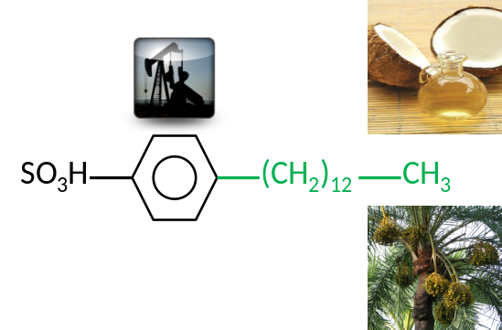
TOC/ABSTRACT ART 1. LAS produced
with renewable feedstocks replacing petroleum
to reduce greenhouse gas emissions
ABSTRACT
Beyond renewable liquid transportation fuels from biomass feedstocks, there is great interest to use renewable feedstocks for sustainable chemical production. The goal of this study is to conduct an original cradle-to-grave carbon footprint for linear alkylbenzene sulfonate (LAS) using petroleum, coconut oil, and palm kernel oil derived paraffins, and including end of life emissions during wastewater treatment. The fully petroleum pathway to LAS was modeled using new inputs from industry (UOP). Mass allocation and energy allocation methodologies were both examined. We found that the greenhouse gas emissions from the production of LAS can be reduced between 45-50% by replacing petroleum based paraffins with coconut or palm kernel oil derived paraffins. End of life emissions of CO₂ during biodegradation in wastewater treatment was a major contributor to and differentiator of emissions in the carbon footprint. Direct land use change (dLUC) emissions of CO₂ were modeled using the IPCC method and were found to make a minor contribution to life cycle emissions when either grasslands or shrublands are converted to either coconut or palm plantations.

