Model for the synthesis of and macrophage responses to nanoscale hydroxyapatite
Garima Bhardwaj¹, Arthur A.Gonzales III¹ Thomas J. Webster¹
1Department of Chemical Engineering, Northeastern University, Boston, MA-02115
Introduction: To monitor the immunological response of implants, the host response to materials must be determined prior to implantation. This response is highly dominated by macrophages which are the primary cells governing the immune response. Macrophages not only fuse to become multinucleated foreign body giant cells, but they also activate T lymphocytes by expressing co-stimulatory molecules (e.g., CD86 and CD80) and surface antigens (e.g., MHC II). T lymphocyte activation and giant cell formation have been observed on macrophages adherent to biomaterials and in retrieved adjacent tissues to failed implants. They are major effectors in the defense against bacterial infection and respond to interactions with gram-negative and gram-positive bacteria with a marked enhancement of their functional activities. Thus, the assessment and control of macrophage responses to various surface nano-modifications on titanium implants is of vital importance. This current study aims to modify the surfaces of titanium by coating it with nanoscale hydroxyapatite, in a range of sizes, using electrophoretic deposition with both AC and DC current. Macrophages were then seeded onto this surface and their behavior observed concerning how to further improve the modification process.
Materials and Methods: Nanoscale hydroxyapatite was synthesized using a wet chemical synthesis process in an array of different sizes in the nanometer scale. By varying the parameters like pH, reaction time and temperature in the synthesis process and analyzing experimental data, a MATLAB model predicting particle size for optimized synthesis was established using the BBD theory of statistics.TEM was used for particle size charecterization. It was then coated onto a titanium mesh purchased from Alpha Aesar (Catalog no.7440-32-6) by electrophoretic deposition with AC and DC current. The mesh was used both as the working and counter electrode. SEM was used for characterizing the coating. Macrophages were purchased from ATCC (RAW 264.7 (ATCC® TIB-71™)) and were cultured using EMEM (ATCC® 30-2003™), 10% FBS (ATCC® SCRR-30-2020™) and a 1% penicillin-streptomycin solution (ATCC® 30-2300™). Cell adhesion and proliferation was observed using an MTT assay for 1, 3, 5 and 7 days. Levels of TNF-α, IL-1, IL-6 and nitrite released by the macrophages were studied. Bacterial assays were conducted using Staphylococcus aureus (ATCC® 29740™) and Pseudomonas aeruginosa (ATCC® 39324™) strains of bacteria. Experiments were conducted in triplicate and repeated at least three separate times each.
Results and Discussion: The particle size was predicted using the following equation:
R= a*A + b*B + c*C + d*A^2 + e*B^2 + f*C^2 + g*A*B + h*A*C + i*B*C + j
Where R= response (hydroxyapatite particle size) and A =pH, B=temperature, and C =reaction time.
The change in the surface topography of the material affected the adhesion and proliferation of the macrophages leading to reduced activation of macrophages with increased nanometer roughness. The level of TNF-α, IL-1, IL-6 and nitrite released decreased with increasing hydrophilicity of the surface but increased overall with time. Bacterial activity decreased with smaller particle size of hydroxyapatite.
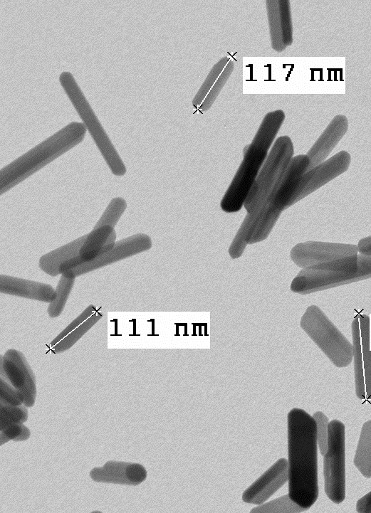
Figure 1: TEM image of the 110 nm HA powder. Scale bar- 100 nm
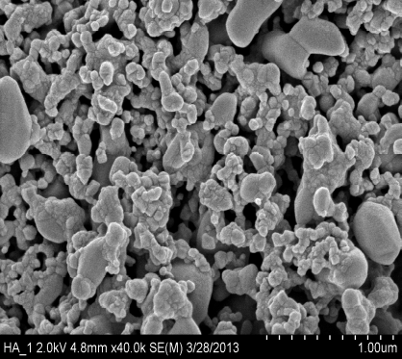
Figure 2: SEM image of the 110 nm HA powder coated onto the titanium mesh using EPD. Scale bar- 1µm
Conclusions: The model helps us determine the particular parameters needed to synthesize a particular particle size.Controlling the size of the nanophase hydroxyapatite, the coating procedure and its parameters can help influence the fate of macrophage attachment, activation and functionality at the implant surface by reducing levels of TNF-α, IL-1, IL-6 and nitrite released with increased nanoscale topography.
Acknowledgements: The authors would like to thank Northeastern University for funding.

References: 1.) Y. Chun et al, Control of macrophage responses on hydrophobic and hydrophilic carbon nanostructures, Carbon 49 (2011) 2092–2103. 2.) D. Khang et al, Reduced responses of macrophages on nanometer surface features of altered alumina crystalline phases, Acta Biomaterialia 6 (2010) 3864–3872.

