Molecular Simulation Based Analysis of Stress Dissipation and Polymer Strength Near a Surface
- Sunil Kumar, Sudip K. Pattanayek* and Sanat Mohanty!
Dept. of Chemical Engineering, Indian Institute of Technology, New Delhi, 110016 India

Understanding of behavior of polymers under external force in the vicinity of surfaces is important to the development of high performance polymer systems required for the development of Pressure Sensitive Adhesives (PSAs)^{1, 2} and design of high performance nano-composites^{3,4} for increased toughness etc. The development of the above applications require the detailed understanding of the mechanisms by which the nano-surface – polymer interactions help to dissipate the energy of the stress. A number of experimental⁵⁻¹⁷ and simulation studies¹⁹⁻³³ have been reported to understand the structure and dynamics of polymers under the application of stresses, especially close to surfaces. Experimentally researchers have studied the effect of force in the perpendicular to the surface on polymer chain. They found that the dissipation of energy depends on the structure of polymers during pulling, interaction among polymer chains and between polymer chain and surface. Creton and his group⁵ have studied the responses of polymer with different cohesive energy at constant applied velocity. They pointed out that as the surface forces decrease; the polymer sees an adhesive failure in that it is cleanly detached from the surface. However, as surface interactions become more favorable between the polymer and the surface, the polymer is stretched before forming fibrils and subsequently being cleanly displaced. The processes of fibrillation and of formation of cavities are important pathways to dissipation of energy and impact the properties of the polymer formulation.
We have studied pulling of a single polymer chain adsorbed randomly on a graphene surface using molecular dynamics simulation. Force is applied parallel and perpendicular to the surface in separate experiments. The choice of polymer (polyethylene) allows simulations of simple straight chains that have primarily van der Waals interactions with the surface. A Graphene surface is chosen because it results in a well-defined, regular surface structure. We note that graphite based nanoparticles have also been in use in adhesive formulations. The behavior of polyethylene on graphene surfaces is perhaps the simplest of systems that allows us to focus on the role of surface interactions with the polymer and polymer-polymer interactions (both of which are tunable through the simulation parameters) and their roles in debonding mechanisms and strength of the bond.
We implemented constant temperature molecular dynamics simulations^{34, 35} in this study. The procedure adopted can be found in our recent publications^{36.} Briefly, we put a randomly generated polymer chain containing N connected beads, where each bead corresponds to united atoms CH₂ in a simulation box (362Å × 362Å × 362Å). The boundaries are assumed to be repulsive. The N value chosen for all simulations in this study is 1000. In addition, a square graphene sheet (edge length = 100Å) consisting of a network of hexagonally orientated (defined by Al-Haik et al.³⁷) carbon atoms (sp² hybridized) was kept at the center in the X-Y plane of the simulation box and the polymer chain placed above the surface. The graphene sheet is kept stationary in the simulation box. The coordinates of the beads in three dimensional is generated by using VMD³⁸ (Visual Molecular Dynamics) and used in the MD simulations box. We assumed that mass of beads of polymer and graphene sheet is m.
- Results
- Chain displacement due to application of external force parallel to surface (F_{xext}):
F_{xext} is applied on all the beads of the polymer chain along the x direction (parallel to the surface). Snapshots of the polymer at different time steps for external force values are shown in figure 1. At low values of F_{xext} (for example, F_{xext} = 0.025 kcal/mol.Å), the chain slides slowly along one face of the surface, comes to the edge and crawls to the other face of the plane. At a higher applied force the polymer evolves into a fibrillated structure, and then escapes from the surface. Figure 2 shows the variation of nonbonded polymer-surface energy (E_{PS}) with time at different values of the applied external force.
Chain displacement due to application of force perpendicular to surface (F_{zext}):
Continuing this analysis of the behavior of a polymer chain close to a surface, the impact of the chain in the presence of a force perpendicular to the plane of the surface is studied. An external force F_{zext} (perpendicular to the plane of the surface) is applied on all beads of an equilibrated polymer chain (equilibration time t=1500ps). Figure 3 shows snapshots of the polymer chain on the graphene surface at different times and with increasing value of the applied force. We have measured non bonded interaction potential energy between polymer- graphene surface (E_{PS}) as shown in figure 4. At a very low value of external force F_{zext} (for example, F_{zext} = 0.1 kcal/mol.Å), the polymer chain does not escape from the surface. At the higher values of the external force (F_{zext} = 1.0 kcal/mol.Å), the polymer chain takes much less time to escape from the surface completely.
- Conclusions
The stiffness of the polymer, the relative energy of interaction between the polymer moiety and between the polymer and surface, all affect the energy dissipated during the process of stress transfer. While these ideas were presented and developed for macroscopic polymer systems by Creton et al. ^{9,10} , this study shows that the mechanisms of stress dissipation hold true for single polymers in the vicinity of a nano-surface. The above analysis also implies that the presence of nano-surfaces affects the nature of polymer response to stresses and thus will affect the polymer failure. Choice of the polymer, the nano-surface (and how it interacts with the polymer) affects the mode of failure for both PSAs and composites. Thus, this paper provides a composite designed with the primary parameters of composite design.

 | 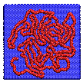 | 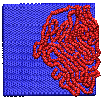  x-axis | 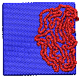 | 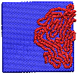 | 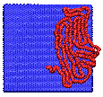
 | 1500ps | 1510ps | 1520ps | 1550ps | 1600ps
(a) F_{xext} = 0.025
 | 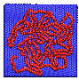 | 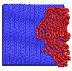 | 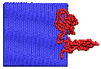 | 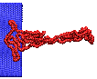 | 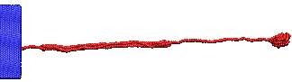
 | 1500ps | 1510ps | 1520ps | 1530ps | 1550ps
(b) F_{xext} = 0.05
 |  | 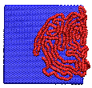 | 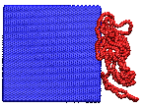 | 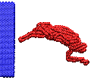 | 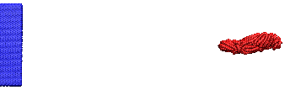
 | 1500ps | 1505ps | 1510ps | 1515ps | 1530ps
(c) F_{xext} = 0.10
 |  | 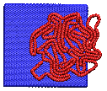 | 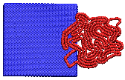 | 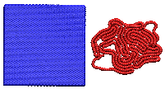 | 
 | 1500ps | 1502ps | 1505ps | 1507ps | 1525ps
(d) F_{xext} = 1.00

Figure 1: Snapshot of polymer chain pulling parallel to the surface (x-axis) at different values of external force, F_{xext}: (a) F_{xext} = 0.025, (b) F_{xext} = 0.05, (c) F_{xext} = 0.1 and (d) F_{xext} = 1.0 kcal/mol.Å and at fixed values of ε_{PP} = 0.3968, ε_{PS} = 0.30, k_{φ} = 2.0 kcal/mol and T=300K.

Figure 2: Non bonded energy profile between polymer beads and surface (E_{PS}) during polymer chain pulling parallel to the surface (x-axis) by various values of external forces F_{xext} (kcal/mol.Å).

 |   z-axis |  |  | 
1500ps | 1525ps | 1550ps | 1575ps | 1600ps
(a) F_{zext} =0.1
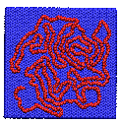 | 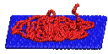 | 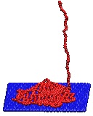 | 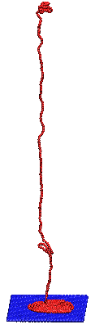 | 
1500ps | 1530ps | 1540ps | 1560ps | 1590ps
(b) F_{zext} =0.2
 | 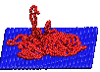 | 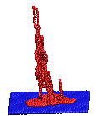 | 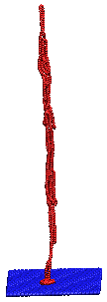 | 
1500ps | 1515ps | 1520ps | 1530ps | 1545ps
(c) F_{zext} =0.3
 | 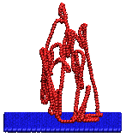 | 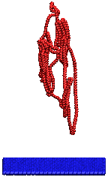 | 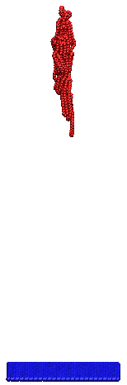 | 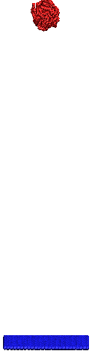
1500ps | 1505ps | 1510ps | 1515ps | 1530ps
(d) F_{zext} =1.0

Figure 3: Snapshot of polymer chain pulling perpendicular to the surface (z-axis) by different values of external tensile force, F_{zext}: (a) F_{zext} = 0.1, (b) F_{zext} = 0.2, (c) F_{zext} = 0.3 and (d) F_{zext} = 1.0 kcal/mol.Å at fixed ε_{PP} = 0.3968, ε_{PS} = 0.30, Kφ=2.0 kcal/mol and T=300K.

Figure 4: Non bonded energy profile between polymer beads and surface (E_{PS}) during polymer chain pulling perpendicular to the surface (z-axis) by various values of external forces F_{zext} (kcal/mol.Å).

References

¹P. Tordjeman, E. Papon, and J-J. Villenave, J. Chem. Phys. 113, 10712 (2000)

²A. Zosel, Colloid Polym. Sci. 263, 541 (1985)
³S. D. Tobing and A.J. Klein, Appl. Polym. Sci. 79, 2230 (2001).
⁴T. N. Krupenkin and G. H. Fredrickson, Macromolecules 32, 5029 (1999)

⁵A. Lopez, E. D. -Contraires, E. Canetta, C. Creton, J. L. Keddie, and J. M. Asua, Langmuir, 27, 3878 (2011)

⁶R. P. Wool and S. P. Bunker, J. Adhesion 83, 907 (2007)
⁷R. Vendamme and W. Eevers, Macromolecules 46, 3395(2013)
⁸S. Yamamoto, Y. Tsujii, and T. Fukuda, Macromolecules 33, 5995 (2000)
⁹T. Hugel, M. Grosholz, H. C.-Schaumann, A. Pfau, H. Gaub, and M. Seitz, Macromolecules 34,1039(2001)
¹⁰J. E. Bemis, B. B. Akhremitchev, and G. C. Walker, Langmuir 15, 2799(1999)
¹¹B. J. Haupt, T. J. Senden, and E. M. Sevick, Langmuir 18, 2174 (2002)
¹²B. J. Haupt, J. Ennis, and E. M. Sevick, Langmuir 15, 3886 (1999)
¹³C. Ortiz and G. Hadziioannou, Macromolecules 32,780 (1999)
¹⁴F. Ritort, J. Phys.: Condens. Matter 18, R531 (2006)
¹⁵D. Soto, G. Hill, A. Parness, N. Esparza, M. Cutkosky, and T. Kenny, App. Phys. Lett. 97, 053701 (2010)
¹⁶F. Kuhner, M. Erdmann, L. Sonnenberg, A. Serr, J. Morfill, and H. E. Gaub, Langmuir, 22, 11180 (2006)
¹⁷Y. Gao, G. Sirinakis, Y. Zhang, J. Am. Chem. Soc. 133, 12749 (2011)

