Process Control of Modified-Release Matrix Tablet Manufacturing Operations and Key Excipient Enablers
True L. Rogers (TLRogers@Dow.com), Kathryn O. Hewlett (KOHewlett@Dow.com), Karen M. Balwinski (KMBalwinski@Dow.com), Jörg Theuerkauf (JTheuerkauf@Dow.com), Louis F. Ruocco (Ruocco@Dow.com)
Purpose: Modified-release (MR) matrix tablets are typically produced using hydroxypropyl methylcellulose (HPMC) as the rate-modifying polymer. Several ingredients in the matrix tablet formulation, particularly the active pharmaceutical ingredient (API) and HPMC, may be irregularly shaped and prone to poor flow and segregation. Although direct compression would be the most streamlined and cost-efficient manufacturing process, inclusion of granulation steps is often necessary to resolve flow and segregation issues. In this study, HPMC matrix tablets were produced via direct compression of a powder blend or by including intermediate roller compaction or high-shear wet granulation steps prior to tabletting. Figure 1 compares the three manufacturing processes investigated. The purpose of this talk is to compare process control, productivity, and achievability of desired end-product attributes by the manufacturing process employed and also to understand how HPMC morphology impacts formulation processability.
Figure 1. Process flow diagrams comparing wet granulation, dry granulation, and direct compression.
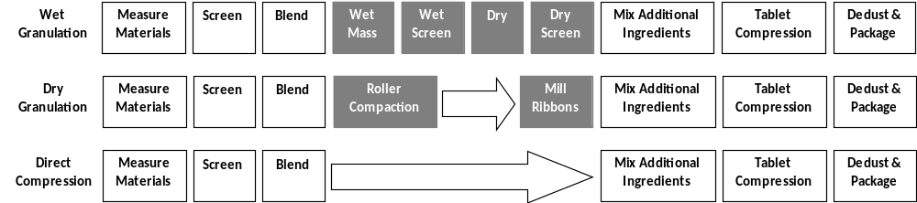

Methods: The matrix tablet model formulation contained 50% metformin HCl, 30% HPMC, 19% microcrystalline cellulose (MCC), 0.5% talc, and 0.5% magnesium stearate. The targeted tablet weight was 1000 mg, so the target API dose per tablet was 500 mg. The standard CR grade of HPMC was used to make tablets via intermediate wet granulation processing steps, a typical practice of matrix tablet manufacture. A new direct compression grade of HPMC, METHOCEL™ DC2, was used to make tablets via direct compression or by using intermediate roller compaction processing steps prior to tabletting. For direct compression, the API, HPMC, MCC, and talc were blended together for 10 minutes. Magnesium stearate was then blended into the powder mixture for one additional minute, and the powder blend was subsequently compressed to caplet-shaped matrix tablets (9.09 x 18.92 mm) using a 26.7-kN compression force. For wet granulation, the API, HPMC, and MCC were blended together, high-shear granulated to desired granularity, and passed through a 20-mesh screen. The granules were oven-dried at 45 °C overnight and passed again through a 20-mesh screen. The sieved granules were blended with talc for 1 minute, and then blended with magnesium stearate for one additional minute before being tabletted. For dry granulation, the API, HPMC, MCC, and talc were roller compacted under 18-kN of force. The roller compacted ribbons were then milled to granules, which were subsequently blended with magnesium stearate and compressed to tablets. Tablets were collected every 3 minutes during each tabletting trial, so run charts could be generated to gauge process control over time.
Results: It is typical to include wet granulation processing steps when manufacturing matrix tablets containing irregularly shaped, poorly flowing ingredients, such as METHOCEL CR, the established standard of HPMC. METHOCEL DC2 and METHOCEL CR are chemically identical; but DC2 exhibits a spheroidal morphology to enable flow in dry processing techniques, such as direct compression and roller compaction. Figure 2 shows the morphological differences between DC2 and CR.
Figure 2. Morphological differences between METHOCEL DC2 and METHOCEL CR.
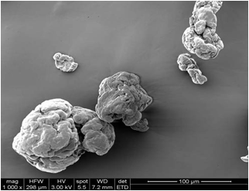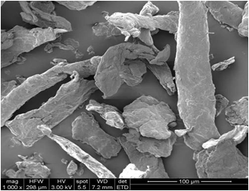
METHOCEL CR
METHOCEL DC2

Tablet weight, breaking force, API unit-dose uniformity, and dissolution performance were compared across each tablet manufacturing process employed. DC2 matrix tablets produced via direct compression weighed 971 ± 23 mg, reflecting satisfactory process control (see Figure 3a). DC2 matrix tablets produced using roller-compaction intermediate steps weighed 995 ± 10 mg, reflecting exceptional process control (See Figure 3b). CR matrix tablets produced using wet granulation intermediate steps weighed 838 ± 14 mg, well below the 1000-mg target (see Figure 3c). A control tabletting trial was conducted using direct compression to make CR matrix tablets (see Figure 3d). Like the CR tablets made from wet granulation, the CR control tablets from direct compression were below the 1000-mg target weight, and the CR control tablets reflected significantly inferior process control compared to DC2 tablets produced either by direct compression or using roller compaction.

Figure 3. Process run charts for individual tablet weight measurements collected throughout the tabletting trials for a) DC2 matrix tablets made by direct compression, b) DC2 tablets made using roller compaction, c) CR tablets made using wet granulation, and d) CR control tablets made by direct compression.
a) b) c) 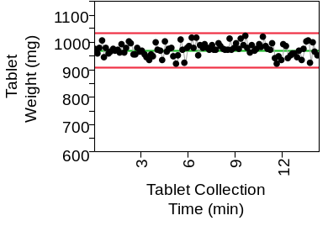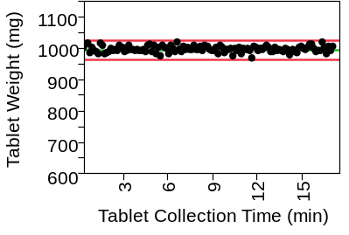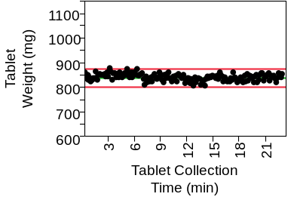
d) 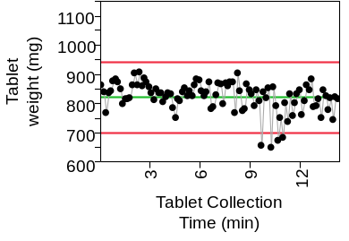
DC2 matrix tablets produced via direct compression or using roller compaction exhibited breaking forces of 112 ± 22 and 108 ± 12 N, respectively. CR tablets produced using wet granulation exhibited a breaking force of 69 ± 4 N. Tablets produced via direct compression or using roller compaction exhibited satisfactory unit-dose uniformity within 90-110% of the labeled claim of 500 mg API per tablet. Expected MR performance was achieved in all cases.
Conclusions: Direct compression is well known as the most streamlined of the tabletting processes but often is not a feasible option due to flow or segregation issues. A key learning from this study is that matrix tablets produced by direct compression required the use of METHOCEL DC2 in order to achieve the desired end-product attributes and sufficient process control. DC2 tablets produced using roller compaction exhibited more reproducible attributes than DC2 tablets produced via direct compression, but did require three additional processing steps. DC2 matrix tablets produced via both manufacturing processes met the desirable end-product attributes. Streamlined manufacturing coupled with sufficient process control rendered direct compression a viable matrix tablet manufacturing option as long as the more flowable METHOCEL DC2 excipient was utilized.

