Effect of organic acids on nucleation and growth of calcium phosphate crystals on glutamic acid functionalized nanofibers
Danial Barati, Seyedsina Moeinzadeh, Esmaiel Jabbari
Department of Chemical Engineering, University of South Carolina, Columbia, SC, USA 29208
Introduction: Aligned collagen fibrils nucleated with calcium phosphate (apatite) crystals are the building blocks of cortical bone. The high strength of compact bone stems from the high loading of calcium phosphate crystals (250-300% based on the fibril weight) deposited on the aligned collagen fibers, facilitated by the acidic ECM proteins. ECM proteins that are rich in glutamic acid (Glu) residues nucleate CaP crystals by surface-immobilization on collagen fibrils. Further, it has been shown that the spacing between carboxylate groups matches those between calcium ions in the growing CaP nanocrystals. Considering that carboxylate-rich organic acids account for 5.5% of the organic matter in bone, they should play a key role in controlling crystal growth and size. The objective of this work was to investigate the effect of organic acids on the extent of crystal nucleation, average size and crystal type of Glu-functionalized aligned nanofiber microsheets. Organic acids included citric acid (CA), maleic acid (MA), and salicylic acid (SalA).
Materials and method: Cysteine-terminated EEGGC (GLU) peptide was synthesized in the solid phase. The peptide was conjugated to low molecular weight acrylated poly(L-lactide) (PLA) via Michael addition to synthesize the PLA-Glu conjugate. Aligned PLA nanofibers sheets were electrospun from a 10 wt% solution of high molecular weight PLA and PLA-Glu with 1.0 mL/h injection rate, 20 kV electrical potential, and 7.5 cm needle-to-collector distance and the fibers were collected on a rotating wheel at 1200 rpm. The nanofiber sheets were incubated in a modified solution of 10x concentrated SBF supplemented with citric acid (CA), malic acid (MA) and salicylic acid (SalA). The amount of CaP nucleation on the nanofibers was characterized using a QuantiChrom calcium assay. The elemental composition of the samples was analyzed using an Energy Dispersive X-ray Spectrometer (EDS) connected to FESEM at an accelerating voltage of 15 kV.
Results: Figure 1a and 1b shows the effect of incubation time and organic acid concentration on CaP content of nanofiber microsheets. The CaP content of nanofibers increased over 16 hours of incubation in the organic acid modified SBF, and did not change significantly with further incubation. The plateau CaP content depended on type of organic acid with citric acid (CA) having the highest CaP content and SalA the lowest. The CaP content was also a strong function of organic acid concentration and reached a maximum value between concentrations of 5-10 mM. The maximum CaP content of the nanofibers was 225±10, 200±10 and 170±10 wt% (based on fiber mass) for citric acid, maleic acid, and salicylic acid, respectively. Further, the type, average size, and calcium to phosphate ratio of the crystals nucleated on the fibers depended on the type of organic acid. For example, based on EDS data, the calcium to phosphorous (Ca:P) ratio increased from 1.77±0.02 to 1.79±0.04 and 1.83±0.04 as the organic acid changed from citric acid to maleic anhydride and salicylic acid, respectively. Results of this work could be used to synthesize fiber-reinforced composites mimicking the nanostructure of compact bone.
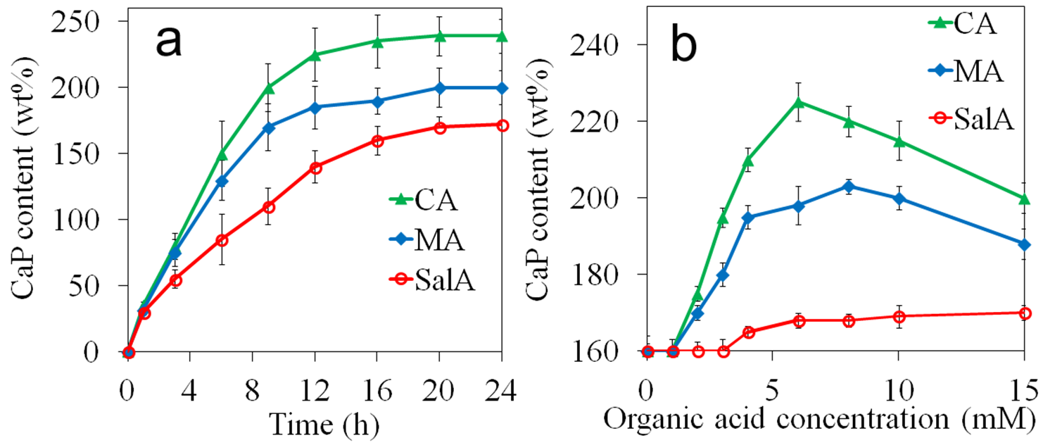
Figure 1. (a) effect of incubation time and (b) organic acid concentration on CaP content of the nanofibers.

