CATALYST-SCALE MODELING OF FISCHER-TROPSCH SYNTHESIS FROM SYNGAS USING COMSOL MULTIPHYSICS

Arvind Nanduri
Department of Natural Gas Engineering
Texas A&M University-Kingsville

Patrick L. Mills
Department of Chemical and Natural Gas Engineering
Texas A&M University-Kingsville

Introduction. In the early 1920’s, Gas-To-Liquids (GTL) and Coal-To-Liquids (CTL) technologies were developed to account for the depleting crude oil resources. During this period, Franz Fischer and Hans Tropsch developed a process to convert synthesis gas (syn gas), derived from coal gasification, to a wide range of high value-addedproducts. This process later came to be known as Fischer-Tropsch (F-T) synthesis. F-T synthesis was an experimental success but its economic viability became a topic of concern as refining of crude oil was a more developed and an economically attractive option [1]. The syn gas used in F-T synthesis can be derived from various feed stocks like coal, natural gas, biomass, and waste. This indirect liquefaction process, also termed as feed-to-liquids, is often referred to as XTLs (Where X: C=coal, G=natural gas, B=biomass, W=waste) [2].
Multi-Tubular Fixed Bed Reactors (MTFBR) and Slurry Bubble Colum Reactors (SBCR) are widely employed for FTS. An MTFBR is similar to a shell and tube heat exchanger with a catalytic reaction taking place on the tube-side and a typical MTFBR contains about 10 to 50,000 tubes. A coolant flows on the shell-side to maintain isothermal conditions in the reactor. To model such a system, detailed knowledge about shell-side fluid solid interactions coupled with tube-side fluid-solid transport kinetics is required. In this study, attention is focused on modeling of diffusion and nonisothermal reaction in FT catalyst particles since this analysis is a fundamental underpinning for any reactor-scale model.
The primary objective of this study is three-fold: (1) to simulate an isothermal 1-D catalyst pellet model; (2) use the isothermal pellet model results as a starting point for the non-isothermal case ; and (3) use extrusion coupling in COMSOL Multiphysics to link the catalyst pellet (2-D domain) to a single reactor tube (1-D domain)
Methods. A micro kinetic olefin readsorption model proposed by Wang et al. (2003) for an iron-based catalyst and a macro kinetic model used by Pangarkar et al. (2009) for a cobalt-based catalyst are used to study the coupled diffusion, reaction and transport effects using COMSOL Multiphysics. The kinetic equations and parameters are given in Table 1. Transport of diluted specie is coupled to catalytic reaction in the catalyst particle.
Table 1: Kinetic Equations and Parameters
Micro Kinetic Olefin Readsorption Model on Fe-based Catalyst (Wang et al. 2003) | Macro Kinetic model on a Co-based Catalyst (Pangarkar et al. 2009)
$R_{{CH}_{4}}=\frac{k_{5M}P_{H_{2}}α_{1}}{1+\left(1+\frac{1}{K_{2}K_{3}K_{4}}\frac{P_{H_{2}O}}{{P_{H_{2}}}^{2}}+\frac{1}{K_{3}K_{4}}\frac{1}{P_{H_{2}}}+\frac{1}{K_{4}}\right)\sum_{i=1}^{N}{\left(\prod_{j=1}^{i}{α_{J}}\right)}}$(n =1)  $R_{C_{n}H_{2n+2}}=\frac{k_{5}P_{H_{2}}\prod_{j=1}^{n}{α_{j}}}{1+\left(1+\frac{1}{K_{2}K_{3}K_{4}}\frac{P_{H_{2}O}}{{P_{H_{2}}}^{2}}+\frac{1}{K_{3}K_{4}}\frac{1}{P_{H_{2}}}+\frac{1}{K_{4}}\right)\sum_{i=1}^{N}{\left(\prod_{j=1}^{i}{α_{J}}\right)}}$ (n ≥ 2)  $R_{C_{n}H_{2n}}=\frac{k_{6}\left(1-β_{n}\right)\prod_{j=1}^{n}{α_{j}}}{1+\left(1+\frac{1}{K_{2}K_{3}K_{4}}\frac{P_{H_{2}O}}{{P_{H_{2}}}^{2}}+\frac{1}{K_{3}K_{4}}\frac{1}{P_{H_{2}}}+\frac{1}{K_{4}}\right)\sum_{i=1}^{N}{\left(\prod_{j=1}^{i}{α_{J}}\right)}}$ (n ≥ 2)  $$R_{{CO}_{2}}=\frac{k_{v}\left(\frac{P_{CO}P_{H_{2}O}}{P_{H_{2}}^{0.5}}-\frac{P_{{CO}_{2}}P_{H_{2}}^{0.5}}{K_{p}}\right)}{1+\frac{K_{v}P_{CO}P_{H_{2}O}}{P_{H_{2}}^{0.5}}}$$ | $$r_{syn}=\frac{aP_{H_{2}}P_{CO}}{{\left(1+bP_{CO}\right)}^{2}}$$  $$a=8.8533*{10}^{-3}\left[4494.41\left(\frac{1}{493.15}-\frac{1}{T}\right)\right]$$  $$b=2.226 e^{\left[-8236\left(\frac{1}{493.15}-\frac{1}{T}\right)\right]}$$  $$α =\frac{1}{1+k_{0}exp\left(\frac{-∆E}{RT}\right){\left(\frac{C_{s,H_{2}}}{C_{s,CO}}\right)}^{0.5}}$$  Where: k₀ = 22.1 and ΔE = 19.822 J/mol  $$r_{H_{2}}=-2r_{syn}$$  $$r_{CO}=-r_{syn}$$

Table 1: Continued
$$α_{n}=\frac{k_{1}P_{CO}}{k_{1}P_{CO}+k_{5}P_{H_{2}}+k_{6}\left(1-β_{n}\right)} (n≥2)$$  $$β_{n}=\frac{\frac{k_{-6}}{k_{6}}P_{C_{n}H_{2n}}}{\left[α_{A}^{i-2}\frac{k_{1}P_{CO}}{k_{1}P_{CO}+k_{5}P_{H_{2}}}+\frac{k_{-6}}{k_{1}P_{CO}+k_{5}P_{H_{2}}+k_{6}}\sum_{i=2}^{n}{\left(α_{A}^{i-2}P_{C_{(n-i+2)}H_{2(n-i+2)}}\right)}\right]}$$  $$α_{A}=\frac{k_{1}P_{CO}}{k_{1}P_{CO}+k_{5}P_{H_{2}}+k_{6}}$$  $$K_{p}=exp\left[\frac{5078.0045}{T}-5.8972089+13.958689*{10}^{-4} T-27.592844*{10}^{-8}T^{2}\right]$$ | $$r_{H_{2}O}=r_{syn}$$  $$r_{C_{n}}=\left(1-α\right)α^{n-1}r_{syn}$$  Where: n ≥ 1

Results and Discussion. The concentration profiles of the species in a typical Fe-based and Co-based catalyst pellet are shown in Figure 1 and Figure 2. Additional results for higher pellet radius under typical process conditions will be presented. The vapor Liquid equilibrium (VLE) calculations using Soave-Redlich-Kwong (SRK) equation of state will also be presented to identify the phase of the species.
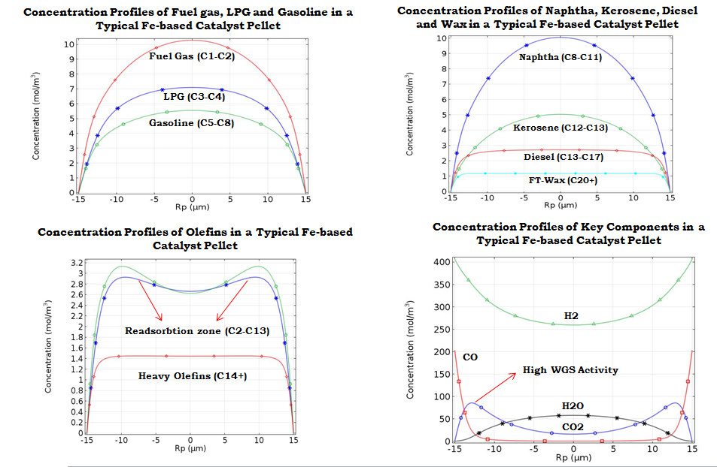
Figure 1: Concentration Profiles of Species in a Typical Fe-based Catalyst Pellet.
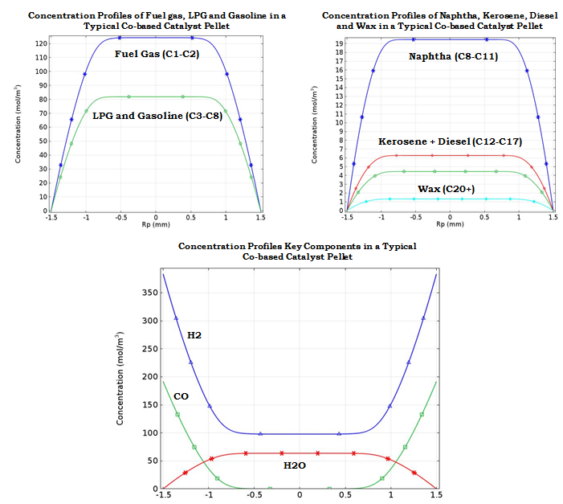
R_{p} (mm)
R_{p} (mm)
R_{p} (mm)
Figure 2: Concentration Profiles of Species in a Typical Co-based Catalyst Pellet.
It is shown that to properly model the FT system and capture the catalyst performance, detailed models for the transport kinetic interactions that define the yield of various hydrocarbon products are required.
References
- D. A. Wood, C. Nwaoha and B. F. Towler, "Gas-to-Liquids (GTL): A Review of an Industry Offering Several Routes for monitizing Natural Gas," Journal of Natural Gas Science and Engineering, vol. 9, 2012.

- O. O. James, B. Chowdhury, M. Adediran Mesubi and S. Maity, "Reflections on the Chemistry of the Fischer-Tropsch Synthesis," RSC Advances, vol. 2, no. 19, 2012.

- Y. N. Wang, W. P. Ma, Y. J. Lu, J. Yang, Y. Y. Xu, H. W. Xiang, Y. W. Li, Y. L. Zhao and B. J. Zhang, “ Kinetic Modelling of Fischer-Tropsch Synthesis over an Industrial Fe-Cu-K catalyst,” Fuel, 2003.

- K. Pangarkar, T. J. Schildhauer, J. Ruud Van Ommen, J. Nijenhuis, J. A. Moulijn and F. Kapteijn, “Experimental and Numerical Comparison of Structured Packings with a Randomly Packed Bed Reactor for Fischer-Tropsch Synthesis,” Catalysis Today, 2009.

