Study of tyrosinase-immobilized gold nanoparticles coated eggshell membrane for determination of polyphenols in tea using differential pulse voltametry and electrochemical impedance spectroscopy
Sudeshna Datta, Baishali Kanjilal, Priyabrata Sarkar

Antioxidant properties of polyphenols have sparked current research interest owing to their role in disease and ageing prevention. Determination of such polyphenol content in widely consumed beverages like tea is a difficult task because of their chemical complexity. Tea leaves contain upto 30% by weight of many polyphenols, mainly catechins which are difficult to determine quantitatively by conventional techniques. Electrochemical sensors offer simple and rapid analytical and diagnostic procedures. Biosensors combine a biological component with a physicochemical detector component, and enzymatic biosensors, which overlay enzymatic reactions with electrochemical methods of detection and have been the subject of intensive research. This work utilized gold nanoparticles along with tyrosinase (polyphenol oxidase) to achieve satisfactory electrochemical response for polyphenols estimation. The experiment design entailed immobilizing tyrosinase on gold nanoparticles (AuNPs) coated eggshell membrane (ESM) which is a biopolymer network on a glassy carbon electrode for polyphenol estimation in tea . AuNPs are used to enhance electron transfer as well as to improve analytical sensitivity. AuNPs were synthesized on the surface of an ESM without using any external reducing agents. The working principle is based on oxidation of polyphenols to their corresponding quinone by ESM-AuNPs bound tyrosinase and then regenerated through electrochemical reduction of quinone. A bioelectrcatalytic amplification cycle was created by generating electrons, passed between glassy carbon electrode and working solution Experimental results also indicated that the current response of modified electrodes with nanoparticles was larger than only enzyme electrode. Modification and characterization of ESM was done with SEM, XRD, EDAX, FTIR and EIS. Four different types of polyphenols - catechin, gallic acid, caffiec acid and catechin gallate- were estimated in differential pulse voltammetry using different working potential and electrochemical impedance spectroscopy. The EIS results were modelled to deconvolute the various circuit components. A single membrane was reused for around 200 reactions without loss of activity. The sensor showed optimum response at pH 6.5 and 35ºC. The sensor exhibited excellent sensitivity (the detection level is 18.2 nM for catechin ), fast response time (less than 10s) and wider range ( for catechin 10nM to 250nM ). The Tyr-AuNPs/ESM membranes were stable for 2 months when stored in buffer at 4ºC. The sensor exhibited very good selectivity to polyphenols and the results show great promise for rapid, simple and cost effective analysis of total polyphenols in tea and subsequent commercial gradation of tea and wine.
Key world : polyphenols, Tyrosinase, gold nanoparticles

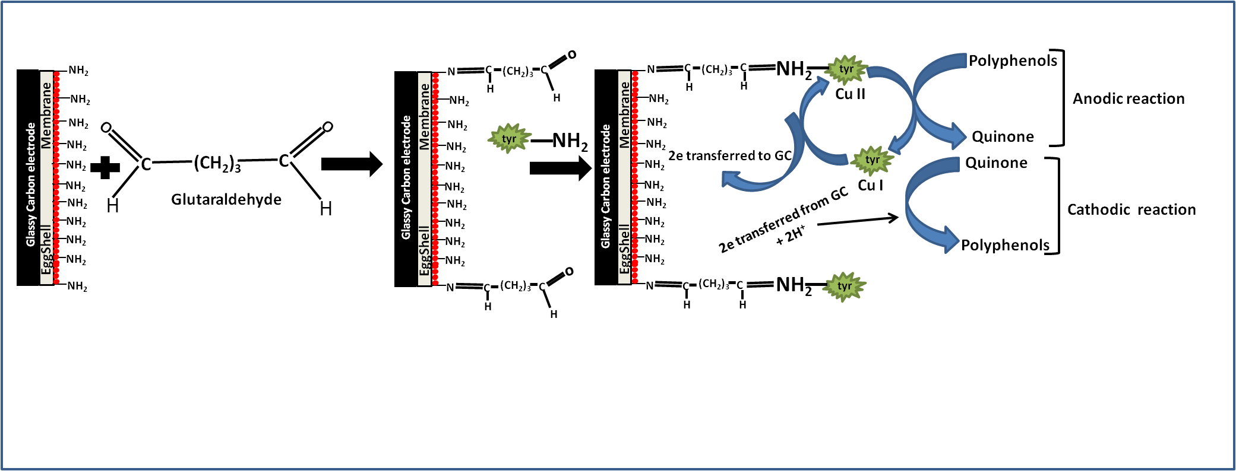
Fig 1: Schematic presentation of the enzymatic reaction at the glassy carbon electrode
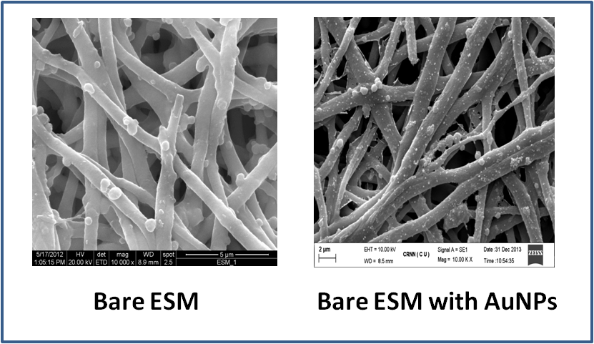
Fig 2: Bare ESM of Eggshell biopolymer network with and without Gold nanoparticles

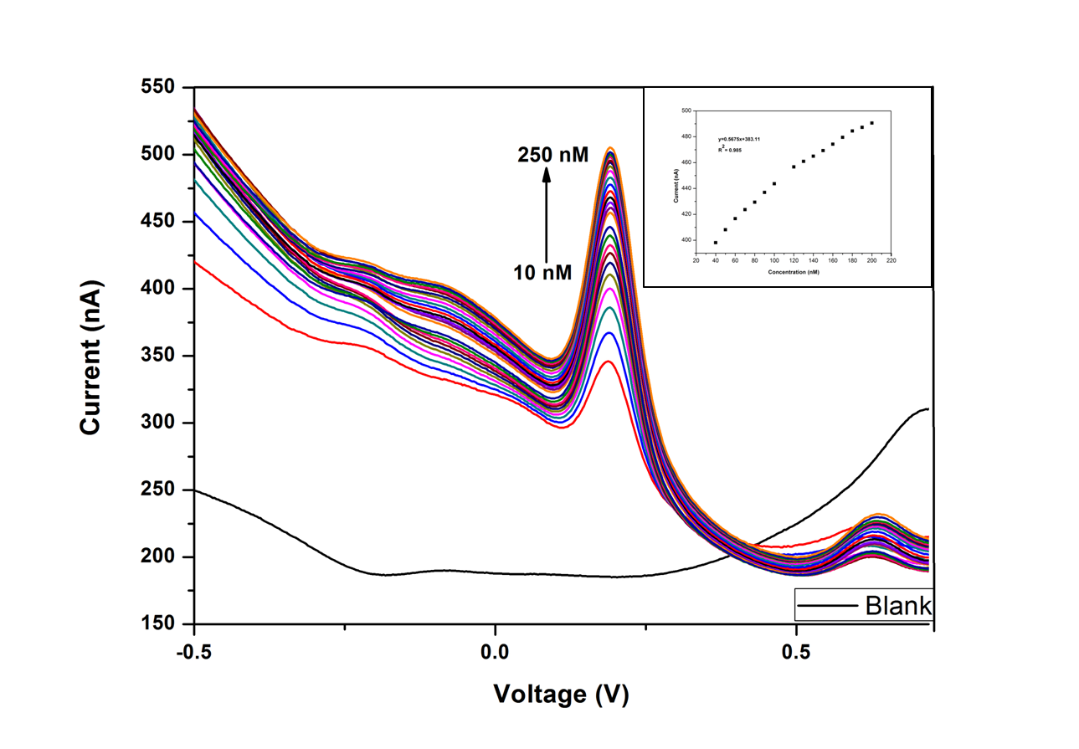Fig 3: Differential pulse voltamtric results using membrane modified glassy carbon electrode containing phosphate buffer at pH 6.5 , scan rate: 30mV/s inset is showing calibration plot

