Abstract:
Bio-based chemicals constitute a promising alternative platform for industrial chemical production, allowing for feedstock diversification, utilization of renewable resources, and potentially reduced environmental burdens relative to petrochemicals. Bio-based chemicals also present new market opportunities in a range of end-use applications, from coatings to polymers. Global production of chemicals and polymers from petroleum is about 330 million tons, and it mainly consists of basic platform chemical that are basis for production of fine chemical and polymers. Studies have shown that most of these building blocks can be produced from biomass resources.[1] Current bio-based chemical production, from both woody and herbaceous resources, is estimated to be around 50 million tons.[1] Among all available sources, lignin with annual production of 200 million metric tons/yr. is the second most abundant natural polymer on earth after cellulose.[2, 3] Lignin accounts for approximately 25–35 % of the organic matrix of wood. The monomer structure has been reported to consist of a phenyl propanoid skeleton.[4] Transformations of lignin have been developed with the goal of preserving the phenolic structure for more ready production of complex aromatic chemicals , but these routes have been difficult and relatively energy consumptive.[4, 5] There are several transformation methods such as pyrolysis and liquefaction techniques, acidic or basic hydrolysis, and more selective depolymerization through catalytic processes,[5, 6] but there is little modeling work on the economic and environmental feasibility of large-scale bio-based chemical production via these routes.

Here we consider bio-based production of catechols from catalytic depolymerization of lignin from candlenut nutshells. These nutshells have 12% (wt. %) lignin in their structure[5] and are typically burned or piled as waste. Target product, catechol, is an organic compound with molecular formula C₆H₄(OH)₂ consumed in the production of pesticides, the remainder being used as a precursor to fine chemicals such as perfumes and pharmaceuticals. Integrated process consists of nutshell preparation (rinsing, drying and milling) and lignin extraction with methanol followed by lignin depolymerization in presence of Cu-doped porous metal oxide (Cu-PMO) catalyst. Our study is mainly focused on catalyst synthesis and lignin depolymerization.
A life cycle assessment (LCA) was conducted in order to model predicted energy use and environmental impacts associated with this bio-based production scheme at industrial scales and to compare catechol production from both lignin and petroleum sources. All major upstream processes were considered, including candlenut cultivation, harvesting, and transport, for the bio-based route and oil&gas extraction, transport, and petrochemical refining for the petrochemical route. Lignin extraction and modification steps were modeled by scaling up bench-scale process and estimating energy consumption. Conde-Mejía, C., et al. [7] was modified based on solvent to wood ratio and used. For catalyst synthesis and lignin depolymerization, commercial-scale process simulation was performed using ASPEN plus v.8.4. Input chemicals from original research [5, 8] and data from the NREL biomass ASPEN data bank [9] were used to model the reaction components and kinetics. Simulations were based on input lignin flow rate of 75 tons/day (matching current US industrial scales for lignin processing). Catalyst degradation (5000 hr lifetime [10]) and solvent recycling rates of 97% were assumed. Figures 1 and 2 show the ASPEN process flow sheets for these steps.
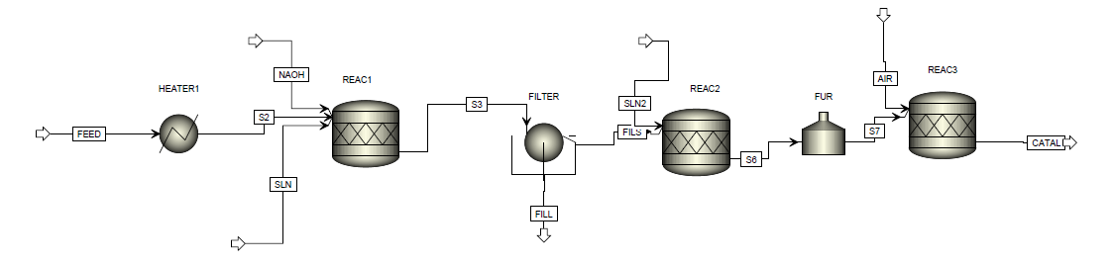
Figure 1. Flow diagram of catalyst synthesis
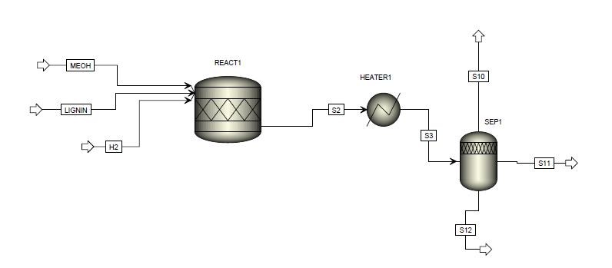
Figure 2. Flow diagram of lignin depolymerization
Energy use for catalyst synthesis is estimated as 5,920 kWh/kg of Cu-PMO catalyst, while depolymerization requires 2.46 kWh/kg of catechol. Phenol and ethanol are co-products of depolymerization process with daily production of 10 and 27 tons. Ethanol will be recycled back to extraction and used as solvent and phenol can be sold to the market.
Resource inputs (energy and material) were modeled in SimaPro 8.01 LCA software using ecoinvent 2.2 life cycle inventory unit processes adjusted for the US energy system. The U.S. EPA’s Tool for the Reduction of Chemical and Other Environmental Impacts (TRACI) 2.1 fate-effect model was used for estimation of environmental impacts. Associated impacts were normalized based on 1 kg catechol in output stream, considering burden allocation for catalyst synthesis over its lifetime and two types of credits; one from carbon sequestration during candlenut tree growth prior to harvesting and the second from phenol as a co-product of depolymerization.
Figure 3 demonstrates the relative process contribution, normalized in each category, for the field-to-gate production of catechols from candlenut lignin.

Figure 3. Process contribution of catechol production from lignin, considering extraction, depolymerization and catalyst synthesis
From the chart, it can be seen that almost in all categories, dichloromethane and heat used in extraction process drive life cycle impacts. Dichloromethane is produced from methyl chloride at high temperatures (400-500 °C) and it is highly volatile, which makes it an inhalation and atmospheric hazard. It is a potent ozone-depleting substance and its contribution is 97% in ozone depletion and 62% in human respiratory effects.
Catalyst contribution is not that significant compared to other processes. The production of 1 kg catechol requires 0.76 kg of catalyst. Results demonstrated that maintaining operational conditions for high retention time of catalyst synthesis process leads to excessive electricity consumption. Electricity production is the dominant contributor in all categories with about >99% of total burdens, while the actual catalyst materials themselves are relatively insignificant.
Final step is comparing environmental burden of proposed catechol production with convenient catechol from petrochemical phenols. Phenol reacts with hydrogen peroxide to form catechol based on equation 1.[11]
C₆H₅OH + H₂O₂ C₆H₄(OH)₂ + H₂O , ∆H_{reaction}= -200.4 (kJ/mol) eq. 1
The process was simulated in SimaPro and associated burden was estimated. Its process contribution is shown in figure 4.

Figure 4. Process contribution in catechol production from petroleum based phenol
Based on above figure, phenol production at first place is the most dominant contributor almost in all environmental impact categories.
Comparing petroleum-based and lignin-based catechol illustrates interesting results. Table 1 shows total impacts for each of the production routs.
Impact category | Unit | Total (lignin-based catechol) | Total (petroleum-based catechol)
Ozone depletion | kg CFC-11 eq | 1.6E-04 | 1.5E-07
Global warming | kg CO2 eq | 3.0E+01 | 4.0E+00
Smog | kg O3 eq | 1.5E+00 | 1.7E-01
Acidification | kg SO2 eq | 1.1E-01 | 1.6E-02
Eutrophication | kg N eq | 3.6E-02 | 8.8E-03
Carcinogenics | CTUh | 1.0E-06 | 2.4E-07
Non carcinogenics | CTUh | 2.5E-06 | 3.0E-07
Respiratory effects | kg PM2.5 eq | 1.0E-02 | 1.2E-03
Ecotoxicity | CTUe | 2.7E+01 | 8.5E+00
Fossil fuel depletion | MJ surplus | 6.9E+01 | 1.3E+01
Table 1. Total environmental burden of lignin-based and petroleum-based catechol
Petroleum-based catechol seems to have lower environmental impacts compared to the bio-based catechol and that might be because of high complexity and resistance in lignin structure that needs more effort for conversion to simpler aromatic compounds. Utilization of dichloromethane as a solvent for modification of crude lignin is a driver of negative environmental impacts and its substitution should be a target of further research.
Finally, the results points that proposed pathway for bio-based catechol is not as promising as expected. More development and process optimizations are needed for industrial scale production of such chemicals. Choosing appropriate solvents and reaction modifications can be the first step while using catalyzed reactions to mitigate energy consumption of the whole process can be another consideration.

References:
1. de Jong, E., Bio-based Chemicals Value Added Products from Biorefineries. IEA Bioenergy, Task42 Biorefinery, 2012.
2. Ragauskas, A.J., et al., The path forward for biofuels and biomaterials. Science, 2006. 311(5760): p. 484-489.
3. Percival Zhang, Y.-H., M.E. Himmel, and J.R. Mielenz, Outlook for cellulase improvement: screening and selection strategies. Biotechnology advances, 2006. 24(5): p. 452-481.
4. Kleinert, M. and T. Barth, Phenols from lignin. Chemical engineering & technology, 2008. 31(5): p. 736-745.
5. Barta, K., et al., Depolymerization of organosolv lignin to aromatic compounds over Cu-doped porous metal oxides. Green Chemistry, 2014. 16(1): p. 191-196.
6. Huber, G.W., S. Iborra, and A. Corma, Synthesis of transportation fuels from biomass: chemistry, catalysts, and engineering. Chemical reviews, 2006. 106(9): p. 4044-4098.
7. Conde-Mejía, C., A. Jiménez-Gutiérrez, and M. El-Halwagi, A comparison of pretreatment methods for bioethanol production from lignocellulosic materials. Process safety and environmental protection, 2012. 90(3): p. 189-202.
8. Hansen, T.S., et al., One-pot reduction of 5-hydroxymethylfurfural via hydrogen transfer from supercritical methanol. Green Chemistry, 2012. 14(9): p. 2457-2461.
9. Wooley, R.J. and V. Putsche, Development of an ASPEN PLUS physical property database for biofuels components. 1996: National Renewable Energy Laboratory Golden, CO.
10. Griffiths, O.G., et al., Using life cycle assessment to measure the environmental performance of catalysts and directing research in the conversion of CO 2 into commodity chemicals: a look at the potential for fuels from ‘thin-air’. RSC Advances, 2013. 3(30): p. 12244-12254.
11. Sienel, G., R. Rieth, and K. Rowbottom, Ullmann's encyclopedia of industrial chemistry. Wiley-VCH, Weinheim, 2000.

