Single-Step Delamination of a MWW Borosilicate Layered Zeolite Precursor under Mild Conditions without Surfactant and Sonication

Xiaoying Ouyang ¹, Son-Jong Hwang ², Ron C. Runnebaum ¹, Dan Xie ³, Ying-Jen Wanglee ¹, Thomas Rea ³, Stacey I. Zones *, ^{1, 3}, and Alexander Katz *^{, 1}
¹ Department of Chemical and Biomolecular Engineering, University of California at Berkeley, Berkeley, California 94720
² Department of Chemical Engineering, California Institute of Technology, Pasadena, California 91125
³ Chevron Energy Technology Company, Richmond, California 94802

Abstract
This presentation focuses on synthesis of delaminated Layered borosilicate zeolite precursor ERB-1P (Si/B = 11). Our approach lies on isomorphous substitution of Al for B using a simple aqueous Al(NO₃)₃ treatment. TEM demonstrates transformation of rectilinear layers in the precursor to single and curved layers in the delaminated material, and characterization by PXRD shows loss of long-range order. N₂ physisorption and base titration confirm the expected decrease of micropore volume and increase in external surface area for delaminated materials relative to their calcined 3D zeolite counterpart. FTIR and multinuclear NMR spectroscopies demonstrate synthesis of Brønsted acid sites upon delamination. Comparative synthetic studies demonstrate that this new delamination method requires (i) a borosilicate layered zeolite precursor, in which boron atoms can be isomorphously substituted by aluminum, (ii) neutral amine pore fillers instead of rigid and large quaternary amine SDAs, and (iii) careful temperature control, with the preferred temperature window being around 135 ºC for ERB-1P delamination. Acylation of 2-methoxynaphthalene was used as a model reaction which is only catalyzed by the acid sites located near the external surface, instead of the acid sites located within the 10-MR micropores to investigate the catalytic benefits of delamination.^{1,2} A partially dealuminated delaminated material (e.g. ERB-1-del-135) displays a 2.3-fold enhancement in its initial rate of catalysis relative to the 3D calcined material. This is nearly equal to its 2.5-fold measured increase in external surface area. Our simple, surfactant- and sonication-free, mild delamination method is expected to find broad synthetic utility.

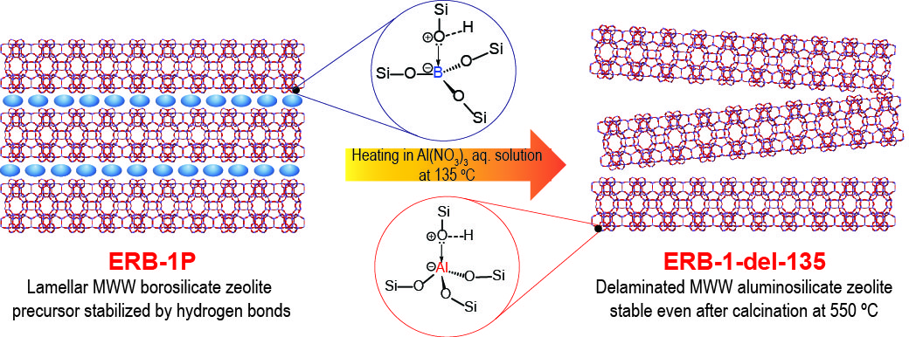

(1) Andy, P.; Garcia-Martinez, J.; Lee, G.; Gonzalez, H.; Jones, C. W.; Davis, M. E. J. Catal. 2000, 192, 215-223.
(2) Ouyang, X.; Hwang, S.-J.; Runnebaum, R. C.; Xie, D.; Wanglee, Y.-J.; Rea, T.; Zones, S. I.; Katz, A. J. Am. Chem. Soc. 2013, 136, 1449-1461.

