The Physical Chemistry Nature of Hydrogen Sulfide Gas as it Affects Sulfide Stress Crack Propagation in Steel

W.D. Grimes
Shell Global Solutions International
Grasweg 31
Amsterdam, 1031 HW
Netherlands

R.N. French
Shell International E&P, Inc
3333 Hwy. 6 South
Houston, TX 77082
USA

B.P. Miglin
Shell International E&P, Inc
200 N. Dairy Ashford
Houston, TX 77079
USA

M.A. Gonzalez and B.D. Chambers
Shell Global Solutions US, Inc
3333 Hwy. 6 South
Houston, TX 77082
USA

ABSTRACT

Sour well design is often based upon the partial pressure of the acid gases, which have most often been correlated to equivalent partial pressures in laboratory studies conducted at a much lower total pressure. This partial pressure approach is supported by industry standards, notably ISO 151561 / NACE MR0175¹. However, total pressure and temperature, as seen in the wells, will impact the solubility and chemical behavior of these acid gases in the water phase, in some instances potentially reducing the corrosive impact by a factor of 3-10, depending upon the potential critical parameters of hydrogen sulfide activity or solubility.
This paper summarizes a test program that studied the physical chemistry of hydrogen sulfide (H₂S) and its impact on the sour material properties of low alloy steels. The program investigated various parameters of H₂S to determine the most influential environmental factor in sulfide stress cracking (SSC) of alloy steels typically used in mildly sour wells. The parameters assessed included gas partial pressure, gas fugacity, aqueous solubility, and aqueous chemical activity. Statistical data analysis of the results with 95% confidence limits indicated that fugacity was the primary parameter for control of sulfide stress crack propagation for a casing steel.
Incorporating fugacity determinations into well assessments potentially provide opportunities for use of lower grades of materials, especially for high pressure gas wells. However, there are other implications that need to be understood for high pressure liquid systems. In particular, the current approach of using the H₂S value at the bubble point of an oil may prove to be non-conservative for high pressure liquid hydrocarbon systems. Lastly, this paper describes some challenges facing ISO 15156 when moving forward to address incorporation of thermodynamic calculations to determine the actual degree of sour severity in the field.

Key words: Sulfide Stress Cracking, SSC, Fugacity, Sour Wells, Oil Country Tubular Goods

INTRODUCTION

Currently sour materials selection referring to ISO 15156 standards is based upon acid gas partial pressure up to 10 bar (145 psi), which has most often been correlated to equivalent partial pressures in laboratory studies conducted at a much lower total pressure. However, at total high pressures, typically above about 100 bar (1450 psi), non-ideal gas behavior can have a quite significant impact on H₂S behavior in the water phase, influencing both aqueous chemical activity (or base corrosivity) and aqueous concentration (influencing mass transport), to different degrees. Nevertheless, as other effects may also participate in SSC, e.g., galvanic influences of a sulfide film, it was deemed appropriate to also assess the historical parameter of pH₂S. As differences in physical chemistry behavior are greater at total pressures exceeding 50-100 bar, identification of the most influential physical chemistry parameter was considered most relevant to a high pressure environment, e.g., in a well or high pressure facilities.

Several physical chemistry (or thermodynamic) parameters for H₂S were of interest for this study:
- Partial Pressure of H₂S (P_{H2S} or pH₂S) is defined by the mole fraction (y_{H2S}) of H₂S in the vapor phase and the total pressure (P):
P_{H2S} = y_{H2S} P
This definition corresponds to that in ISO 15156, Part 2, Section C1.¹ For a mixture of ideal gases, the partial pressure represents the pressure that each gas in the mixture would exert if it occupied the volume by itself at the same temperature. At sufficiently low pressures, the gas molecules are sufficiently far apart that they do not interact. However, as pressure (and gas density) increases, the gas molecules can experience attractive and/or repulsive forces from one another, leading to non-ideal behavior.
- The fugacity of H₂S (f_{H2S} or fH₂S) represents the effective pressure of a real gas and is equal to the pressure of an ideal gas which has the same chemical potential as the real gas. It is generally calculated from the total pressure, the mole fraction of H₂S in the mixture and a fugacity coefficient,φ _{H2S}:
f_{H2S} = φ _{H2S} y_{H2S} P
The fugacity coefficient is a function of temperature, pressure and composition, and is generally calculated using an equation-of-state. The concept of fugacity is applicable to all phases, and fugacity can be thought of as representing “escaping tendency” – the driver for a component to leave a phase. At equilibrium, the fugacity for each component is the same in all phases of a mixture:
$$f_{H2S}^{vapor}= f_{H2S}^{liquids}$$
- The chemical activity of H₂S is defined as the ratio of the fugacity divided by the fugacity at a conveniently defined reference state. Thus, the activity is unitless and is meaningless if the reference state is not specified. Fugacities or activities are the proper thermodynamic parameters to use to represent chemical equilibria and chemical reactions. Because the activity is directly proportional to the fugacity, only one parameter, the fugacity, is assessed in this work.
- The concentration (x_{H2S} or xH₂S or mg/L_{aq or} ppm_{aq}) of H₂S in the aqueous phase in equilibrium with the gas phase was also considered in this investigation. For a given partial pressure of H₂S, vapor phase composition, total pressure and temperature, the concentration of H₂S in the brine can be calculated using an equation-of-state or an extended Henry’s law approach incorporating the Poynting correction factor.² Phase equilibrium calculations are normally done using mole fractions to represent concentrations in all phases. For convenience, the H₂S mole fractions in the brine have been converted to alternative units (e.g. mg/L) using calculated densities. In this work, concentration was calculated using an equation-of-state approach.³

A series of thermodynamic calculations was performed using a proprietary cubic equation-of-state. The equation-of-state parameters have been validated for modeling mixtures of H₂S with water and hydrocarbons in the range of tests performed herein. These calculations were performed to predict H₂S fugacity and aqueous solubility as a function of gas composition (balance methane) and total system pressure (up to 1400 bar), at a fixed temperature (25°C) and a fixed H₂S partial pressure (0.3 kPa). The results, shown in Figure 1, indicate that any increase in total pressure up to at least 1400 bar provides lower values of fH₂S and xH₂S relative to their values at ambient pressure. Thus, these alternative parameters would suggest a less severe condition relative to a traditional NACE sour lab test at ambient pressure. Differentiating between pH₂S, fH₂S, and xH₂S as a controlling parameter may require tests at system pressures of at least 500 bar.
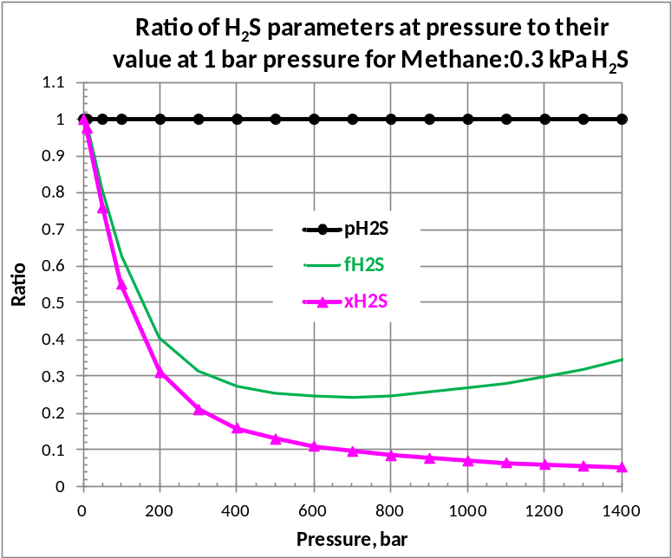
Figure 1: Ratio of pH₂S, fH₂S, and xH₂S to their value at a 1 bar pressure for a 0.3 kPa H₂S (balance methane) gas at an increasing total pressure at 25°C.

RESULTS OF TEST PROGRAM

A laboratory test program that investigated the SSC response of an alloy steel as a function of physical chemistry parameters of H₂S was reported ⁴. The objective of the program was to see which physical chemistry parameter of hydrogen sulfide had the greatest influence on the sulfide stress cracking of a casing grade steel. Key to the program was to minimize variability between tests and to control the H₂S environments during the testing. Those items that remained constant were: test material; test vessel; type and number of specimens; test environment (NACE solution A; initial pH 4.0); mass of H₂S; gas replenishment; and duration. The tabulated test results from that work are summarized in Table 1.⁴ Figure 2 shows the graphical presentation of the quantified SSC behaviour as a function of H₂S partial pressure, solubility, and fugacity. Included in the plots of Figure 2 are the results of a regression analysis (solid curves) and the 95% confidence intervals as noted by the dotted lines.
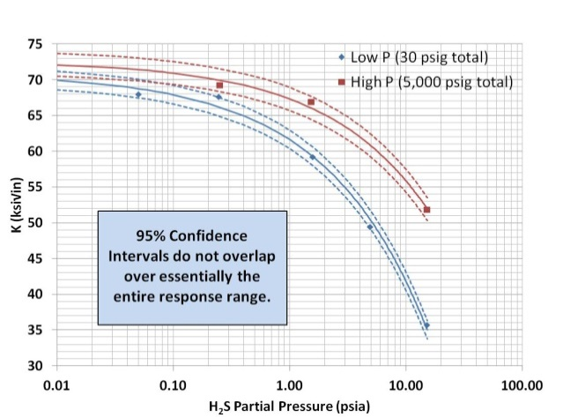 | 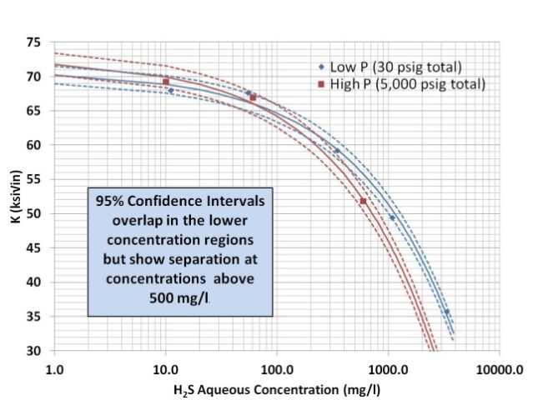
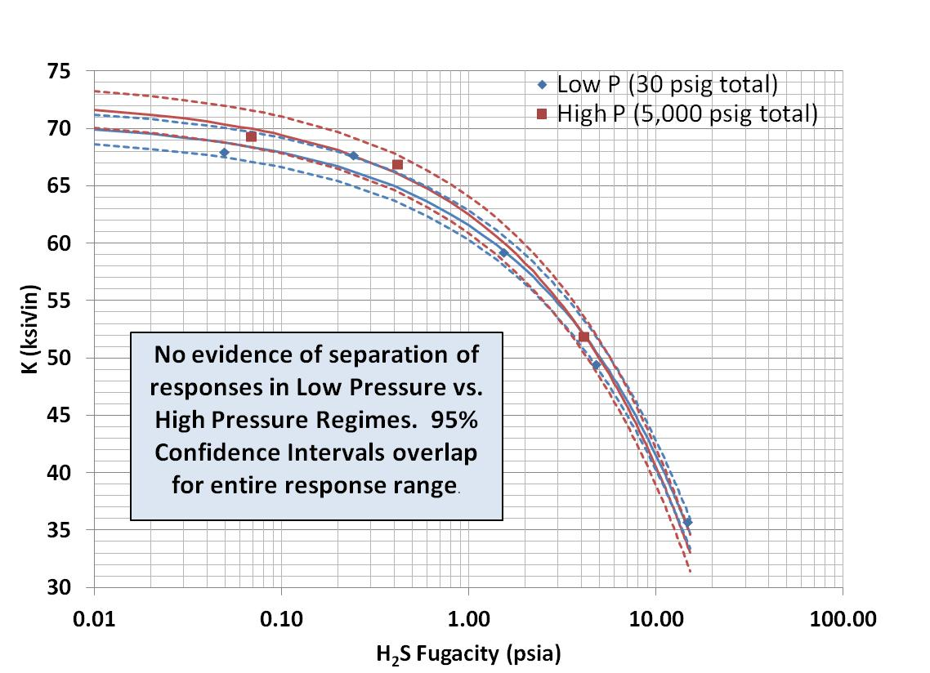
Figure 2: SSC results versus partial pressure of H₂S, aqueous concentration, and fugacity. 95% confidence limits at both test pressures also shown.

Table 1
Hydrogen Sulfide Values for Each Test with SSC Test Results
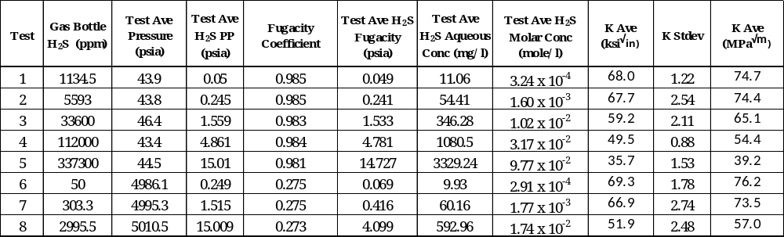
The results of the tests were analyzed with a rigorous statistical approach. The main conclusions are shown as the boxed text and were summarized as:
- Partial pressure of H₂S: Clear evidence that the cracking responses to partial pressure at the high and low total test pressure conditions differ. For example, comparison of results from test 3 to test 7 (see Table 1), the average K varied from 59.2 to 66.9 ksi √in (65.1 to 73.5 MPa √m) even though the partial pressures of H₂S were about the same. This means that another factor, total system pressure, is influencing the sour material response in addition to the H₂S partial pressure. .
- Solubility of H₂S: Some evidence that the cracking response to solubility at the high and low total test pressure conditions differs. This indicates that the use of H₂S solubility alone may not sufficiently describe the sulfide stress cracking response of alloy steel.
- Fugacity of H₂S: Evidence is that the cracking response to the fugacity at the high and low total test pressure conditions is the same. This indicates that the use of H₂S fugacity alone sufficiently describes the sulfide stress cracking response of alloy steel.

APPLICATION AND LIMITATION OF RESULTS

Application of the observation that fugacity is the controlling factor (as opposed partial pressure of hydrogen sulfide) in SSC propagation in steel oil country tubular good (OCTG) products has some attractive benefits. Users of such results, however, should verify their applicability to specific situations by appropriate fit-for purpose testing based upon proven physical chemistry principals. The impact of field lifecycle exposures needs to be considered in application of physical chemistry properties.

Predicting Well Conditions (Sweet vs. Sour)

The potential presence (and the amount) of H₂S in a given untested well is needed information to ensure the proper materials selection. In the absence of accurate data, conservative estimates are warranted. Various sources of H₂S in reservoirs have been identified;⁷ these include sulfate reducing bacteria, thermo-chemical sulfate reduction and thermal cracking. Thermal cracking as a source of reservoir H₂S is particularly important for many HPHT developments. At temperatures in excess of 250°F (120°C) sulfides in sulfur rich source rock can decompose to form H₂S. Various mineral reactions act as buffers, controlling the concentration of H₂S in the reservoir fluid.⁸ From an analysis of compiled bottom hole temperatures and hydrogen sulfide measurements for gas production from clastic type reservoirs, an empirical relationship, the JT Smith Correlation, was developed. Grimes and McNeil ⁸ provide further background on the JT Smith correlation. Figure 3 from their publication shows the log of the partial pressure of H₂S as a linear function of reservoir temperature. Note that this figure includes the 95% confidence interval and lines of construction indicating that the 0.05 psi (0.003 bar) H₂S partial pressure level can occur (conservatively) at 275°F (135°C).

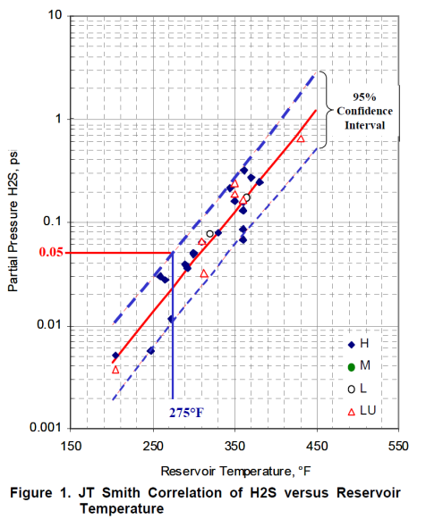  Figure 3: JT Smith Correlation⁷ in terms of H₂S partial pressure as function of reservoir temperature for clastic reservoirs in the Gulf of Mexico, based on gas well production data. | 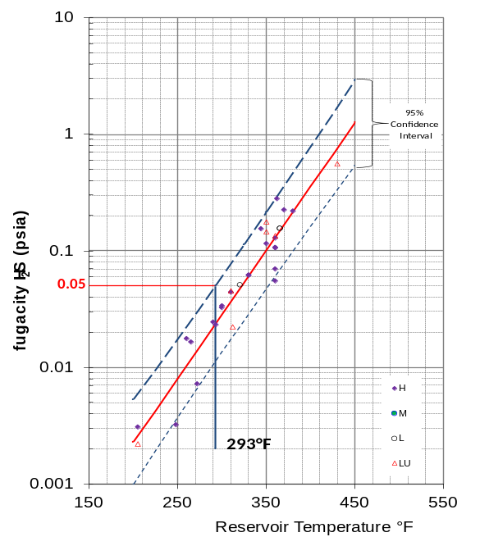  Figure 4: JT Smith Correlation presented in terms of H₂S fugacity as function of reservoir temperature using same database as ref 7 with fugacities calculated using the GERG-2008⁸ equation-of-state assuming the gas as pure methane.

Since H₂S fugacity rather than partial pressure is of interest for sulfide stress crack propagation, the JT Smith Correlation should be revisited in this context. The gas phase H₂S partial pressure data used by Grimes and McNeil were converted to H₂S fugacity values using fugacity coefficients for H₂S calculated by the GERG-2008⁹ model in the REFPROP program from the National Institute of Science & Technology (NIST⁽⁾).¹⁰ Figure 4 shows that the H₂S fugacity values are systematically lower than the corresponding H₂S partial pressure values. The offset decreases with increasing temperature. Thus, the correlation and 95% confidence lines for the fugacity-based plot are shifted to higher temperatures. The 0.05 psi (0.003 bar) H₂S fugacity level occurs (conservatively) at 293°F (145°C), nearly a 20°F (10°C) change.

The gases were modeled as pure methane because fugacity coefficients calculated using measured gas well compositions (typically >90% CH₄) differed by less than 4% from values assuming pure methane. The problem of calculating fugacities in the gas phase is equivalent to the problem of estimating volumetric properties.¹¹ Figure 5 shows that molar volumes predicted by GERG-2008 for methane-hydrogen sulfide binary mixtures deviate from experimental data¹² by less than about 0.5% even up to 10,000 psia (690 bar). Errors of about 0.5% in molar volume prediction would correspond to uncertainties in predicted H₂S fugacity coefficients on the order of about 2% at 10,000 psia (690 bar). Similar fugacity calculations for oil wells should probably consider further components.

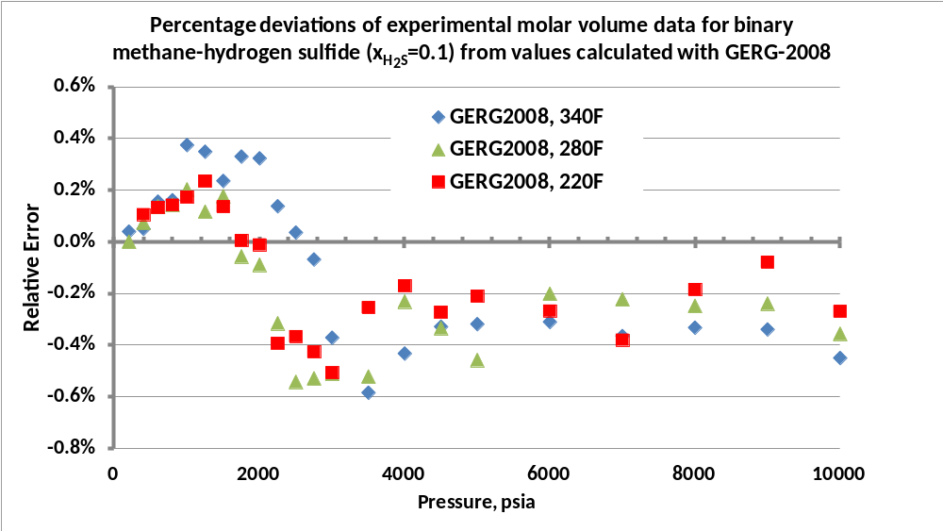
Figure 5: Molar volumes calculated with GERG-2008 deviate by less than about 0.5% from experimental data for binary methane-hydrogen sulfide (x_{H2S} = 0.1)
Cautions and Implications on Application to Wells

In those situations where fugacity is applicable, it should be noted that temperature can have a significant impact on fugacity values. When assessed in the context of a high pressure well, this impact should be considered when assessing material cracking resistance. For example, to consider the impact of temperature, additional fugacity data needs to be added to Figure 1, as shown in, e.g., Figure 6.
Thus in a high pressure well approximately representing this gas composition, one would not only need to consider the ambient static fluid compositions and pressure and temperature conditions, but also the impact of well operations to assess fH₂S. Normally, when a well is flowing it will have a higher operating temperature, with a concurrent temperature impact on fugacity. When a typical flowing well is shut-in, it will initially contain not only hotter fluids but will also very quickly reach the higher static pressure gradient. Subsequently, the well will slowly cool to the static, ambient fugacity condition, traversing in the process all the fugacity exposures between, sometimes in a timeframe of months, as shown in Figure 7. Such a long timeframe is a more than adequate time for SSC to typically occur.

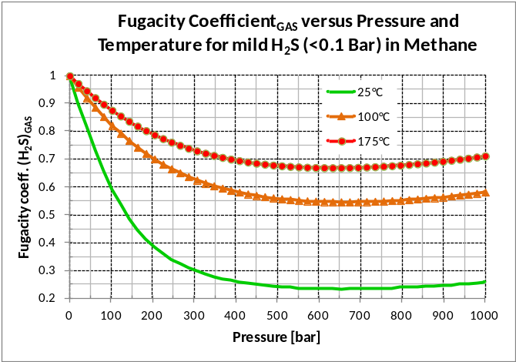
Figure 6 – The Fugacity Coefficient of H₂S versus Pressure and Temperature. Note that the fugacity coefficient shown, as calculated using a proprietary cubic equation-of-state, will change with the gas composition and is not a generalization.
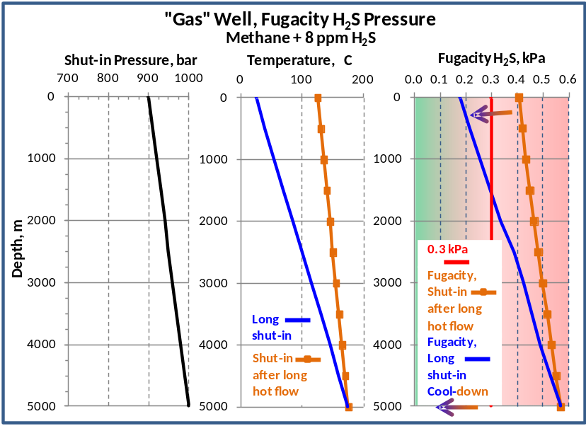
Figure 7 – Example demonstrating impact of “gas” well operating conditions on fugacity⁽⁾. Shown are example (a) ambient equilibrium shut-in condition and (b) condition soon after shut-in from a flowing state. The time required to cool from condition (b) to (a) may be months. To use fugacity, intermediate conditions need proper consideration.
Of concern is the implication of using fugacity versus other calculation protocols published in ISO 15156. Per ISO 15156, Part 2, Annex C, Section C.2, in systems where no gas phase is present, calculations are shown whereby the partial pressure of H₂S at the bubble-point of a gas-liquid system is acceptable. However, fugacity is sensitive to the total pressure, and as shown by the example in Figure 8 and 9, use of a bubble-point partial pressure may be non-conservative compared to fugacity, especially in cases where high pressures are encountered.
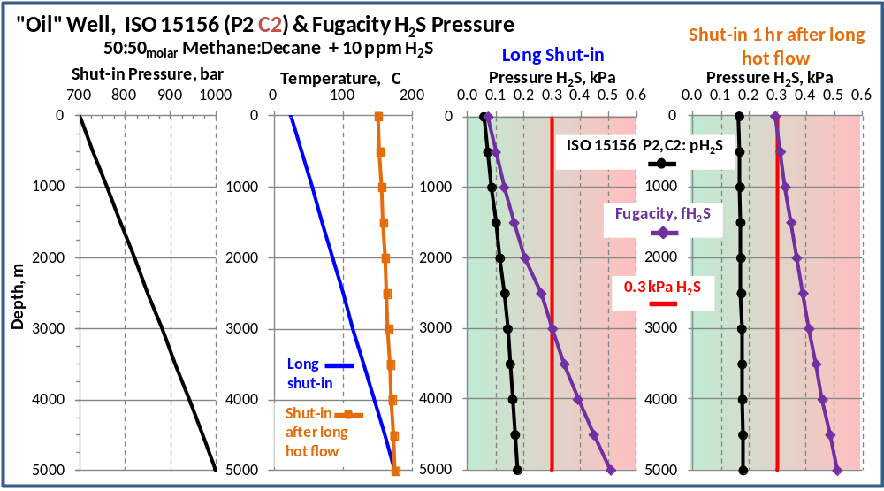
Figure 8 – Example of an “Oil” well H₂S Pressure calculation using an ISO 15156 P2, C.2 “bubble-point” protocol⁽⁾ compared to one for Fugacity³

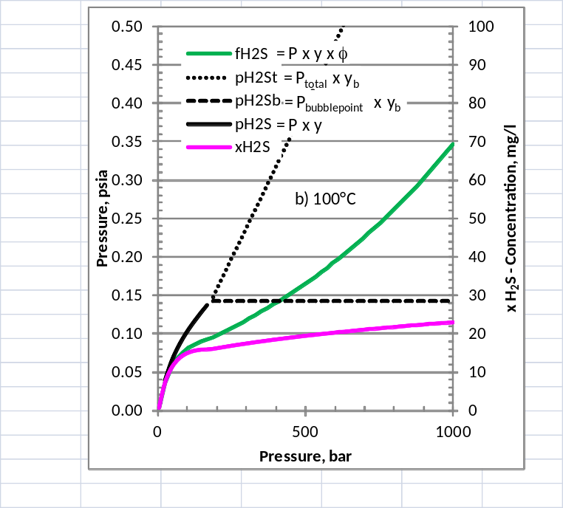
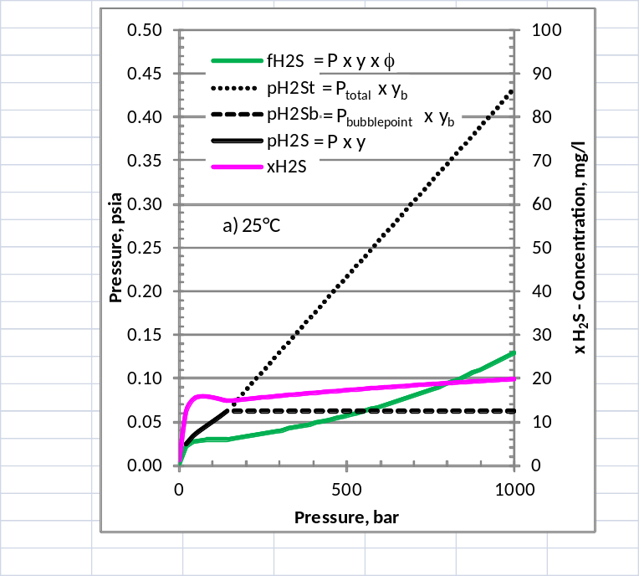
Figure 9: Calculations⁴ of P_{H2S}, f_{H2S}, and x_{H2S} for 10 ppm H₂S in a 45:45:10 molar Methane:Decane:Water fluid at 25° and 100°C, with a pressure bubble point of 146 bar @ 25ºC and 178 bar @ 100°C. (Note: Above P_{Bubblepoint}, calculations were performed based on the bubblepoint gas composition using both “P_{total}“ and P_{Bubblepoint}.
Aq. Concentration, mg/l

The implication that fugacity is the governing parameter also suggests that a thorough understanding of the application environment and material performance in that environment is important to the proper application of sour materials. The significance of this is that we obtained data and are sharing it with industry to show the magnitude of the variation and the case for action to address the non-conservative situations.
Other cautions/limitations include:
- Degradation mechanisms other than SSC propagation and arrest have not been addressed. SCC initiation tests, e.g., per TM0177 Methods A, B, or C, were not performed. There have been reported three design limitations applicable to low alloy steels in sour service,¹³ yield, sour fracture toughness (sour propagation), and sour threshold stress (sour initiation). Figure 10 shows an example of threshold stress based on NACE A tests.¹⁴ The work to date did not focus on sour threshold stress, and thus, does not validate that fugacity is the controlling parameter in cases where this failure mode could dominate. Indeed, when a linear elastic fracture mechanics (LEFM) analysis¹⁵ was performed on a hypothetical flaw in a pipe exposed to a sour environment and compared to crack initiation data, there was only partial overlap of data suggesting that these processes, brittle fracture and crack propagation, need to be considered separately (see Figure 11).

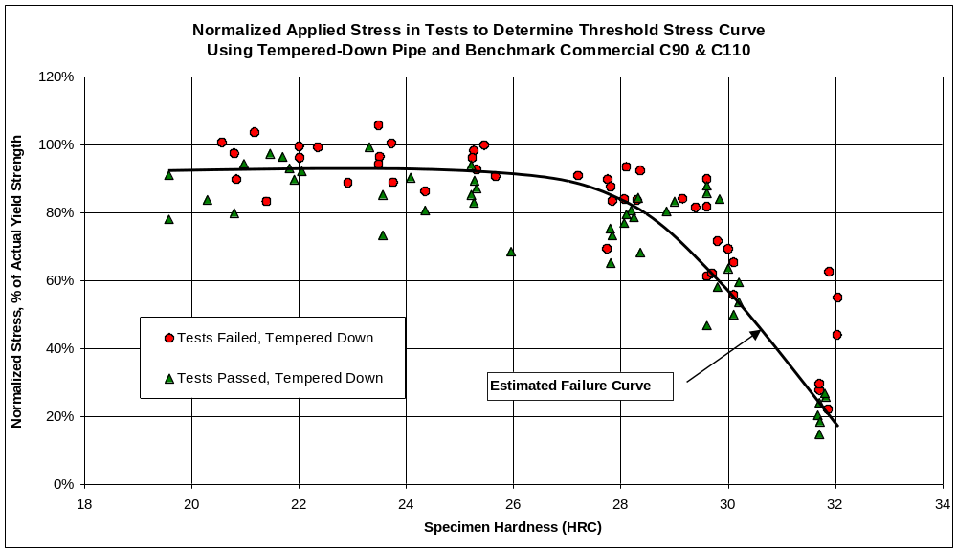
Figure 10: Example of a sour threshold determined from crack initiation studies using smooth tensile NACE A specimens.¹⁴

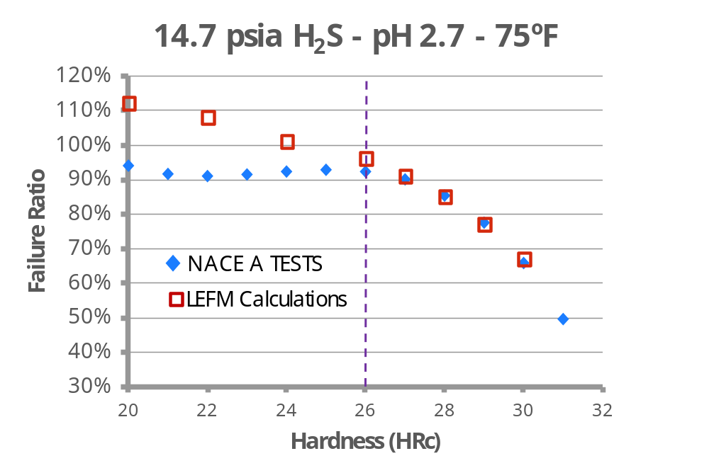
Figure 11: Comparison of crack initiation curve from NACE A tests and predicted failure ratio (load to failure/actual yield strength) calculated using LEFM for a saturated solution.¹⁵

- The application of these results to other, more corrosion resistant alloys where other corrosion mechanisms may dominate is not supported by these tests. Corrosion resistant materials more-often fail by environmental stress cracking; and no data are presented validating that fugacity governs in such a case.

Potential ISO/TC67 work on ISO 15156

If, as identified by this work, fugacity is a controlling parameter for SSC, then the partial pressure calculations in ISO 15156, part 2, Annex C, should be revisited. Specifically, the calculations in Section C2 should be re-assessed, as they may in some circumstances provide results of a non-conservative nature, e.g., indicating sweet conditions when sour conditions may in fact prevail. There are also corresponding concerns regarding identification of equivalent test exposures for the fit for purpose qualification of materials, where non-conservative test parameter selection could occur.
It is advised that joint industry work be initiated to address the limitations identified, and to further conclusively delineate if the governing parameter at high pressure is fugacity or solubility. A concern is that achieving a better physical model simulation may effectively eliminate a design factor benefit where previously a simulation of partial pressure effectively produced a more conservative test condition versus future use of e.g., fugacity. This aspect needs discussion. Nevertheless, studies to further better assess the governing parameter are suggested and a number of laboratory approaches are possible. To accentuate differences between fugacity and concentration sour material performance, or to identify mixed regime effects, the following test options are briefly noted:
- Perform continuous purge tests, as herein, at higher pressure. A review of Figure I indicates that as total pressure continues to increase, the relative difference between fugacity and concentration will also increase. The tests conducted herein were at ~345 bara, when the relative ratio of f_{H2S}/P_{H2S}:x_{H2S}/P_{H2S} is 1.6 to 1. At higher total pressures this ratio increases, e.g. the same ratio at 700 bara (10,150 psia) is 2.5 to 1 and at 1000 bara (14,500 psia) the ratio is 3.8 to 1. The 1000 bar test would produce relative differences between f_{H2S} and x_{H2S} that correspond to the relative differences very apparent between P_{H2S} and f_{H2S} (or x_{H2S}) observed in these tests. Further tests as noted in this study, at higher P_{H2S}, would also be of statistical benefit.
- The same concentration of dissolved gas in a solution will exhibit a fugacity that increases as total pressure increases. For example, given a starter solution containing H₂S at a given pH at low pressure, tests may be performed in which specimens are exposed to the same solution at a range of hydrostatic pressures. The total pressure increase will impact the fugacity, while having no impact on the concentration. The total pressure change required to change the fugacity significantly is high (the fugacity of a 25°C, 100 ppm H₂S solution at 1000 bar total pressure versus at 2 bar total pressure is a factor of about 3.85). Operational issues are also present. Avoiding hydrostatic control valve pressure surges suggest that the high pressure injection should be through a control or backpressure valve into an autoclave at nearly the same high pressure (See Figure 12). To maintain constant pH it is suggested that the buffering compounds chosen to regulate pH not be similarly impacted by the total pressure change (e.g., not CO₂).
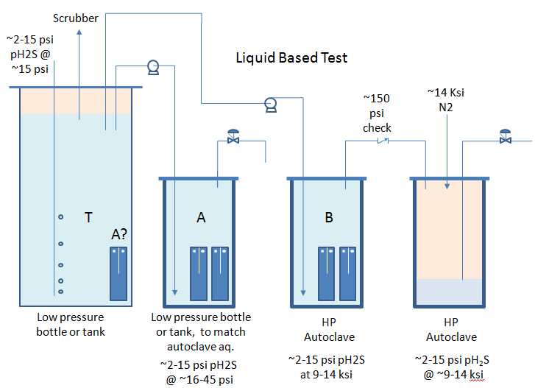
Figure 12: Example of a liquid based test setup.
- The same concentration of solution will be seen as two different concentrations at two different mass transfer velocities, while the same velocity will have minimal impact on the solution fugacity. This observation is based upon the fact that if the governing parameter is concentration, then it is not the concentration of H₂S in the bulk solution which will govern the rate of reaction and H⁺ production, but the reduced concentration of H₂S in the laminar boundary layer adjacent to the metal surface, analogous to current models that predict the rate of CO₂ corrosion.^{16,17}
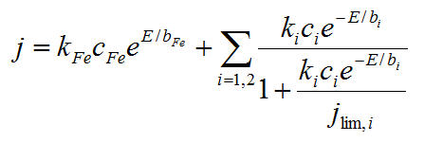
Figure 13: Mixed potential theory where j_{lim,i} is the limiting corrosion current/rate from species transport and reactions in boundary layers. See ref 18 for details.
Certainly other approaches to differentiate between governance by fugacity or concentration of both will exist. However, it is suggested that the over 30 years of experience used to assess the controlling parameters for CO₂ corrosion be considered (in 1975 reports¹⁹ suggested that only pCO₂ and temperature need be considered) and that options that will limit other influencing variables be addressed in any industry test program.

CONCLUSIONS

- Fugacity is a more appropriate parameter than partial pressure of H₂S in controlling SSC crack propagation.
- The use of the H₂S partial pressure at the bubble point may not be conservative when assessing the risk of SSC at pressures above the bubblepoint.
- In the absence of data, the fugacity of the H₂S in the reservoir fluid can sometimes be estimated from the reservoir bottom hole temperature.

ACKNOWLEDGEMENTS

The authors gratefully acknowledge the Shell Oil Company for permission to present this work. Special gratitude is also extended to Scott Lester of Shell Exploration & Production Company for mentoring this effort.

REFERENCES

- ISO/NACE International, ISO 15156/NACE MR0175-2009 Standard "Petroleum and natural gas industries - Materials for use in H2S-containing environments in oil and gas production", NACE International, Houston, 2009.

- Jocelyn L. Nelson and Ramani V. Reddy, “Selecting Representative Laboratory Test Conditions for Fit-For-Purpose OCTG Material Evaluations”, Society of Petroleum Eng., SPE 97576, 2005.

- W.D. Grimes, B.P. Miglin, R.N. French, and A.T. Coleman, “Physical Chemistry Tests of Hydrogen Sulfide Gas and SCC Results at Near-Ambient and Elevated Pressures”, European Federation of Corrosion, Manuscript #1587, 2013.

- NACE International Test Method TM0177-2005, “Laboratory Testing of Metals for Resistance to Sulfide Stress Cracking and Stress Corrosion Cracking in H2S Environments”, NACE International, 2005.
- ISO 11960/API 5CT (2011), “Petroleum and natural gas industries —Steel pipes for use as casing or tubing for wells” (Geneva, Switzerland: ISO or Washington DC, USA:API ).

- W.D. Grimes and R.I. McNeil, “Prediction of Hydrogen Sulfide and Carbon Dioxide in HPHT Wells”, SPE paper 97568 presented at the 2005 SPE HPHT Advanced Technology Symposium held in the Woodlands, TX USA, May 17-19, 2005.

- P. Aagaard, J. S. Jahren and S. N. Ehrenberg, “H2S-controlling reactions in clastic hydrocarbon reservoirs from the Norwegian Shelf and US Gulf Coast“, in Water-Rock Interaction 2001, Cidu (ed.) Swets & Zeitlinger, 2001.

- O. Kunz and W. Wagner, “The GERG-2008 Wide-Range Equation of State for Natural Gases and Other Mixtures: An Expansion of GERG-2004”, J. of Chem. Eng. Data, Vol. 57, 3032-3091, 2012.

- E.W. Lemmon, M.L. Huber, and M.O. McLinden, NIST Standard Reference Database 23: Reference Fluid Thermodynamic and Transport Properties-REFPROP, Version 9.1, National Institute of Standards and Technology, Standard Reference Data Program, Gaithersburg, 2013.

- J. M. Prausnitz, R.N. Lichtenthaler, E. G. de Azevedo, “Fugacities in Gas Mixtures” Chapter 5 in “Molecular Thermodynamics of Fluid-Phase Equilibria” 3rd edition, Prentice Hall, 1999.

- H.H. Reamer, B.H. Sage, and W.N. Lacey, Ind.Eng.Chem., 43(4), 976-981, 1951.

- E.P. Cernocky and W.D. Grimes, “Recommended Use of Three Separate Stress Formulas for the Design of Low Alloy Carbon Steel Tubing and Production Casing for Sour HPHT Wells”, Society of Petroleum Eng., SPE 97572, 2005.

- E.P. Cernocky, D.L. Sponseller, and T.E. Sponseller,” Unconventional Applications of NACE Method A Tests to Investigate and Characterize Fundamental Aspects of Low Alloy Steel in H2S Environments” NACE International, Corrosion 2006, Paper 06129, 2006.

- W.D. Grimes, M.A. Gonzalez and B. Yang, “Sour Well Design-Three Sour Material Design Limitations, Including Test Data Verification”, ADIPEC 2013 Technical Conf, Paper 735, 2013.

- C. De Waard, U. Lotz, “Prediction of CO2 Corrosion of carbon Steel”, NACE International, Corrosion 1993, Paper 069, 1993.

- B.F.M. Pots, “Mechanistic models for the prediction of CO2 corrosion rates under multi-phase flow conditions”, NACE International, Corrosion 1995, Paper 137, 1995.

- B.F.M. Pots, R.C. John, I.J. Rippon, M.J.J. Simon Thomas, S.D. Kapusta, M.M Girgis, and T. Whitham, “Improvements on de Waard-Milliams Corrosion Prediction and Applications to Corrosion Management”, NACE International, Corrosion 2002, Paper 02235, 2002.

- C. De Waard, and D.E. Milliams, “Carbonic acid corrosion of steel”, NACE Corrosion, Vol. 31, 177-181, 1975.

National Institute of Science and Technology, Washington, DC
Pressure for fH₂S calculated using proprietary cubic equation of state .
Bubble point pressure and pH₂S at the bubble point as function of temperature calculated using a proprietary cubic equation of state

