Oxy-Combustion Coal Based Power Plants: Study of Operating Pressure, Oxygen Purity and Downstream Purification Parameters
Rengarajan Soundararajan*ª, Truls Gundersenª, Mario Ditaranto^{b}
ªDepartment of Energy and Process Engineering, Norwegian University of Science and Technology, Trondheim, Norway.
^{b}SINTEF Energy Research, N-7465; Trondheim, Norway
*rengarajan.soundararajan@ntnu.no
Oxy-combustion coal based power plants are considered one of the cost effective ways to produce CO₂ emission free (captures at least 90 % of the CO₂ produced) electricity. Recovery of compression heat and the latent heat from the flue gases can further improve the efficiency of such power plants. Power plants that employ a boiler operating at a pressure higher than ambient pressure avoid air leakage into the boiler and also recover more of the latent heat available in the flue gases. Such power plants require compression of the oxygen stream before the combustor, an entirely new boiler house design and modifications to the downstream flue gas processing systems. Selection of an operating pressure that is energy optimal is the key to design of such systems. Besides the operating pressure, the oxygen purity and the downstream separation parameters have a considerable impact on the overall performance of such power plants. In this paper, the impact of operating pressure, oxygen purity and downstream purification parameters on the performance of oxy-combustion coal based power plants are studied.

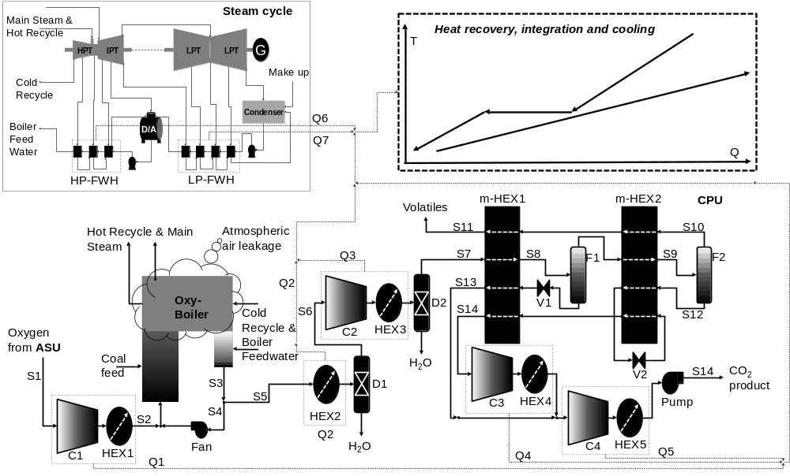
Scope
The main focus of this work is to identify near optimal values in terms of thermal efficiency for the boiler operating pressure (pressure at S2 in the figure), the oxygen purity (at S1), and CPU operating parameters such as the pre-compression pressure (pressure at S7 in the figure) and the temperature at S8. Issues related to the investment cost and operating economics are beyond the scope of this work.
Results
Adiabatic compression of the oxygen stream from the ASU (S1) to 16 bars is found to be near optimal for the overall performance of the system. Alternatively, isothermal compression using multiple stages and intercooling can be used to achieve similar efficiency values. In case of isothermal compression, preheating of the compressed oxygen is required to achieve the best efficiency. Owing to the simplicity, adiabatic compression of the oxygen is recommended as the best option. The temperature at S8 is found to have very minimal impact on the overall performance of the system. The impact of oxygen purity and pre-compression pressure is shown in the figures below.
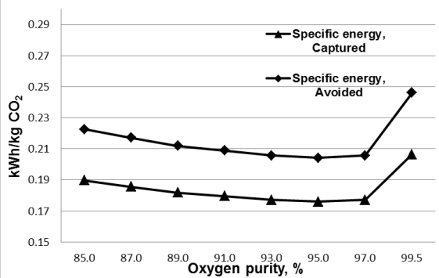  (a) | 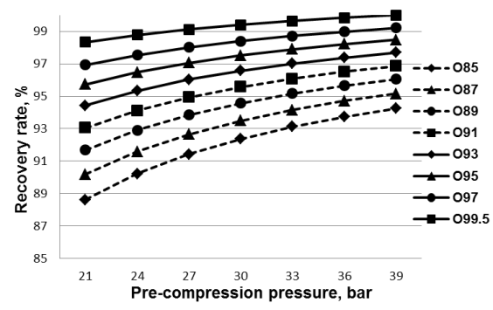  (b)
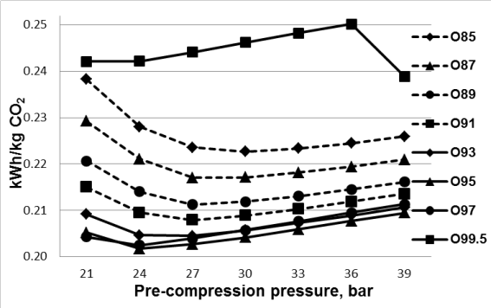  (c) | 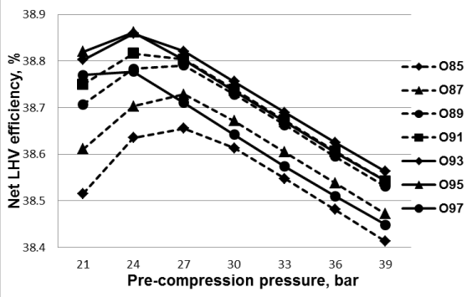  (d)
Conclusion
The baseline power plant without CO₂ capture has a net LHV efficiency of 44.7 % and the baseline oxy-combustion power plant with capture has a net LHV efficiency of 37.9 %. The low energy penalty (6.8 % points) of the capture plant is due to flue gas heat recovery and CPU heat integration. Increasing the boiler operating pressure to 16 bars recovers the flue gas latent heat and the compression heat thereby resulting in a net LHV efficiency of 38.7 %. A study of the impact of oxygen purity and CPU operating parameters provides a near optimal combination of these parameters (~97 % oxygen purity and 24 bars pre-compression pressure) resulting in a final net LHV efficiency of 38.9 %.
Acknowledgment This publication has been produced with support from the BIGCCS Centre, performed under the Norwegian research program Centres for Environment-friendly Energy Research (FME). The authors acknowledge the following partners for their contributions: ConocoPhillips, Gassco, Shell, Statoil, TOTAL, GDF SUEZ and the Research Council of Norway (193816/S60). The authors wish to thank Chao Fu (Norwegian University of Science and Technology) for providing the ASU energy consumption values.

