Membrane technology in co2 removal
Next to its environmental impact, CO2 reduces the heating value of natural gas (mainly CH4) in power plants and due to its acidic character, the presence of CO2 can lead to corrosion in equipment and pipelines. This makes the removal of Co2 from natural gas of crucial importance.
Traditional methods used to separate CO2 from gas mixtures are pressure swing adsorption, cryogenic distillation and the most frequently used method is amine absorption; also, membrane processes are frequently used for gas separation.
Energy requirements on the other hand significantly benefit the use of membrane technology over other technologies: membrane technology uses 70-75 kWh per ton of recovered CO2 compared to significantly higher values for pressure swing adsorption (160-180 kWh), cryogenic distillation (600-800 kWh) or amine absorption (330-340 kWh), making membrane technology an attractive alternative.

Fundamentals
Certain gases permeate or pass through the membrane more easily than others. This allows the more rapidly permeating “fast” components to be collected in one stream and the slower permeating “slow” components to be collected in a second stream. In natural gas treating, CO2, hydrogen, helium, H2S, and water vapor are highly permeable gases, sometimes characterized as “fast” gas molecules that permeate to a greater extent across the membrane to the lower pressure side than do the “slower” gases (i.e., hydrocarbons).
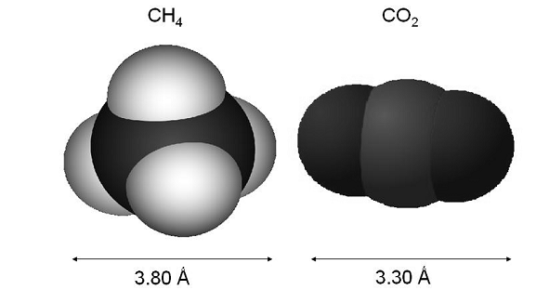
The driving force for permeation is the difference in partial pressure of a given component between the feed “high pressure” side and the permeate “low pressure” side of the membrane. The greater the partial-pressure difference, the greater the driving force.

The classical thermodynamics tells us nothing about the rate at which diffusion process takes place, but Fick’s law for solution-diffusion membranes in rectangular co-ordinates do
J_{i}=(S_{i}*D_{i}*P_{i})/l where,
J » the flux of component; (the molar flow of component I through the membrane per unit area of membrane.)
S » solubility term.
D » diffusion co-efficient.
∆P » partial pressure difference across the membrane.
The term Pi/L is membrane and operating conditions dependent.
∆P is process dependent.
S, D depends on temperature and pressure.
Selectivity α 1-2, the ratio of two permeabilities, P1/P2.
A selectivity α of 20 for co2/CH4 means that co2 moves through the membrane 20 times faster than does methane.

The permeability coefficient, K, is a function of both the “solubility” and the “diffusivity” of the gas in the polymer matrix. Several mathematical models are available that derive the permeability coefficients.
Next to the permeability, the main factor to describe the performance of a membrane is its separation ability, called the selectivity α. The ideal selectivity using pure gases is given by the ratio of the permeability coefficients (Pi), which is, when assuming solution-diffusion to occur, composed of a diffusivity selectivity term (DCO2/DCH4) and a solubility selectivity term (SCO2/SCH4):
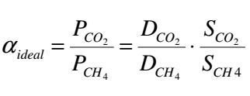
For gas mixtures, the feed composition has to be taken into account as well, and the membrane selectivity is expressed as:
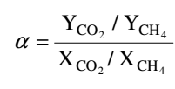
Where Yi is the concentration of component (i) in the permeate stream and Xi is the concentration of component (i) in the feed.
Selectivity refers to the ratio of the permeation rates of a fast gas (CO2) and a slow gas (methane or other hydrocarbon). The selectivity of CO2 to methane determines the efficiency of the separation and the methane recovery.
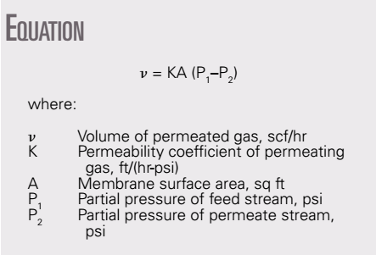

Membrane structure
Membranes can be used to separate other gaseous components such as H2S, N2, He, and water vapor from non-associated or associated gas stream under a partial pressure differential.
Typical membrane used | Category  preferred polymer material | Component to be permeated
Cellulose acetate, polyimide | Glass | Co2
Cellulose acetate, ether-amide block  Copolymer | Glass and rubber | H2s
Polyimide, perfluor polymers | Glass | N2
Many | Glass and rubber | Water vapor

The table shows typical membrane materials that can be used to separate the impurities from natural gas.
Membrane uses include dehydration, fuel gas conditioning and bulk co2 removal which is the most important application. The membrane market share is about 2%, essentially all for CO2 removal. This fraction will likely increase because other applications of membranes in the natural gas processing industry are under development.
Many different types of membranes have been developed for industrial separation, but for CO2 removal, the industry standard is presently cellulose acetate.
Membrane composition
A thin layer (0.1-0.5) ή m of cellulose acetate is on top of a thicker layer of a porous support material. Permeate compounds dissolve into the membrane, diffuse across it, then travel through the inactive support material. The membranes are thin to maximize mass transfer, minimize surface area and cost. The support layer is necessary to support the needed mechanical strength.
Commercial membrane configurations are either hollow fiber elements or flat sheets wrapped into spirally wound elements.
Spiral wound membrane structure

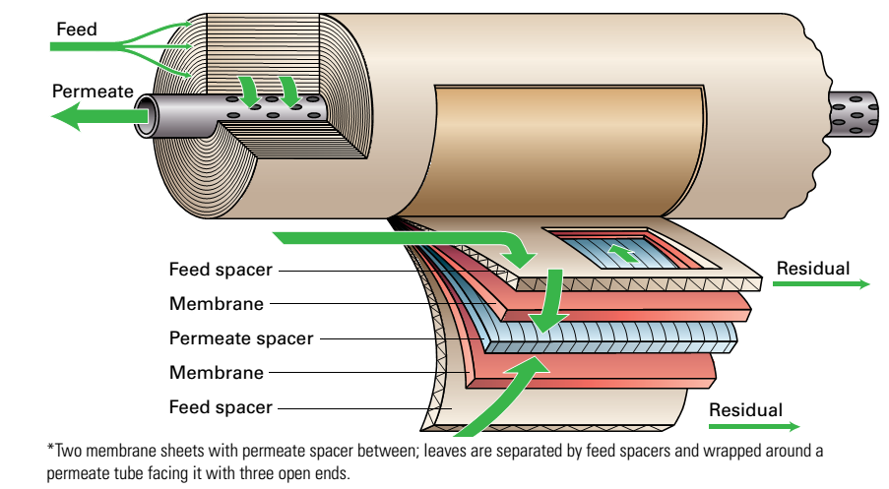

A membrane sheet has two layers: a relatively thick microporous layer that is in contact with the cloth support, and a thin active layer on top of the microporous layer.
The membrane sheets are separated by a permeate spacer and glued shut at three ends to form an envelope or leaf. Many of these leaves, separated by feed spacer are wrapped around the permeate tube, with the open end of the leaves facing the tube.
Feed gas travels along the feed spacer, the permeating species diffuse through the membrane and down the permeate spacer into the permeate tube, the residue gas exits at the end and the gas flow is cross flow. The spiral configuration is inherently more resistant than the hollow fiber membranes to trace components that would alter the polymer permeability. It also allows a wider range of membrane material to be used. The hollow fiber membrane is cheaper than the spiral one.
Each membrane unit contains a pretreatment unit and membrane skids. Each pretreatment unit consists of a filter coalescer, a guard bed, and a particle filter. Each membrane skid consists of membrane tubes containing membrane elements

