Priyanka Padmanabhan¹*, Ankit Kumar²

¹A 301, Siesta Dwelling, Thaltej, Ahmedabad, 380059 , India
11bch054@nirmauni.ac.in

²602, Antique Tower, Morbi, 363641, India
11bch047@nirmauni.ac.in

Introduction

DESIGN OF PHOTOREACTOR FOR THE TREATMENT OF SYNTHETIC WASTEWATER
Across the world, one major topic among the educated society is the non-conventional energy sources, and more specifically the optimization of this aspect to practical usage. Solar energy has been at the vortex of this topic as its availability is abundant and relatively easy to access in comparison with the other sources of energy.
“Being continually replenished by nature, solar energy is an energy source that cannot be depleted. Assuming 100% absorption of solar radiation, it would only require 88 minutes of solar radiation to cover for humanity’s total energy consumption for a year”. Our sun provides an immense amount of potential energy to our world, but it needs to be harnessed and transformed to be used [1].

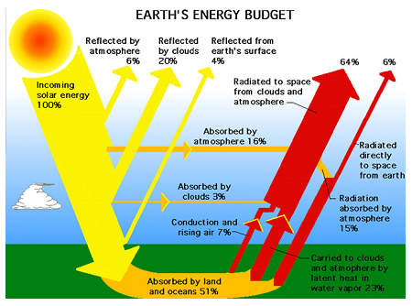
Figure 1: The Earth’s Energy Budget [2]

Across the world, there continues to be huge volumes of wastewater pumped directly into rivers, streams and the ocean itself. The impact of this is severe, aside from the damage to the marine environment and to fisheries it can

cause, it does little to preserve water at a time when many are predicting that a global shortage is just around the corner.

Objective
The objective is to develop an effective reactor for the treatment of synthetic wastewater generated by various industries. The aim is to design a reactor that degrades the contaminants using the natural solar radiations only. The possible designs have been proposed later in the document keeping in mind the feasibility and economics of the system.

Features required of the effective reactor
The following are the features required in the photoreactor to be designed:-
- Maximum contact between light, catalyst, waste water and air
The reactor design should be such that the contact between the photons, wastewater, catalyst and oxygen should be maximum to increase the efficiency of the process. This requires the development of a thin layer of the process stream in the reactor that will come in contact with the photons for the reaction.

- Maximum turbulence in the system
The process stream should be under considerable velocity in the reactor for a good rate of reaction. This can be achieved by incorporating obstructions in the path of the fluid.

- Providing a residence time of about 10-15 minutes with/without recycling
The reaction mechanism is such that it requires about 10-15 minutes to complete the reaction. This amount of time has to be given to the stream to come into contact with the photons. This can be done by providing a recycle tear in the system.

- Increase in temperature is not the objective
The objective of the reactor is not to increase the temperature but to obtain the maximum optical efficiency. So, the reactor design will be based on the non-concentrating solar collectors.

- Effective regeneration and recycling of the process fluids should be attained
The catalyst would be of nano size and thus, costly. The regeneration of the catalyst is thus an important factor in the process. Moreover, effective recycling should be done for the completion of the reaction.

Our Proposed Designs
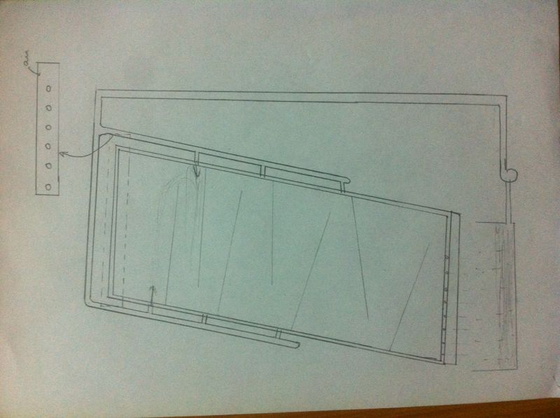
Figure 2: Proposed Design 1

Water and catalyst mixture is pumped into tubes placed along the side of an inclined plate. These tubes have holes in them at different heights that will introduce the fluid into the plate. The plate has slab-like obstructions placed at an increasing height difference with a tilt. Each slab will have a turbulator placed in it and the whole plate is placed inside a casing. The fluid that enters the plate will encounter the obstruction, thus, increasing the turbulence. This fluid flows along the length of the plate where new fluid is introduced along the length. This makes sure of intermixing of the fluid and the concentration gradient is always present as a favorable condition for the reaction. The treated fluid is then collected and recycled till all of the feed is treated. The casing of the plate is left open on the top to allow air to enter.

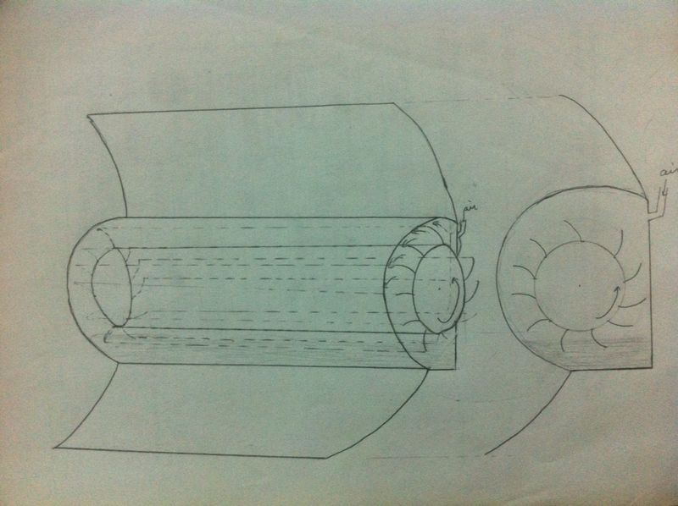
Figure 3: Proposed Design 2

A hollow cylinder is attached to a parabolic mirror. Here, the curved surface area of the cylinder is greater than the aperture of the mirror. This makes sure that all the light that hits the mirror falls on the surface of the cylinder. Inside the hollow of the cylinder, a rotating cylinder with spatulas attached to it is placed. A pool of liquid is maintained inside. The rotating cylinder inside would collect the water and throw it onto the inner surface of the fixed cylinder. This creates a thin film of water and creates the reaction environment. The rotation is left to be done until all the fluid in the pool is reacted.

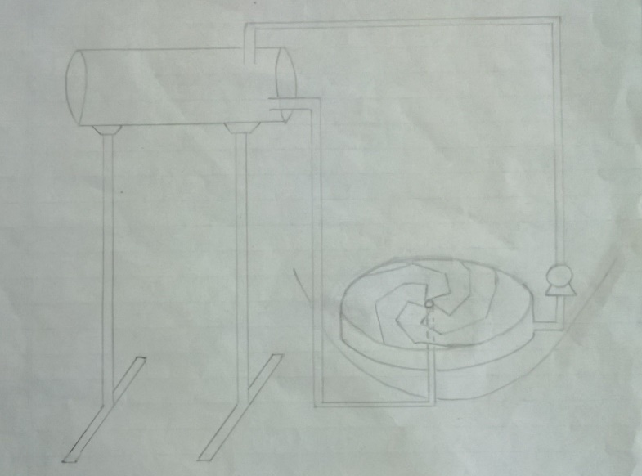
Figure 4: Proposed Design 3

The wastewater and catalyst mixture is stored in an overhead tank. The stream due to the head will flow into the disk vane through the centre. A rotor rotates this vane that will project the incoming fluid radially. This divided the stream into thin ones. These divided streams will hit the obstructions in the reactor thus, increasing the turbulence and the residence time. The material of construction would be of a transparent material and a parabolic mirror would be placed under the vane to project light. The reacted stream then falls into the casing and recycled back into the process until the feed is fully treated.

References
[1]http://www.renewablegreenenergypower.com/ solar-energy-pros-and-cons/, 12.08.2014, 22:03

[2]http://www.nasa.gov/images/content/57911 main_Earth_Energy_Budget.jpg/, 10.08.2014, 22:23

