Exploiting Absolute Negative Mobility with Dielectrophoresis for Mitochondrial Sample Preparation
Jinghui Luo,¹ Alexandra Ros¹
¹Department of Chemistry and Biochemistry, Arizona State University, Tempe, AZ 85287.
The study of mitochondria is important due to the organelle’s contribution to many cellular functions, including metabolism, cellular signaling and apoptosis. The atypically sized giant mitochondria¹ were found in the models of aging and some diseases. Thus it would be advantageous for related studies if mitochondrial subpopulations could be prepared in accordance with their particular sizes. Conventional methods such as centrifugation and electrophoresis can separate mitochondria from cell cytoplasm and further purify them from other organelles. However, the separation of mitochondrial subpopulations has rarely been studied. Here, we present the numerical simulation with the design of a microfluidic device to elucidate absolute negative mobility (ANM) utilizing insulator-based dielectrophoresis (iDEP) for the separation of mitochondrial subpopulations.
ANM has recently been proposed as a separation mechanism for micron-sized particles². It is the motion of a particle into the direction opposite to a net applied force³, which can be realized when Brownian particles migrate in a non-linear structure under non-equilibrium conditions. For instance, when particles migrate with flow (y direction in Figure 1a) in an ANM structure, they could be trapped by adjacent posts which form a gap smaller than their diameter. On the other hand, probability exists that they can also avoid the trap due to their diffusion in the direction perpendicular to the flow. This probability for a Brownian particle - being trapped or avoiding a trap - relates to the diffusion property of the particle, i.e. its size. Therefore, under non-equilibrium conditions particles within a certain size range may move towards the direction of a net force while other particles may move in the opposite direction and consequently, separation based on ANM may be realized. The design of the ANM structure has been studied previously both in theory with the variation of geometric post shapes and in experiment with micron-sized colloidal particles in a microfluidic device⁴. However, this approach is not transferrable to evoke ANM for the separation of mitochondrial subpopulations with typical sub-micron sizes (0.1 – 1 µm)¹. Thus, we additionally exploit the dielectrophoretic properties of this important organelle in tailored microdevices in order to generate ANM. DEP is a migration phenomenon based on the polarization property of a particle in an inhomogeneous electric field. This property has been used to separate, concentrate or distinguish many biological species, including cells, tissue, proteins, bacteria and DNA⁵. Our previous studies⁶ revealed that isolated Fischer 344 rat semimembranosus muscle mitochondria and C57BL/6 mouse hepatic mitochondria exhibited negative DEP (nDEP) under both DC (0 – 3000 V/cm) and AC (0 – 2000 V/cm, 0 – 50 kHz) conditions in low conductivity buffer in physiological pH. In addition, the potential thresholds for trapping the mitochondrial samples were weakly depended on the applied frequencies. Based on that, a structure modified to suit the small size exploiting the nDEP property of mitochondria was designed (Figure 1b).
First, the migration properties of particles exhibiting nDEP were studied in numerical simulation using COMSOL Multiphysics 4.4. Properties of micron and sub-micron polystyrene beads were used to mimic the mitochondrial subpopulations. Non-equilibrium conditions were realized by an alternating electric field, which was tunable by combining the static study result of the Electric Currents module with a rectangle and an analytic function. This was further coupled with the time-dependent study using the Creeping Flow module, resulting in an alternating flow profile, which was further integrated with DEP and Brownian forces in the time-dependent study of the Particle Tracing for Fluid Flow module. The resultant particle trajectory allowed for the investigation of the conditions such as the applied potential and the dimensions of the posts and the gaps needed for realizing ANM for the separation of micron- and sub-micron sized particles and thus accessing a regime suitable for mitochondrial subpopulations. We found that with certain conditions, ANM could be observed with particles of 5-µm diameter (Figure 1d) while 1-µm particles do not show ANM. This novel approach to induce differential ANM migration behavior for particles of varying sizes allows retaining simple photolithographic device fabrication strategies for experimental ANM applications with organelles, and similarly preserves the size selectivity for sub-micron bio-species.

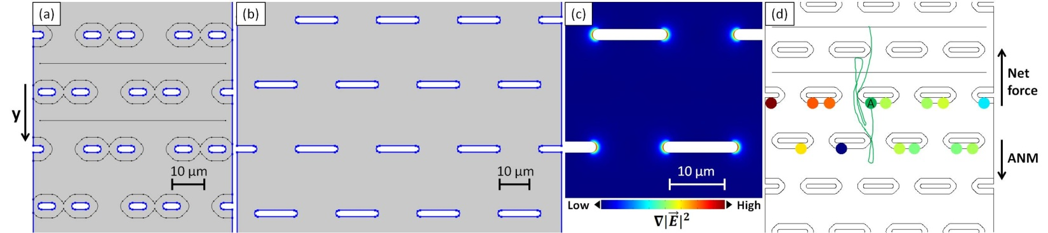

Figure 1: Schematics of the ANM devices. Electric potential was applied along the y-axis. The posts and the channel walls are outlined in blue, while the black lines in (a) indicate the virtual walls which are used to exclude particles from the post regions with a distance equal to or smaller than their radius. (a) The two black horizontal lines indicate the positions where particles are released in the simulation. Because the small gap is 5 µm wide, this exemplary structure is suitable for the ANM study of particles with diameter no smaller than 5 µm. (b) Alternative layout to couple a DEP component. This structure is suitable for the ANM study of mitochondria of which the typical size range is from 0.1 µm to up to 1 µm¹. (c) Zoom-in of (b) showing the electric field gradient distribution around the posts. If there is flow in the y direction, a particle exhibiting nDEP will be pushed towards and trapped in the center of a post similarly to a geometrical trap as shown in (a). (d) ANM behavior simulated with particles of 5 µm diameter in two consecutive time periods of the applied frequency. Particles started at the two horizontal lines and migrated with flow in the y direction. The trajectory of particle A was labeled in the figure demonstrating ANM.
References
1. M. Navratil, A. Terman, and E. A. Arriaga, Exp. Cell Res. 314, 164 (2008).
2. A. Ros, R. Eichhorn, J. Regtmeier, T. Duong, P. Reimann, and D. Anselmetti, Nature 436, 928 (2005).
3. R. Eichhorn and P. Reimann, Acta Physica Polonica B 37, 1491 (2006).
4. J. Regtmeier, S. Grauwin, R. Eichhorn, P. Reimann, D. Anselmetti, and A. Ros, Journal of Separation Science 30, 1461 (2007).
5. T. Z. Jubery, S. K. Srivastava, and P. Dutta, Electrophoresis 35, 691 (2014).
6. J. Luo, B. G. Abdallah, G. G. Wolken, E. A. Arriaga, and A. Ros, Biomicrofluidics 8, 021801 (2014).

