Highly permeable peptide-appended pillar[5]arene artificial water channel in block copolymer membranes

Yue-xiao Shen, Tingwei Ren, Daniel Tsai, Ian T. Sines, Manish Kumar*
Department of Chemical Engineering, Pennsylvania State University, University Park, PA, 16802, USA
*Corresponding author: 155 Fenske Laboratory, Pennsylvania State University, University Park, PA, 16802, USA, (814) 865-7519, manish.kumar@psu.edu

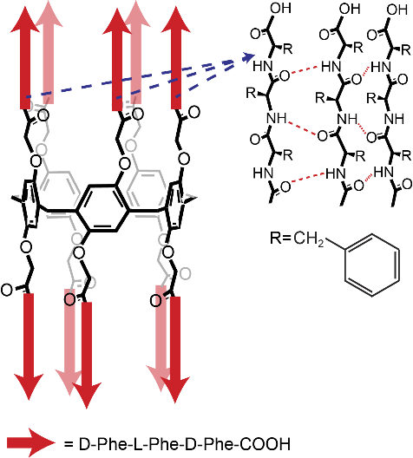
We have reported that peptide-appended pillar[5]arene (PAP) artificial water channels (Fig. 1) combine the advantages of biological water channels Aquaporins (AQPs) and carbon nanotubes (CNTs).¹ It can be synthesized using simple chemistry at gram scale in the lab and provide stable structure and good solvent compatibility. The water conductance of PAP is in the range of AQPs. It can also be vertically aligned in lipid membranes, with much higher packing density than current synthetic CNTs-based membranes.
Fig. 1 Structure of the peptide-appended pillar[5]arene (PAP) channel.
Although the initial testing of the PAP channels was conducted in lipid systems, this is not an ideal format for commercial separation materials. We continue to investigate the functionality of these channels in block copolymer (BCP) membranes. BCPs, with lipid-like structures, are most commonly synthesized for biomimetic applications because of the advantages of BCPs membranes including high mechanical and chemical stability,^{2,3} low water and gas permeability⁴ and customizable properties (e.g., a larger range of membrane thickness² and end groups⁵). We are testing a series of poly(butadiene)-b-poly(ethylene oxide) (PB-PEO) diblock copolymers and polymethyloxazoline-polydimethylsiloxane (PMOXA-PDMS-PMOXA) triblock copolymers. These two kinds of BCPs have different hydrophobicities and thicknesses, and been shown to functionally incorporate water channel proteins aquaporin 0,⁶ potassium channel⁷ and α-hemolysin.⁸
We incorporated fluorescently labeled channels into polymersomes using the film rehydration method. The number of channels per vesicle was measured based on a fluorescence correlation spectroscopy (FCS) technique.⁹ We combined the channel number data and permeability data using stopped-flow light scattering technique (Fig. 2B) and obtained the single channel water permeability in PB₂₃-PEO₁₆ vesicles (1.4±0.4×10⁸ H₂O molecules per second). This value is close to that in lipid system (3.5±1.0×10⁸ H₂O molecules per second, Fig. 2C).¹
In the future, we will systematically test the PAP channels in different BCPs systems, visually confirm the incorporation in giant unilamellar vesicles and discuss the interaction of different BCPs and the PAP channels. We will also plan to use fluorescence recovery after photobleaching (FRAP) technique to determine the diffusion coefficient of the PAP channels in lipid and BCPs bilayers and expect these results can provide insights into to maximizing the channel’s packing density in BCP membranes.

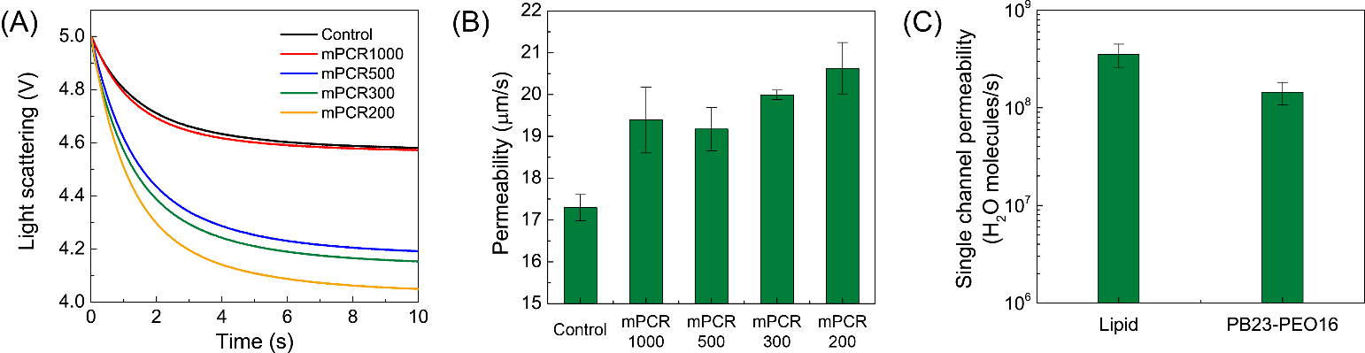
Reference
Fig. 2 Functional analysis of peptide-appended pillar[5]arene (PAP) artificial water channel in block copolymer vesicles. (A) The light scattering traces of PB₂₃-PEO₁₆ polymersomes with different molar polymer-to-channel ratio (mPCR) after a rapid exposure to a hypotonic solution (−100 mM PEG600) on a stopped-flow instrument. We normalized all the traces to the same PMT value. (B) The water permeability of PB₂₃-PEO₁₆ polymersomes with different mPCRs. (C) Single-channel water permeability of the PAP channel in lipid and block copolymer systems. The value in lipid vesicles was obtained from previous PNAS paper and the value in polymer system was calculated from the vesicles formed at an mPCR of 200 (Figure 2B) and fluorescence correlation spectroscopy (FCS) data. Data shown are the average of triplicates with error bars representing standard deviation.
1 Shen, Y.-x. et al. Highly permeable artificial water channels that can self-assemble into two-dimensional arrays. Proc. Natl. Acad. Sci. U.S.A. 112, 9810-9815, (2015).
2 Discher, D. E. & Eisenberg, A. Polymer Vesicles. Science 297, 967-973, (2002).
3 Discher, B. M. et al. Polymersomes: Tough Vesicles Made from Diblock Copolymers. Science 284, 1143-1146, (1999).
4 Kumar, M. et al. Highly permeable polymeric membranes based on the incorporation of the functional water channel protein Aquaporin Z. Proc. Natl. Acad. Sci. U.S.A. 104, 20719-20724, (2007).
5 Rakhmatullina, E. & Meier, W. Solid-Supported Block Copolymer Membranes through Interfacial Adsorption of Charged Block Copolymer Vesicles. Langmuir 24, 6254-6261, (2008).
6 Kumar, M. et al. High-Density Reconstitution of Functional Water Channels into Vesicular and Planar Block Copolymer Membranes. J. Am. Chem. Soc. 134, 18631-18637, (2012).
7 Kowal, J. Ł. et al. Functional surface engineering by nucleotide-modulated potassium channel insertion into polymer membranes attached to solid supports. Biomaterials 35, 7286-7294, (2014).
8 Zhang, X. et al. Natural channel protein inserts and functions in a completely artificial, solid-supported bilayer membrane. Sci. Rep. 3, (2013).
9 Erbakan, M. et al. Molecular Cloning, Overexpression and Characterization of a Novel Water Channel Protein from Rhodobacter sphaeroides. PLoS ONE 9, e86830, (2014).

