ZIF-67 filled PDMS Mixed Matrix Membranes for comprising of recovery of bio ethanol via Pervaporation

Amin Khan.¹, Asim Laeeq Khan¹
¹Chemical Engineering Department. COMSATS Institute of Information Technology,
Defense road, off Raiwind road, Lahore Pakistan
*aminkhan@ciitlahore.edu.pk

ABSTRACT

Due to the drastic effects of global warming and concerns on energy scarcity, it has become necessary to explore and develop both energy-saving and environment friendly processes to meet the energy demands. It has been reported that separation alone currently contains about 60 to 80% of the process cost in most of the chemical processes. Several techniques (e.g. Distillation, Gas stripping and Molecular sieve adsorption) have been proposed for the effective and sustainable separation of alcohol/water mixtures but they all are very costly and high energy intensive due to the formation of azeotropic mixtures. Among these techniques, membranes provide a promising opportunity due to their several advantages such as low ecological footprint, high energy efficiency and low capital cost¹.
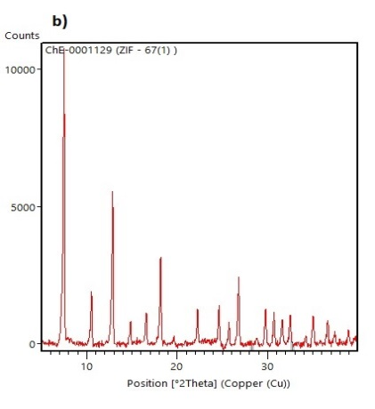
Zeolitic Imidazole Frameworks (ZIFs) are composed of metal ions linked by organic ligands and offer exceptionally high surface area and relatively high thermal stability². In this study, Mixed Matrix Membranes (MMM) were prepared by using PDMS as a hydrophobic polymer and ZIF-67 as a filler material. According to the best of our knowledge, this is the first study using this type of ZIF in MMM for any application. The synthesized membranes were tested in custom built pervaporation testing set-up for the measurement of separation factor and flux. The results showed that incorporation of ZIF-67 not only enhanced the flux but also helped in further improving the separation properties. The data of performance parameters and SEM images of the synthesized membranes suggest that the fillers adhered well to the polymer matrix. The ease of synthesis of these filler materials and improved performance make them attractive choice as filler in the MMMs for pervaporation applications. a) b)
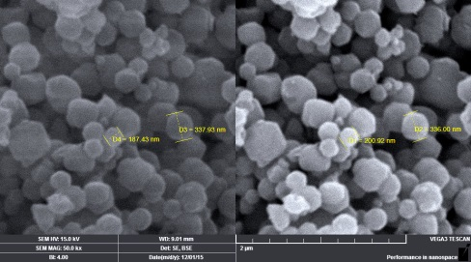

Fig. 1. a)SEM images of ZIF-67 particles b) XRD Pattern of ZIF-67 particles

Keywords: Pervaporation; Zeolitic Imidazole Framework; Mixed Matrix Membranes

BIOSKETCH


Amin Khan earned his Masters of Science in Chemical Engineering from COMSATS Lahore with majoring in membrane based separation. He obtained his BS Chemical Engineering from COMSASTS Lahore with majoring in petroleum refinery and polymer engineering. He is currently working as a faculty member at the department of Chemical Engineering, COMSATS Lahore. He is also the head of Membrane based separation Lab. His research interests include, membrane based separation, synthesis of green membranes, designing of testing setups of membranes.
Passport-sized
Photo

