Elevated Performance of Thin Film Nanocomposite Membranes Enabled by Modified Hydrophilic MOFs for Nanofiltration
Junyong Zhu,ª Bart Van der Bruggen^{a*}

ª Department of Chemical Engineering, KU Leuven, Celestijnenlaan 200F, B-3001 Leuven, Belgium

Metal-organic frameworks (MOFs) are studied for the design of advanced composite membranes because of their high surface area, regular and highly tunable pore structures, and superior polymer affinity. However, developing engineered MOF-based membranes for water treatment lags behind. In this study, thin-film nanocomposite (TFN) membranes containing poly(sodium 4-styrenesulfonate) (PSS) modified ZIF-8 (mZIF) in a polyamide (PA) layer were constructed via interfacial polymerization (IP). The modified hydrophilic mZIF nanoparticles were evenly dispersed into an aqueous solution comprising piperazine (PIP) monomers, followed by polymerizing with trimesoyl chloride (TMC) to form a composite PA film. FT-IR spectroscopy and XPS analyses confirm the presence of mZIF nanoparticles on the top layer of the membranes. SEM and AFM images evince a retiform morphology of the TFN-mZIF membrane surface, which is intimately linked to the hydrophilicity and adsorption capacity of mZIF nanoparticles. Furthermore, the effect of different ZIF-8 loadings on the overall membrane performance was studied. Introducing the hydrophilizing mZIF nanoparticles not only furnishes the PA layer with a better surface hydrophilicity and more negative charge but also more than doubles the original water permeability, while maintaining a high retention of Na2SO4. The ultrahigh retentions of reactive dyes (e.g., reactive black 5 and reactive blue 2, >99.0%) for mZIF-functionalized PA membranes ensure their superior nanofiltration performance. This facile, cost-effective strategy will provide a useful guideline to integrate with other modified hydrophilic MOFs to design nanofiltration for water treatment.
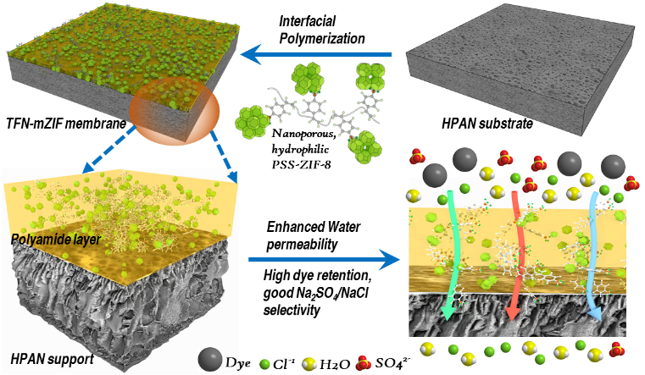
Graphical Abstract

