Cupric Phosphate Nanosheets-Wrapped Inorganic Membranes with Superhydrophilic and Outstanding Anti-Crude-Oil Fouling Property for Oil/Water Separation
Shenxiang Zhangª, Feng Zhang^{b}, Jian Jinª*
ª i-Lab,Suzhou Institute of Nano-Tech and Nano-Bionics, Chinese Academy of Sciences, Suzhou, 215123, China.
Abstract:
Developing an effective and sustainable solution for cleaning up or separating oily water is highly desired. In this work, we report a completely inorganic mesh membrane made up of cupric phosphate (Cu₃(PO₄)₂) in a special intersected nanosheets-constructed structure. Combing the hierarchical structure with strong hydration ability of Cu₃(PO₄)₂, the nanosheets-wrapped membrane exhibits a superior superhydrophilic and underwater anti-oil fouling and anti-bio fouling property for efficient oil/water separation to various viscous oils such as heavy diesel oil, light crude oil, and even heavy crude oil with underwater oil contact angles (CAs) all above 158° and nearly zero underwater oil adhesive force even when a large preload force up to 400 μN applied on the oil droplet. Simultaneously, the membrane exhibits a high chemical and thermal stability, outstanding salt tolerance. Continuous separation operated on a cross-flow filtration apparatus demonstrates a large separation capacity and long-term stability of the membrane during treating a 2000 L crude oil/water mixture with constantly stable permeating flux of ~4000 L/m² h and oil content in the filtrate below 2 ppm. The excellent anti-oil-fouling property, high separation capacity, and easily scaled-up preparation process of the membrane show great potential for practical application in treating oily wastewater.
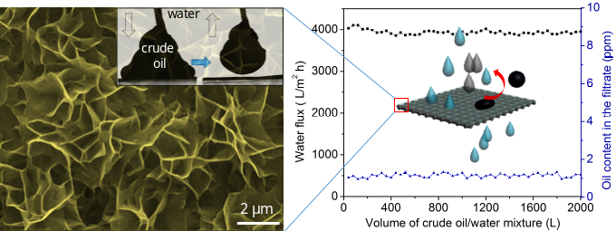

Keywords: crude oil/water separation · inorganic membrane · superhydrophilic/underwater superoleophobic property · cupric phosphate nanosheets · anti-crude-oil fouling

