Nanoporous Materials: Enabling the Translation From High Performance Polymers to High Performance Membranes

Stefan J.D. Smithª, Rujing Hou^{b}, Huanting Wang^{b}, Cher Hon Lau^{c}, Neil B. Mckeown^{c}, Kristina Konstasª and Matthew R Hill^{a,b}

ªCSIRO, Clayton, VIC Australia.
^{b}Department of Chemical Engineering, Monash University, Clayton VIC, Australia.
^{c}Department of Chemistry, University of Edinburgh, Scotland.

Abstract

Aging in super-glassy polymers such as poly(trimethylsilylpropyne) (PTMSP) prohibits it from being used in polymer membranes for separating gas mixtures. While these polymers are initially very porous and large amounts of gas can selectively pass through them, they quickly pack into a denser phase becoming much less porous and permeable. This age-old problem has been solved by the use of an ultraporous additive that allows PTMSP to maintain its low-density, porous initial state by absorbing a portion of the polymer chains within its pores, and holding them in position. This is the first time that this aging process has been stopped in PTMSP without diminishing its properties when prepared as a gas separation membrane. In fact, the membrane properties are enhanced with an additive, and over approximately one year of long-term measurements show that the performance is maintained.

The addition of a very specific porous microparticle forms an interwoven nanocomposite with PTMSP, freezing the structure and hence stopping the aging process, but doing so whilst increasing the permeability and maintaining the selectivity. Porous Aromatic Frameworks (PAFs) are carbon-based structures formed by the self-condensation of tetrahedral monomer nodes to establish an ultraporous array. The regular nanopores of around 1.2 nm diameter are attractive for the intercalation of polymer side-chain components when incorporated within the PTMSP matrix, thereby freezing the as-cast lower-density polymer structure in place and stopping the aging process. This mechanism is distinct from the enhanced permeability effect of non-porous nanoparticle and porous nanoparticle additions to PTMSP that prop open the polymer chains at the nanoparticle/polymer boundary but do not prevent aging.
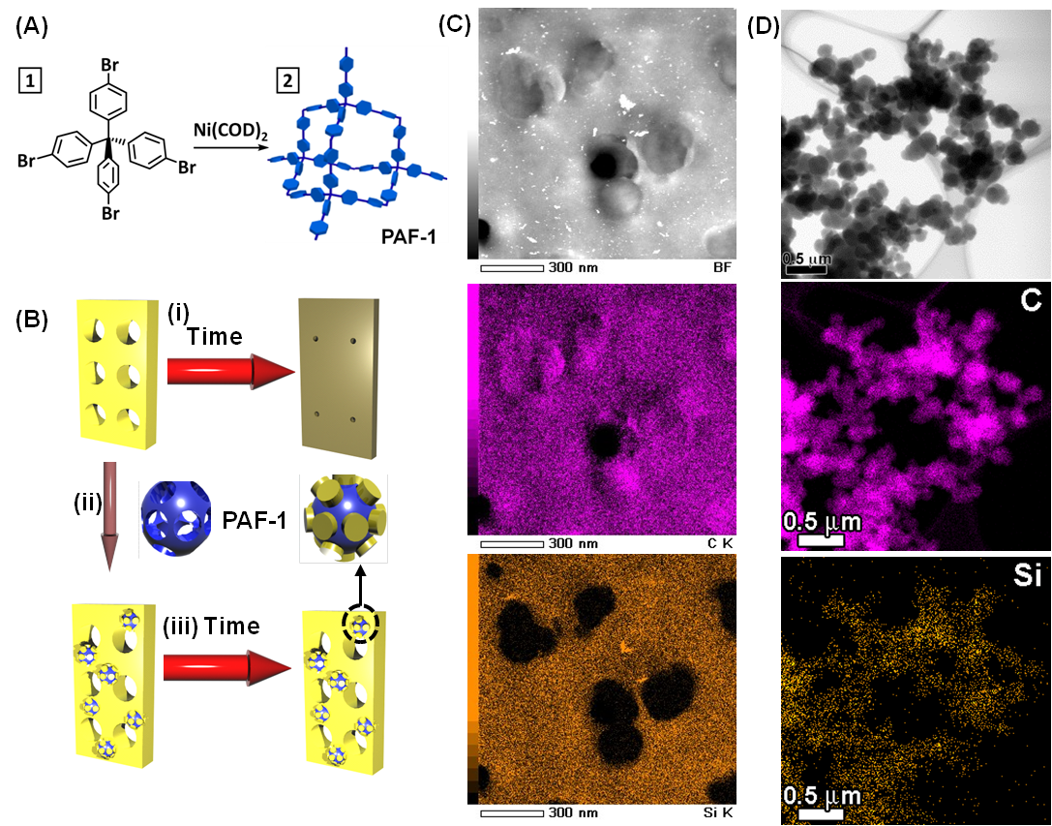
Figure 1. Anti-aging and plasticisation resistance are now possible in mixed matrix membranes.

