Side Chain Rigidity and Backbone Flexibility: New Microporous Polymers for Gas Separations
Francesco M. Benedetti^{a,b}, Yuan He^{c}, Sharon Linª, Chao Liu^{d}, Yanchuan Zhao^{d}, M. Grazia De Angelis^{b}, Timothy M. Swager^{c} and Zachary P. Smithª
ª Department of Chemical Engineering, Massachusetts Institute of Technology, Cambridge, Massachusetts 02139, USA
^{b} Department of Civil, Chemical, Environmental and Materials Engineering, University of Bologna, 40131 Bologna, Italy
^{c} Department of Chemistry, Massachusetts Institute of Technology, Cambridge, Massachusetts 02139, USA
^{d} Center for Excellence in Molecular Synthesis, Shanghai Institute of Organic Chemistry, Chinese Academy of Sciences, Shanghai 200032, China
Key Words: Gas Separation, Porous Polymers, ROMP, Physical Aging, Plasticization
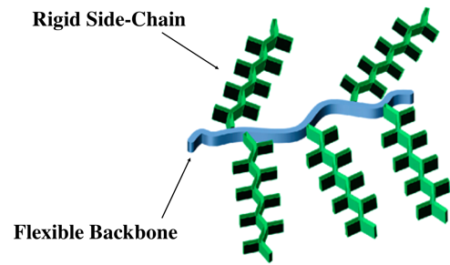
Polymeric membranes represent an energy-efficient alternative to traditional unit operations for gas separations. Within this field, polymers of intrinsic microporosity (PIMs) have seen significant interest over the past 15 years, but their structures are exceedingly difficult to tune while still maintaining synthetic access to high molecular weights. Therefore, it is difficult to access new polymeric materials for PIMs made from traditional step polymerization mechanisms. Herein, we present the synthesis and the characterization of new porous polymers obtained with a novel reaction scheme based on Ring Opening Metathesis Polymerization (ROMP) [1]. While previously reported PIMs are based on the design of 3D rigid and contorted backbones to prevent efficient packing, these ROMP polymers consist of a unique morphology with a flexible backbone and rigid side-chains, as shown in the figure above. These features enable the formation of internal porosity (i.e., BET internal surface areas up to 780 m²/g) and extraordinary gas transport properties. Ultrahigh CO₂ and H₂ permeability values, higher than 18,400 and 8,300 Barrer respectively, were measured on self-standing thick films. Additionally, strong resistance to CO₂-induced plasticization was observed when compared to other highly permeable materials like PIM-1 and PTMSP. Moreover, physical aging studies shown slightly lower aging rates than PIM-1 for over 2,000 hrs. The flexibility of this ROMP chemistry permits the synthesis of a variety of structural variants. In one example, we investigate a structure-property study between a bulkier CF₃-functional side chain compared to a side chain containing methoxy functional groups. The latter material was also characterized following the same methodology, providing a more fundamental understanding of this new family of polymers. This design strategy of combining a flexible backbone with rigid side chains opens a new route for the preparation of high-performance microporous polymer systems for gas separations.
[1] Y. Zhao, Y. He and T. M. Swager; Porous organic polymers via ring opening metathesis polymerization, ACS Macro Lett. 2018, 7, 300-304.

